Table of Contentsghgf
1. Introduction 6
2. Persistence layer requirements 8

The identity of persistent objects 8
Database mapping requirements 8
Object-relational databases 12
Database mapping requirements continued 16
Querying 17
Caching 17
Reflection 17
Library architecture 18
Conclusion 18
3. Evolution of the IOPC 2 library 20

POLiTe 20

Architecture 20
The data access layer 21
Metamodel and object-relational mapping. 21
Persistent object manipulation 24
Querying 27
Conclusion 27
POLiTe 2 28

Architecture of the POLiTe 2 library 28
The cache layer 29
Persistent object manipulation 30
Querying 33
Conclusion 33
IOPC 33

Features of the library 34
Architecture of the library 34
IOPC SP 35
IOPC DBSC 38
IOPC LIB 41
Conclusion 43
Library comparison 44
4. Basic concepts of the IOPC 2 library 45

Library architecture 45
Obtaining the metamodel description 46
Object relational mapping in the IOPC 2 library 48

Base classes 49
ADT mapping 51
Mapping algorithm prerequisites Chyba: zdroj odkazu nenalezen
The mapping algorithm 55
Conclusion 59
5. Architecture of the IOPC 2 library 61

Architecture overview 61
Common services 62

Thread synchronization classes 62
Class metadata 62
Utilities 62
Database access 63

Basic classes 63
Driver features 66
The metamodel 67

The metamodel classes 67
Enhanced data types 70
Class metadata 71
iopcsp 72
Usage transparency differences from IOPC 73
The persistence layer - iopclib 74

Database mapping 74
Persistent object manipulation 76
The cache layer 80
Querying 82
6. Conclusion 84
Literature used 86

List of Figures
1.1. IOPC 2 evolution 7
2.1. Example class hierarchy 9
2.2. Vertical mapping tables 10
2.3. Horizontal mapping tables Chyba: zdroj odkazu nenalezen
2.4. Filtered mapping tables 11
2.5. Combined mapping tables 12
2.6. Proposed architecture of the O/R mapping library 18
3.1. Architecture of the POLiTe library 20
3.2. POLiTe persistent object states 24
3.3. POLiTe references 25
3.4. Architecture of the POLiTe 2 library 28
3.5. Caches in the POLiTe 2 library 29
3.6. States of the POLiTe 2 objects 31
3.7. Dereferencing DbPtr in POLiTe 2 32
3.8. The IOPC library workflow 34
3.9. POLiTe library components used in IOPC LIB 41
3.10. Structure of the IOPC LIB 42
4.1. Reflection using the GCCXML 46
4.2. IOPC 2 base classes 49
4.3. SQL schema generated from classes using combined mapping 55
4.4. Top-level part of the object-relational mapping algorithm 56
4.5. Description of the Insert_Row method. Not used for ADT mapping. 56
4.6. Inserting objects using filtered mapping 57
4.7. Iterative loading algorithm 58
5.1. Overview of the IOPC 2 architecture 61
5.2. Basic classes of the database layer 63
5.3. Using the decorator pattern 64
5.4. Oracle 10g database driver extensions and driver features 66
5.5. The iopcmeta classes 67
5.6. Structure of the enhanced data type classes 70
5.7. Classes involved in the database mapping process 74
5.8. Classes manipulating with persistent objects 76
5.9. The bePersistent operation 77
5.10. Database pointer and cache pointer interaction 78
5.11. Interaction with the O/R mapping services 79
5.12. Basic classes of the cache layer. VoidCache architecture. 80
5.13. Extended interface of the cache layer. 81
5.14. The Query classes 82

List of Examples
2.1. Using object types in Oracle 13
2.2. Accessing objects in Oracle 13
2.3. Nested tables in Oracle 14
2.4. References in Oracle 15
2.5. A polymorphic query using object-relational features of the Oracle database. Chyba: zdroj odkazu nenalezen
3.1. Definition of a class in the POLiTe library 22
3.2. Associations in the POLiTe library 23
3.3. Persistent object manipulation 26
3.4. Queries in the POLiTe library 27
3.5. Persistent object manipulation in the POLiTe 2 library 31
3.6. Executing queries in the POLiTe 2 library 33
3.7. Definition of persistent classes in IOPC 35
3.8. XML metadata file 38
4.1. Basic persistent class definition in IOPC 2 47
4.2. GCCXML output 47
4.3. IOPC SP output 48
4.4. DatabaseObject usage 50
4.5. SQL schema generated for DatabaseObject subclasses. 50
4.6. SQL schema generated for OidObject subclasses. 51
4.7. Using the ADT mapping. 52
4.8. SQL schema from classes that use ADT mapping. 53
4.9. Loading objects using ADTs from an Oracle database 59
5.1. Connecting to an Oracle database in IOPC 2 65
5.2. Type traits 68
5.3. Using the reflection interface 69
5.4. Java annotations and C# attributes Chyba: zdroj odkazu nenalezen
5.5. Java annotations and C# attributes 71
5.6. Example usage of metadata in the IOPC 2 library Chyba: zdroj odkazu nenalezen
5.7. Java annotations and C# attributes 73
5.8. Using the ScriptsGenerator to create required database schema. 75
5.9. Using the bePersistent method 77
5.10. Example query in IOPC 2 83

Chapter 1. Introduction
Today, object-oriented languages represent standard instruments for business application and information system development. These systems usually operate with large amounts of persistent data stored in relational database management systems (RDBMS). Data in RDBMSs are however represented differently from data in the application layer. Developers need to do a lot of programming overhead to deal with this so-called impedance mismatch every time they want to move data between relational databases and application-level object models.
Object-oriented database management systems (OODBMS) try to mitigate the impedance mismatch for example by providing navigation using pointers instead of using joins as in the relational databases. Despite their advantages the object-oriented databases are not as widely used as the relational databases. Mostly because of the lack of various tools like reporting, or OLAP¹ and due to the industry standards pushed by the big players - Oracle, Microsoft and IBM. Moreover many of RDBMS creators already addressed the impedance mismatch issue by incorporating object-oriented features into their products. Doing it a new kind of database management system, object-relational database management systems (ORDBMS), were created.
Another approach to bypassing the impedance mismatch is to isolate the developer from direct data manipulation in the database at application level. This goal can be accomplished by using an object-relational (O/R) mapping layer. This layer transparently maps relational data into application object model and vice versa. The O/R tools usually offer additional services like object querying or caching.
Current information systems are often written in high-level languages like Java or C#. There exist established O/R mapping tools for these environments. Well-known is Hibernate² for Java and nHibernate³ for C# or relatively new ADO.NET Entity Framework from Microsoft⁴.
O/R mapping tools for such languages can use their feature called reflection. Reflection allows program to find out information about its own data model and to modify it at run-time. The O/R mapping layer then can easily inspect the structure of the classes being mapped, and based on this information, it can transparently load or save data from/to the underlying database. Languages that support reflection are often referred to as reflective languages.
Another frequently used language in this area is C++. Unfortunately, C++ is not a reflective language, so the building of O/R mapping layer is a bit more difficult. The goal of this thesis is to develop such a mapping library, which should work as transparently as possible.
<todo>A good O/R mapping library can help C++ application developers to focus on other areas than on complicated database access and can move the C++ development towards the higher level reflective languages. To achieve this goal the library uses GCCXML, a XML output extension to GCC. GCCXML helps the O/R layer to get a description of the class model used in the program and to simulate the reflection. - do Abstraktu</todo>
Another goal of this thesis is to examine possibilities the ORDBMSs can provide to a O/R mapping library.
One of goals of this thesis was to use advantages of three previous projects. Their common predecessor is the POLiTe library⁵ was developed as a part of doctoral thesis [3]. Two follow-ups came after this work as master theses focusing on different areas of the O/R mapping concept:
- Master thesis [1] (called POLiTe 2 in further text) addressed mainly the performance and notably enhanced functionality of the object cache. It also added multithreading support and made the interface of the library safer to use.
- Mater thesis [2] (IOPC⁶) designed a new persistence layer. The main advantage of this new layer is transparent application development without the need to additionally describe classes in it. It uses OpenC++ source-to-source translator to analyze and prepare the source code for the object-relational mapping. Even though brand-new interface was created, the library still supports classes written in the POLiTe-style.

Figure 1.1. IOPC 2 evolution
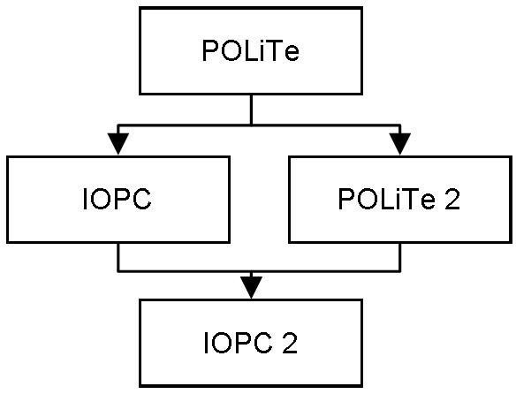
The IOPC 2 library provided in this thesis not only merges the development back into one product offering most of previously implemented features without their drawbacks. Furthermore, the library implements new ideas like standalone reflection mechanism, additional mapping type using object-relational database abilities and many other.
In the following section we will introduce basic concepts of the object-relational mapping, discuss new features of ORDBMSs and describe requirements and goals of the IOPC 2 implementation. Then, in the third chapter, evolution of the IOPC/POLiTe libraries will be presented in the context of requirements placed and their features will be compared with each other. Chapter 4, Basic concepts of the IOPC 2 library describes basic concepts of the IOPC 2 implementation whereas Chapter 5, Architecture of the IOPC 2 library contains detailed architectural information. In conclusion we will evaluate the achievements of this thesis and will propose areas for further development. Appendices contain a user guide
<todo>and additional overview tables</todo>
.
Enclosed DVD contains library source code with examples, binary distribution for Linux, documentation and in the first place a VMWare image with pre-installed environment. The image contains Ubuntu Linux, freely distributable Oracle XE database, latest GCCXML and all other IOPC 2 dependencies. The library source code and source code of the examples is stored in the image as an Eclipse CDT project. So all the examples can be modified, compiled and run right away.
<todo>Predelat citations - precislovat</todo>

Chapter 2. Persistence layer requirements
Sections in this chapter analyze the requirements that may be imposed on a O/R mapping library and were taken into account during design and implementation phase of the development.

The identity of persistent objects
In the world of object-oriented programming object identity represents an object property that helps to distinguish objects from each other. Even if two distinct objects have same values of all their attributes and so their inner state is identical, they are still different instances with different identity. A reference to an object is a closely related term to the identity as it uses this identity to describe the object it is referring to.
If we consider entries in a relational table as objects, the identity of these objects could be based on any key in the table - usually the primary key. Persistence layer would then use such a key as a description of object identity on the application level.
In object-oriented systems, where database is used only as a mere storage of the object model and/or the design focuses on the application-tier, an object identifier (OID) approach is used. OID is a name for a special table column and for corresponding class attribute which has no business meaning. On the application level it is usually hidden from users or application developers. OID contains an identifier, usually a number, UUID¹ or a list of numbers, which is unique for each persistent object within the database scope. Object’s OID never changes during its lifetime. OID is mapped into database tables as a surrogate key. Instances of classes containing an OID attribute are called OID objects further in the text.
Another approach is needed for systems built upon an existing database, for systems where the use of natural, not surrogate, keys is required or for systems with read-only or no-schema-changes-allowed databases. The object-relational layer should be able to absorb identity of persistent objects from keys (even multi-column keys) in existing schema. We will call such objects as database objects.
In several cases, we may want the object-relational layer to manipulate objects without any identity. These objects may represent results of aggregation queries, rows from non-updateable views or rows from tables without any keys. Transience is an important feature of these objects: their modified state cannot be stored back to the underlying database - origin of the data they contain may not even be traceable back to particular row and/or particular table.
The all-purpose O/R mapping layer should support OID objects as well as database objects and even transient objects for query results.

Database mapping requirements
Persistence layer considered in the context of this thesis should be able to manipulate persistent instances of certain classes. These classes are called persistent classes, its instances persistent objects. Storing objects to database implies that the layer should store their attribute values to underlying database structures. Because all predecessors of this thesis used relational database systems as their persistent storage, let’s focus first on this area first.
Persistent classes would be represented as tables and their attributes as their columns. Instances of persistent classes would be inserted into these tables as rows containing instance attribute values associated with corresponding table columns. Requirements on a basic persistence library could be:
- Ability to associate persistent classes with database tables
- Ability to map attributes of these classes on columns in associated tables. This means that the layer should be able to store attributes of certain C++ types (basic numeric types, strings) into the database as column values.
- Classes can also contain attributes of structured types or collections, which are often mapped into separate tables or split into more columns in the relational model.
- Last attribute type to be discussed is an association (C++ pointer/reference). Association can be modelled using foreign key relationship between matching tables. The persistence layer should be able to handle single associations as well as collections of associations.
- An optional requirement may be an ability to generate required database schema in form of a SQL create (or drop) script. The persistence layer may require its own structures in the underlying database or it may be able to operate upon existing database schema.
- Ability to query subsets of object model content. The layer should provide a query language that would abstract from the physical representation of the object model in the database.
Up to now we have considered only single classes without inheritance relations. However, in C++ classes can form complex inheritance hierarchies and it is a natural requirement to be able to store descendants of persistent classes too. There are several ways how to store these hierarchies into a relational database. To help to illustrate these mapping types see the Figure 2.1, “Example class hierarchy” for example class hierarchy. This hierarchy will also be used and modified further in the text.

Figure 2.1. Example class hierarchy
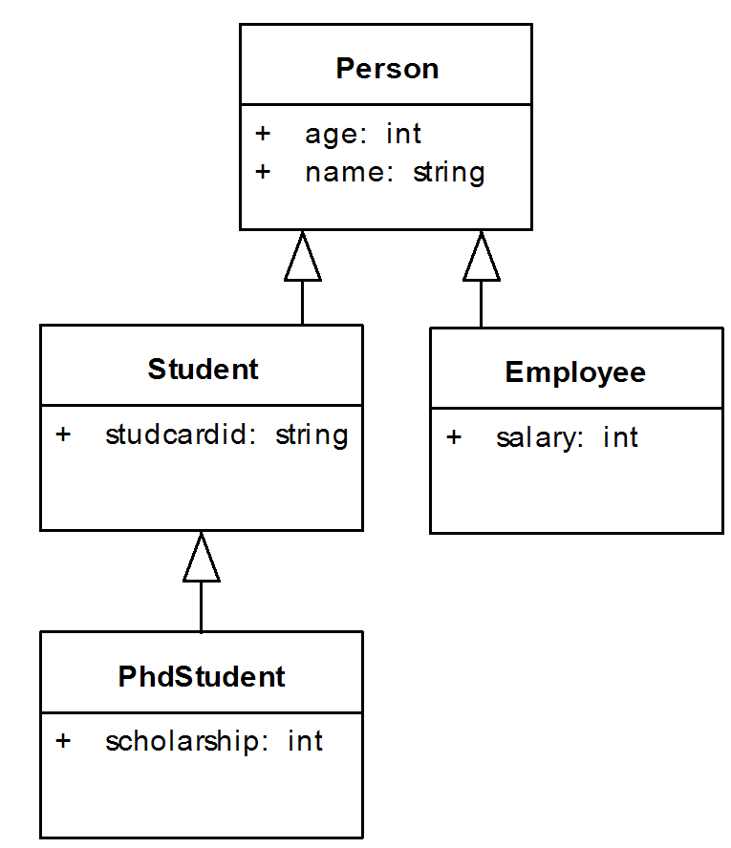
Vertical mapping is a most common (and natural) way of mapping attributes of persistent classes in an inheritance hierarchy into tables in a relational database. Each class in this hierarchy has one associated table in the database. Only values from attributes declared in correspondent classes are stored into these tables. This means that attributes declared in current class are mapped into its associated table, attributes from parent class are mapped into a “parent” table etc. Storing one object invokes a cascade of database inserts. Similar rules apply for updates, deletes and selects. However, selects can be simplified using table joins and database views. This solution offers good performance for shallow hierarchies, which is getting worse with the inheritance graph getting deeper. It is a best choice for scenarios where polymorphism does matter - by querying one table we easily get instances of associated class and its descendants.
Let’s consider following instances of the classes from Figure 2.1, “Example class hierarchy”:
Student(name: “Richard Doe”, age: 22,
studcardid: “WCD-3223”)
PhdStudent(name: “Joe Bloggs”, age: 27,
studcardid: “PHD-1234”, scholarship: 12000)
Employee(name: “Ola Nordmann”, age: 45,
salary: 60000)
Person(name: “Mary Major”, age: 60)
Vertical mapping will spread data from these instances into four tables as illustrated by the Figure 2.2, “Vertical mapping tables”. The tables are arranged so that attribute values belonging to one particular class are displayed in the same row. To be able to join data from the tables we use surrogate OID as explained in the previous chapter. All rows belonging to one particular object are assigned the same OID.

Figure 2.2. Vertical mapping tables
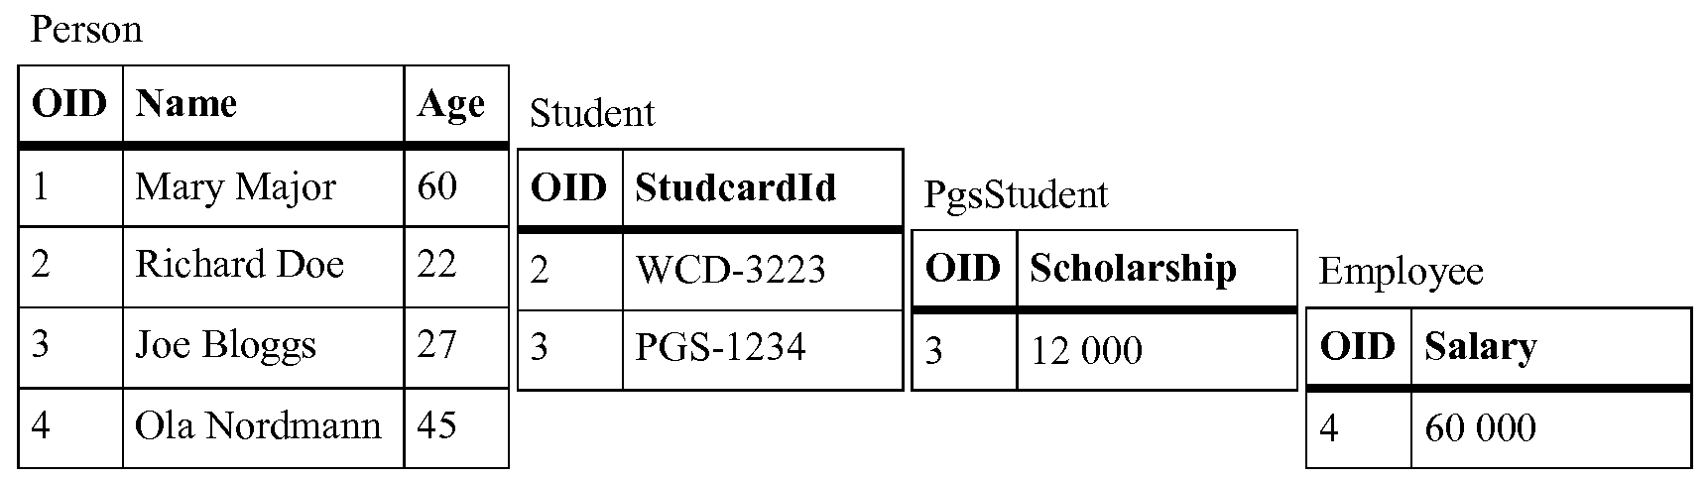
Horizontal mapping offers better performance for scenarios where we don’t need polymorphic queries - accessing descendants of specific class. Again, each persistent class in a hierarchy has one associated table into which its instances store their attributes. The difference from vertical mapping is that these tables contain even attributes inherited from parent persistent classes. Rows in these tables contain enough information to load complete persistent class instances, thus no cascade operations are needed. Every instance of horizontally mapped class is mapped only into one table row in the database.

Figure 2.3. Horizontal mapping tables
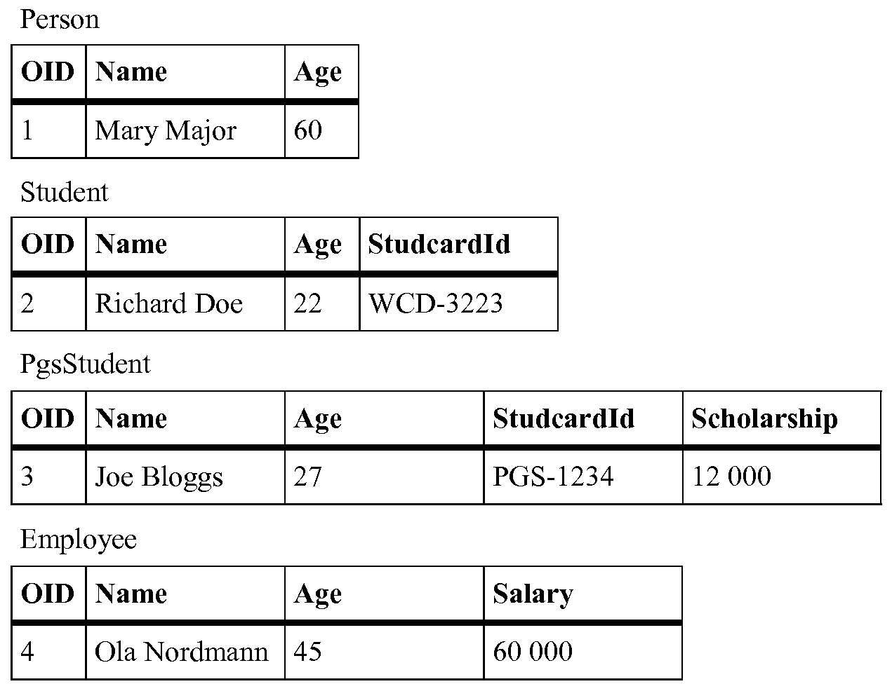
As you can see in Figure 2.3, “Horizontal mapping tables” - queries using polymorphism can be very hard to perform. Finding a specific object of Person type or its descendants involves looking into all the tables. However, opposite to the vertical mapping, if we work with objects of specific type (not including descendants), we don’t need any joins in select statements or cascade inserts/updates.
Filtered mapping assigns only one database table to all persistent classes in one inheritance hierarchy - see Figure 2.4, “Filtered mapping tables”. This table contains columns that represent all attributes from all classes in that hierarchy. Filtered mapping doesn’t suffer from disadvantages of two previous approaches - it performs very well on polymorphic data and doesn’t involve cascaded operations/joins. A disadvantage of this approach is excessive storage requirement. Most of the rows in the table will contain empty cells in columns that belong to attributes from classes not being in ancestor relationship of the matching class or from the matching class itself. Second thing is that it is necessary to add a column telling us which class the rows belong to. As we have all rows in one table there is no other easy way how to distinguish the instance types.

Figure 2.4. Filtered mapping tables
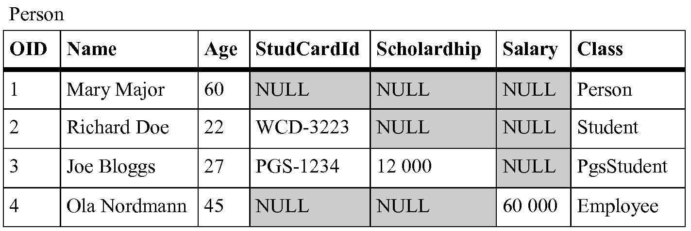
Combined mapping is a combination of mappings mentioned above. It allows users to use all kinds of mappings in one inheritance hierarchy. Combined mapping is the most sophisticated variation that allows users to specify these mappings according to their needs. It is also quite complex for implementation, it has some constraints how the mapping types can be used and it is not well maintainable on the database side. Database structures created for combined mapping would require nontrivial constraints if their content were modified other way than using the persistence layer that created the structures. The persistence layer should hide this complexity beyond views to provide at least convenient read-only access. The mapping algorithm used in the IOPC 2 library will be described later in the section called “The mapping algorithm”. To see how the combined mapping can be used refer to Figure 2.5, “Combined mapping tables”.

Figure 2.5. Combined mapping tables
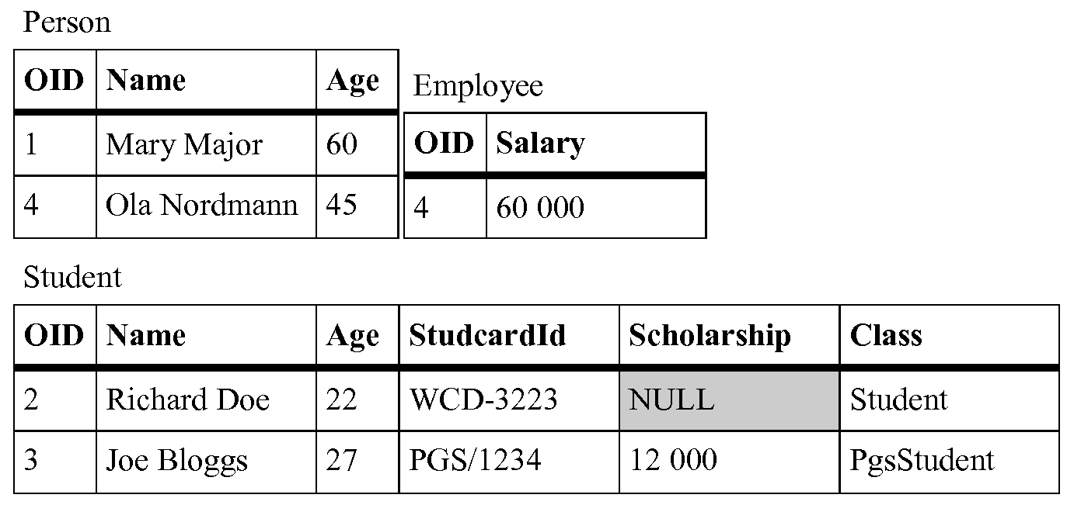
The Employee class uses vertical mapping, the Student class uses horizontal mapping and the PhdStudent class uses filtered mapping. Classes that use filtered mapping can choose into which of their ancestors they will be mapped to. Class PhdStudent is mapped to the table belonging to the Student class.

Object-relational databases
Object-relational databases offer higher level of abstraction over the problem domain. They extend relational databases with object-oriented features to minimise the gap between relational and object representation of application data known as the impedance mismatch problem. One of the features allows developers to create new custom data types and extend them with custom functions. Main features of the object-relational databases are summarised below. For detailed information about user defined types and other features of object-relational databases refer to [7], [8]. This area is introduced by an 1999 revision of the ISO/IEC 9075 family of standards, often referred to as SQL3 or SQL: 1999. Because the level of implementation of the standard varies between available products, you may need to see their manuals too. For Oracle 10g refer to [9].
User-defined types are custom data types which can be created by users using the new features of object-relational database systems. These types are used in table definitions the same way as built-in types like NUMBER or VARCHAR. There are several kinds of UDTs - for example - distinct (derived) types, named row types, and most importantly the abstract data types (ADT), which we will focus on in the following paragraphs.
ADT is a structured user defined type defined by specifying a set of attributes and operations much in a similar way to object-oriented languages like C++ or Java. Attributes define the value of the type and operations its behaviour. ADTs can be inherited from other abstract data types (in terms of object-oriented programming) and can create type hierarchies. These hierarchies can reflect the structure of data objects defined in application-tier modules. Instances of ADTs are called objects and can be persisted in database tables. See Example 2.1, “Using object types in Oracle” for an illustration how these types are defined and used in Oracle ORDBMS.

Example 2.1. Using object types in Oracle
-- type definitions
CREATE TYPE TPerson AS OBJECT (
name VARCHAR2(50),
age NUMBER(3)
) NOT FINAL;
CREATE TYPE TStudent UNDER TPerson(
studcardid VARCHAR2(20)
) NOT FINAL;
CREATE TYPE TPhdStudent UNDER TStudent(
scholarship NUMBER(10)
) NOT FINAL;
CREATE TYPE TEmployee UNDER TPerson(
salary NUMBER(10)
) NOT FINAL;
-- storage
CREATE TABLE Person OF TPerson;
-- fill it with data
INSERT INTO Person VALUES(
TPerson(’Mary Major’, 60)
);
INSERT INTO Person VALUES(
TStudent(’Richard Doe’, 22, ‘WCD-3223’)
);
INSERT INTO Person VALUES(
TPhdStudent(’Joe Bloggs’, 27, ‘PHD-1234’, 12000)
);
INSERT INTO Person VALUES(
TEmployee(’Ola Nordmann’, 45, 60000)
);
First, the supertype TPerson and its descendants TStudent, TPhdStudent and TEmployee are defined. The NOT FINAL keyword allows us to create subtypes of given types. Then physical storage table Person is created. This table can hold not only instances of the TPerson type but also instances of its descendants. Accessing these instances is demonstrated in the following Example 2.2, “Accessing objects in Oracle”.

Example 2.2. Accessing objects in Oracle
SELECT VALUE(x) FROM Person x;
-- returns:
TPERSON(’Mary Major’, 60)
TSTUDENT(’Richard Doe’, 22, ‘WCD-3223’)
TPHDSTUDENT(’Joe Bloggs’, 27, ‘PHD-1234’, 12000)
TEMPLOYEE(’Ola Nordmann’, 45, 60000)
-- accessing descendant attributes:
SELECT
TREAT(VALUE(x) AS TStudent).studcardid AS studcardid
FROM Person x
WHERE VALUE(x) IS OF (TStudent)
-- returns:
WCD-3223
PHD-1234
First, we list all objects stored in the Person table. Then we list all student card IDs of all student objects that are stored in the table.
Nested tables. Nested tables violate the first normal form in a way that they allow the standard relational tables to have non-atomic attributes. Attribute can be represented by an atomic value or by a relation. Example 2.3, “Nested tables in Oracle” illustrates how to create and use nested tables in Oracle database system. The example modifies the Person type by adding a list of phone numbers to it. Interesting is the last step in which we perform a SELECT on the nested table. To retrieve the content of the nested table in a relational form, the nested table has to be unnested using the TABLE expression. The unnested table is then joined with the row that contains the nested table.

Example 2.3. Nested tables in Oracle
-- a type representing one phone number
CREATE TYPE TPhone AS OBJECT (
num VARCHAR2(20),
type CHAR(1)
);
-- a type representing a list of phone numbers
CREATE TYPE TPhones AS TABLE OF TPhone;
-- the modified TPerson type
CREATE TYPE TPerson AS OBJECT (
name VARCHAR2(50),
age NUMBER(3),
phones TPhones
) NOT FINAL;
-- storage
CREATE TABLE Person OF TPerson
NESTED TABLE phones STORE AS PhonesTable;
-- fill it with data
INSERT INTO PERSON VALUES(
TPerson(’Mary Major’, 60, TPhones(
TPhone(’123-456-789’, ‘W’),
TPhone(’987-654-321’, ‘H’)
) ) )
-- obtaining a list of phones of a particular person
SELECT y.num, y.type
FROM Person x, TABLE(x.phones) y
WHERE x.name = ‘Mary Major’;
-- returns rows:
123-456-789 W
987-654-321 H
Please note, that the nested table PhonesTable in Example 2.3, “Nested tables in Oracle” may need an index on an implicit hidden column nested_table_id to prevent full table scans on it.
Collection types. SQL3 defines also other collection types like sets, lists or multisets. In addition to nested tables, Oracle implements the VARRAY construct which represents an ordered set (list). The main difference is that VARRAY collection is stored as a raw value directly in the table or as a BLOB², whereas nested table values are stored in separate relational tables.
Reference types. We can think of the database references as of pointers in the C/C++ languages. References model the associations among objects. They reduce the need for foreign keys - users can navigate to associated objects through the reference. In the following Example 2.4, “References in Oracle” we will add a new subtype TEmployee and modify the TStudent type from previous examples by adding a reference to the student’s supervisor, which is an employee, to it. Note that we need to cast the reference type REF(x) to REF TEmployee in the INSERT statement because REF(x) refers to the base type TPerson.

Example 2.4. References in Oracle
-- type definitions
CREATE TYPE TPerson AS OBJECT (
name VARCHAR2(50),
age NUMBER(3)
) NOT FINAL;
CREATE TYPE TEmployee UNDER TPerson(
salary NUMBER(10)
);
CREATE TYPE TStudent UNDER TPerson(
studcardid VARCHAR2(20),
supervisor REF TEmployee
);
-- storage
CREATE TABLE Person OF TPerson;
-- insert an employee into the Person table
INSERT INTO Person VALUES(TEmployee(’Ola Nordmann’, 45, 60000))
-- insert a student with a reference to his supervisor
INSERT INTO Person
SELECT TStudent(’Richard Doe’, 22, ‘WCD-3223’,
TREAT(REF(x) AS REF TEmployee)))
FROM Person x
WHERE x.name = ‘Ola Nordmann’;
-- select all students with their supervisors
-- dereferencing uses dot notation
SELECT x.name, TREAT(value(x) as TStudent).supervisor.name
FROM Person x
WHERE VALUE(x) IS OF (TStudent)
-- returns a row:
Richard Doe, Ola Nordmann

Database mapping requirements continued
As we already know about the object-relational databases, These new features of object-relational databases can be used to enhance functionality of described mapping types. They can also be a basis for a new mapping type that will entirely depend on the use of ORDBMS. First, let’s have a look how the attribute mapping can be improved:
- Collections (C++ containers) can be mapped into single columns as nested tables or instances of one of the SQL3 collection data types.
- Structured attributes (C++ struct or class) can be mapped into single columns as instances of SQL3 structured data types.
- Associations (C++ pointers or references) can be mapped as SQL3 references.
Second, let’s solve mapping of classes and inheritance hierarchies. It is quite obvious that user-defined types can be used for this task. Abstract data types can be created for each class in the inheritance hierarchy by copying its inheritance graph. Instances of the types can be then inserted into one table. The earlier presented Example 2.1, “Using object types in Oracle” displays structures that may be generated for classes from Figure 2.1, “Example class hierarchy” using such kind of database mapping.
This type of mapping is referred to as ADT mapping in this thesis³. Its benefit is that it moves most of the responsibilities of the persistence layer to the underlying database system. For example obtaining a list of fully-loaded instances of specific type and its descendants involves several joins in the vertical mapping (filtered mappings or other variations using the combined mapping). This must be “planned” by the persistence layer. All such polymorphic queries are best performed using the ADT mapping (see the Example 2.5, “A polymorphic query using object-relational features of the Oracle database.”), as all these tasks can be accomplished only using the user-defined types and SQL3 queries or statements.

Example 2.5. A polymorphic query using object-relational features of the Oracle database.
SELECT
name, age, TREAT(VALUE(x) AS TPhdStudent).studcardid AS studcardid,
TREAT(VALUE(x) as TPhdStudent).scholarship as scholarship
FROM Person x
WHERE VALUE(x) IS OF (TPhdStudent)
A serious problem for a persistence layer using the ADT mapping is that there are major differences between database systems in the object-relational area. For example DB2 doesn’t offer any type similar to the Oracle VARRAY data type. Or another example - in DB2 you have to create whole table hierarchy for inherited object types - much like as you would when creating storage structures for a vertically-mapped data type. These issues imply that the persistence layer should be flexible and modular enough to be able to support different database systems.
Another problem is multiple inheritance of ADTs. Although SQL3 standard supports multiple inheritance, it is not implemented neither in the current version of Oracle nor in the current version of DB2. The problem is discussed later in the section called “ADT mapping”

Querying
Object-relational systems allow users usually to load data in two ways. Either by traversing the model of persistent objects through associations and letting the persistence layer to load missing data into referenced local copies or by exploiting the ability of the underlying DBMS to execute SQL queries against the data stored in it. The persistence layer can provide direct access to the database by allowing its users to run SQL queries on tables or views the layer generated. This approach is not very user friendly as it requires the users to know the internals of database mapping performed by the persistence layer. The layer should therefore offer its own query language which will hide the complexity of the database structures. Queries in such language can be passed as character strings or as objects which represent attributes, values, comparison criteria etc. Depending on the level of implementation, users may filter only objects of one inheritance hierarchy by their attribute values, perform polymorphic queries returning objects of specified type and its descendants or they may query associations between objects. This queries represented in natural language would be:
- Find all students older than 26. (Age >=26)
- Find all students including Ph.D. students. (Actually all queries may be modified to include Ph.D. students).
- Find all students which are supervised by Mrs. Ola Nordmann. (Using the modified model from Example 2.4, “References in Oracle”)

Caching
The role of caching is to speed up applications that use persistent objects by delaying database mapping operations. This is generally achieved by taking ownership of these objects when they are not currently in use by the user application. If the user applications needs an already released object again, the caching facility⁴ looks it up in its catalogue and if found, returns it to the user application, saving the time-consuming database operations. The database operations for storing, updating or loading persistent objects are controlled by the cache layer, not by the user application. The layer is therefore responsible for creating and destroying persistent object instances.

Reflection
Users of the persistence layer may want to examine the structure of persistent classes at run-time. This is not of a big issue in reflective languages like Java or C#, but in the C++, which is not reflective language, this requirement may pose a problem. Yet not necessarily, because the persistence layer must know about the structure of classes it is mapping to database. So, it only depends on the particular implementation of a C++ O/R mapping library whether it provides access to this information and how.
If the library puts these introspection features behind unified interface and allows to inspect wider set of classes than only the persistent classes, it may provide at least simpler alternative to reflection features offered by reflective languages. This may be a big advantage, because developers tend to include O/R mapping features into their application frameworks and O/R mapping is often one of the pillars of infrastructural part of business applications. Therefore it reduces the need for other reflection library.

Library architecture
Based on the discussion in previous sections, we are able to specify three relatively autonomous areas a C++ persistence library should cover:
- Database access. The library should not be database dependent. To achieve this goal, the database access must be virtualised by providing an interface to other parts of the library which will hide the differences between databases the users may use. The library should contain modules called database drivers translating and dispatching requests from the interface to concrete database instances. Database drivers should be separate modules allowing users to select between them without the need to recompile the whole library. The architecture should be flexible enough to be able to handle relational as well as object-relational database systems. It would be also nice if the whole database access infrastructure was a stand-alone module as the discussed database interface could be used as a database access library.
- Reflection. If the reflection capabilities, as described in the previous section, were provided as a stand-alone module, the library could be used in a reflection library configuration.
- Object-relational mapping. The complete O/R mapping library would need both, the database access and reflection configurations: The reflection to inspect the structure of the persistent classes and the database access interface to load and store them from/to a database. The library should provide a module which will manage and perform the O/R mapping including related tasks as caching and querying. This O/R mapping module will depend on the previous two modules.

Figure 2.6. Proposed architecture of the O/R mapping library
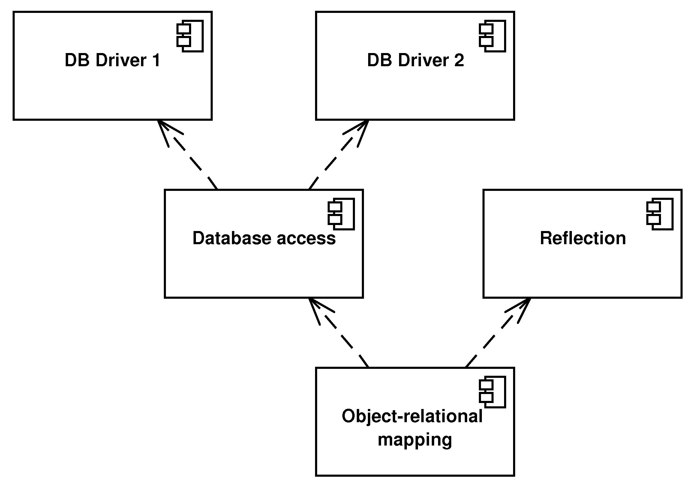

Conclusion
In this chapter, we analyzed basic aspects of an O/R mapping library implementation. Based on this analysis, we can summarise the requirements on the library. Some of the requirements are required while some are optional. We list them for further reference.
- Common O/R mapping requirements
- Ability to associate persistent classes with database tables
- Ability to map attributes of persistent classes to database columns or attributes in instances of user-defined types
- Ability to use at least one type of O/R mapping (better all of them):
- Horizontal
- Vertical
- Filtered
- Object
- Combination of the mapping types
- Ability to persist references between objects
- Ability to persist collections of objects
- Ability to generate required database schema or ability to work with existing non-mutable database schema
- Querying in the object model context.
- Object caching.
- Reflection
- Modular library architecture

Chapter 3. Evolution of the IOPC 2 library
The following paragraphs outline design and functionality of the IOPC 2 library predecessors.

POLiTe
The common predecessor of IOPC, IOPC 2 and POLiTe 2 libraries - POLiTe represents a persistence layer for C++ applications. The library itself is written in C++. Applications incorporate the library by including its header files and by linking its object code. The library offers following features:
- Persistence of C++ objects derived from specific built-in base classes. Class hierarchies are mapped vertically.
- Persistence of all simple numeric types and C strings (char*).
- Query language for querying persistent objects.
- Associations between persistent objects. Ability to combine more associations to manipulate indirectly associated instances.
- Simple database access.
- Common services like logging or locking.

Architecture
Even though the library can be divided to several functional units, it compiles as one shared library. The architecture of the library is outlined in the Figure 3.1, “Architecture of the POLiTe library”. The main functional units are discussed in the following sections.

Figure 3.1. Architecture of the POLiTe library
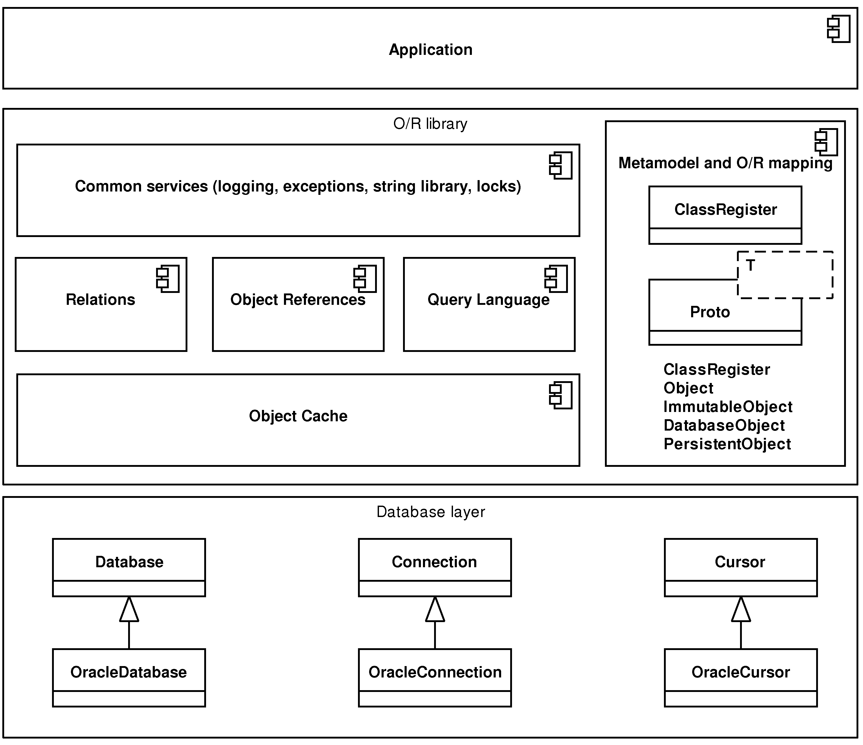

The data access layer
The POLiTe library contains several classes that provide database access. At the time, the library supported the Oracle 7 database and the code used OCI¹ 7 interface to access it. The classes are accessed via common interface that can be used for implementing other RDBMs to the library.
The interface consists of a set of abstract classes - Database, Connection and Cursor. Communication with the database flows exclusively through this interface and its implementation (OracleDatabase, OracleConnection and OracleCursor). The interface Database provides a logical representation of a database (e.g. an Oracle instance), Database can create one or more connections (Connection) to the database. The Connection interface represents the only communication channel with the database. Using the implementations of the Connection interface it is possible to send SQL statements to database and receive responses in the form of cursors (Cursor). The response consists of a set of one or more rows that can be iterated through the Cursor.

Metamodel and object-relational mapping.
Every persistent class maintainable by the POLiTe library has to be described by a set of pre-processor macro calls. These calls are included directly into the class definitions or near them. Description of the class attributes and the necessary mapping information has to be provided together with declaration of every persistent class. Metainformation covers class name, associated database table, parents, every persistent attribute with its type and corresponding table columns and more. For complete list see [4]. Example 3.1, “Definition of a class in the POLiTe library” displays definition of our classes Person and Student in the POLiTe library.

Example 3.1. Definition of a class in the POLiTe library
class Person : public PersistentObject {
// Declare the class, its direct predecessor(s) ...
CLASS(Person);
PARENTS(”PersistentObject”);
// ... and its associated table
FROM(”PERSON”);
// Define member attributes
dbString(name);
dbShort(age);
// Primary key OID is inherited from PersistentObject
// Map other attributes
MAP_BEGIN
mapString(name,”#THIS.NAME”,50);
mapShort(age,”#THIS.AGE”);
MAP_END;
} ;
// Define method returning pointer to the prototype
CLASS_PROTOTYPE(Person);
// Define the solitaire prototype instance Person_class
PROTOTYPE(Person);
class Student : public Person {
CLASS(Student);
PARENTS(”Person”);
FROM(”STUDENT”);
dbString(studcardid);
MAP_BEGIN
mapString(studcardid,”#THIS.STUDCARDID”,20);
MAP_END;
} ;
CLASS_PROTOTYPE(Student);
PROTOTYPE(Student); // Student_class
class Employee : public Person {
CLASS(Employee);
PARENTS(”Person”);
FROM(”EMPLOYEE”);
dbInt(salary);
MAP_BEGIN
mapInt(salary,”#THIS.SALARY);
MAP_END;
} ;
CLASS_PROTOTYPE(Employee);
PROTOTYPE(Employee); // Employee_class
Because the library needs to track the dirty status of persistent objects, the programmer has to maintain this flag either by himself or better he should restrict manipulation with persistent attributes to the use of getter and setter methods defined by the macros. For every class T described by these macros the library creates an associated template class prototype Proto<T>. The solitaire instance of this prototype class holds information about the metamodel described by the macros and provides the actual database mapping. Prototypes are registered within the ClassRegister. Using ClassRegister, the library and/or application can search for prototypes by their names, and access methods needed for CRUD² operations.
Persistent classes inherit their behaviour from one of four base classes defined in the library - the Object, ImmutableObject, DatabaseObject or PersistentObject class. Depending on what the parent is, several features of the persistence are supported:
- Object - instances of descendants of this class can be obtained by database queries. These objects don’t have any database identity and can represent results from complex queries containing aggregate functions. More obtained instances can thus be the same.
- ImmutableObject - instances of this class have a database identity mapped to one or more column(s) in the associated table (or view) and represent concrete rows in database tables or views. They can be loaded repetitively, but the ImmutableObject class descendants still don’t propagate changes made to them back to the database. To use this class as a query result, the query has to return rows that match rows in corresponding database tables or views.
- The DatabaseObject class is much the same as the ImmutableObject, but changes are propagated back to the database.
- The PersistentObject class offers the most advanced persistence options. The PersistentObject defines and maintains a unique attribute OID that holds the identity of every PersistentObject’s instance within the database. Unlike previous classes, persistence of whole type hierarchies is expected and supported.
As mentioned before, the library offers vertical mapping for descendants of the PersistentObject. Tables related to mapped inheritance hierarchies are joined using the surrogate OID key. If using DatabaseObject descendants, the object model can be created upon an existing (and in case of ImmutableObject descendants even upon the read-only) database tables with arbitrary keys. In this case, however, no inheritance between classes is allowed.
Associations in the POLiTe library are not modelled as references but as instances of the Relation class. There are five subclasses of this class - OneToOneRelation, OneToManyRelation, ManyToOneRelation, ManyToManyRelation and ChainedRelation according to cardinality of the association. Their names describe which kind of relation between the underlying tables they manage. ChainedRelation is built from other relations and it can be used to define relation for indirectly associated objects. Example 3.2, “Associations in the POLiTe library” demonstrates how a one-to-many relation between the Employee and Student classes can be created and used.

Example 3.2. Associations in the POLiTe library
OneToManyRelation<Employee, Student> Employee_Student_Supervisor(
“EMPLOYEE_STUDENT_SUPERVISOR”, dbConnection
);
// Let’s suggest that the Employee variable represents
// a reference to a “Ola Nordmann” persistent object
// and Student represents a reference to a “Richard Doe”
// persistent object.
// Create a supervisor relation between “Ola Nordmann”
// and “Richard Doe”.
Employee_Student_Supervisor.InsertCouple(
*Supervisor, *Student
);
The relation can be queried for objects on both of its sides. So we may run queries like “Which students are supervised by Ola Nordmann?”, “Who is the supervisor of Richard Doe?” or even more complex ones, but that would be out of the scope of this thesis.
The one-to-many relation can be replaced by a reference to s supervisor in the Student class definition:
...
dbPtr(supervisor);
dbString(studcardid);
MAP_BEGIN
mapPtr(supervisor,”SUPERVISOR”);
...
Usage of the references is closer to the object-oriented approach in which we navigate using such pointers or references to gain access to the related objects. The drawback is, that the navigation is usually one-way and in this case, the retrieval of all supervised students of an employee is not trivial.

Persistent object manipulation
Persistent objects can enter one of the following states (see the state diagram in Figure 3.2, “POLiTe persistent object states”):

Figure 3.2. POLiTe persistent object states
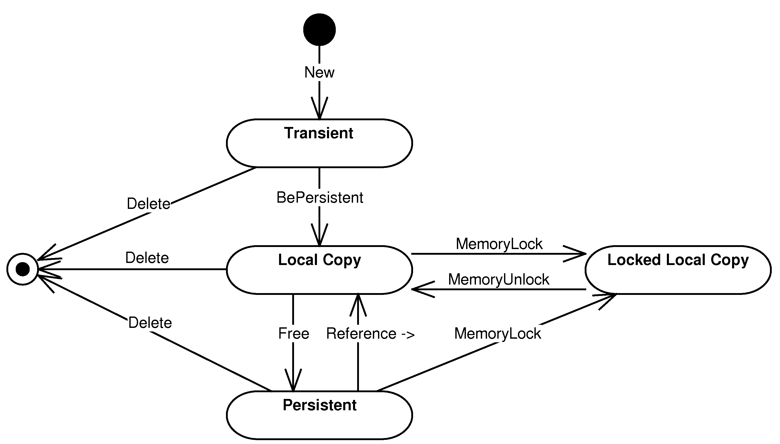
- Transient - Each new instance of persistent class enters this state. The instance data are stored only in the application memory and are not persisted.
- Local copy - A persistent image of the transient instance can be created by calling the BePersistent() method. The method inserts attribute values of the instance to the database. The memory instance can be deallocated at any time as it is considered as a cached copy of the inserted database data. This state can be entered also at a later time when loading a persistent instance which has no local copy in the application memory.
- Locked local copy - To prevent the local copy deallocation, the local copy can be locked in the application memory. Local copy is not deallocated until its lock is released. After unlocking, the locked local copy enters the local copy state.
- Persistent instance - A persistent object can enter this state if its local copy is removed from the application memory. During the state transition, the changes in the local copy are usually propagated to the database. The object exists now only in the database; it can be loaded later and enter one of the local copy states.
All local copies and local locked copies are managed by the ObjectBuffer which acts as a trivial object cache. The buffer is implemented as an associative container between object identities and local object copies. If the buffer is full, all non-locked local copies are freed and dirty instances updated in the database.
Because persistent object can exist in one of those states, library uses indirect references to access the object’s attributes. Users don’t have to know whether the object is loaded into the object cache or if it exists only in the database. Users can just access it via the Ref<T> reference type using the overloaded -> operator. The library looks for the requested instance in the object cache and if not found, it loads it from the database. C++ chains the operator -> calls until it gets to a type that doesn’t overload the -> operator and there it accesses the requested attribute or calls the requested function. So if the variable e is of the Ref<Employee> type, the following expression:
e->salary(65000);
doesn’t invoke the setter method on the Ref<Employee> instance, but it looks for the object in the object cache, loads it eventually, and invokes the setter method on it. The process is illustrated by the Figure 3.3, “POLiTe references”.

Figure 3.3. POLiTe references
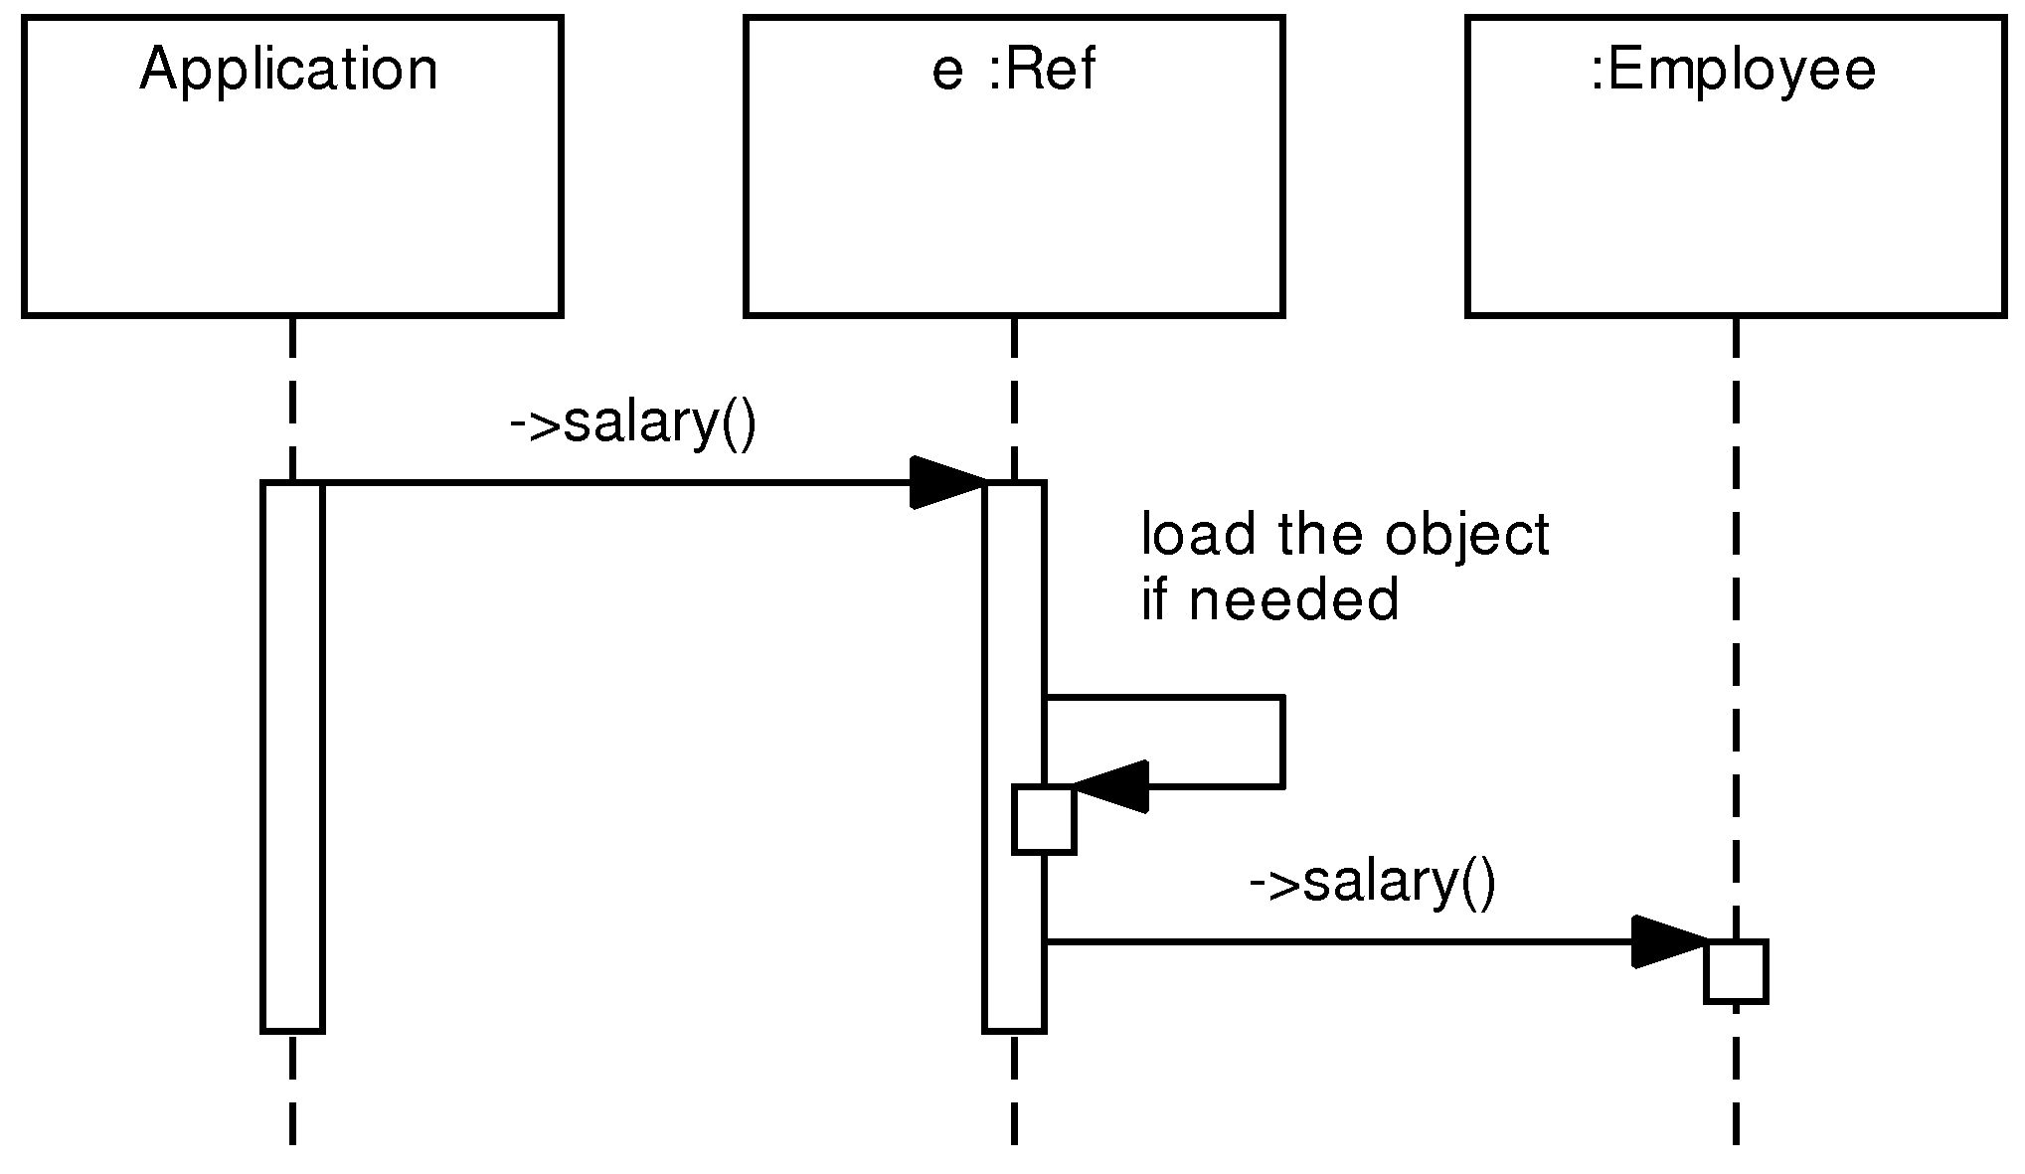
POLiTe allows the users to specify several concurrent data access strategies the ObjectBuffer will use. These strategies are used to influence the safety or speed of concurrent access and cached data coherence.
- Updating strategy - determines whether changes done to local copies are propagated to the database immediately or they can be deferred.
- Locking strategy - determines how the rows in the database are locked when they are loaded into local copies. Shared, exclusive or no locking can be requested.
- Waiting strategy - if the application tries to access a locked database resource (by another session), this strategy specifies whether the application waits until the resource gets unlocked or an exception is thrown.
- Reading strategy - determines behaviour of the persistence layer if a local copy is accessed using the indirect reference. The local copy can be either used right away or it can be refreshed with the data stored in the database. The refresh option can be speeded up by comparing timestamps of the local copy and of the stored image.
Object manipulation is illustrated by the Example 3.3, “Persistent object manipulation”. Two objects - an employee and a student, which is supervised by that employee, are created as transient instances and inserted into the database. The BePersistent() call returns a reference to the unlocked local copies of the created objects. Then the salary of the employee is modified and the change propagated to the database. In the end, the student object is deleted from the database and also from the memory.

Example 3.3. Persistent object manipulation
// Create a new employee
Employee* e = new Employee();
e->name(”Ola Nordmann”);
e->age(45);
e->salary(60000);
Ref<Employee> employee = e->BePersistent(dbConnection);
// Create a new student supervised by the employee created
Student* s = new Student();
s->name(”Richard Doe”);
s->age(22);
s->studcardid(”WCD-3223”);
s->supervisor(empl);
Ref<Student> student = s->BePersistent(dbConnection);
// Update the employee’s salary
e->salary(65000);
e->Update(); // Propagates the change to the database
// The change could be propagated immediately if the
// updating strategy was set to the “immediate” setting.
// Delete the new student
s->Delete();
);

Querying
Queries in the POLiTe library search for objects of a specified class. Search criteria restricting the result set can be specified. Queries are represented as instances of the Query class which contains only two data fields: The search criteria, in fact the WHERE clause of the final SELECT statement together with the ORDER BY clause specification, determines what object will be returned and how the result will be ordered. The search criteria can be written using SQL (referencing physical table and column names) or using a C++-like syntax. The C++-like syntax hides the O/R mapping complexity and allows the users to use more convenient class and attribute names. The query objects can be then combined using the C++ !, && and || logical operators. Results of the query execution are accessed using instances of the Result<T> template class. The template is used similarly to the Ref<T> template. Example 3.4, “Queries in the POLiTe library” illustrates how the queries are created, combined and executed.

Example 3.4. Queries in the POLiTe library
// All employees with salary > 40000
Query q1(”Employee::salary > 40000”)
// All employees with the first name Ola
Query q2(”Person::name LIKE ‘Ola %’);
// All employees with salary > 40000 having the first name Ola
Query q3 = q1 && q2;
// Order the result by the salary descending.
q3.OrderBy(”Employee::salary DESC”);
// Execute q3 and iterate through the result
Result<Employee>* result = Employee_class(q3, dbConnection);
while (++(*result)!=DBNULL) {
// members of the current object are accessible
// using (*result)->
} ;
result->Close();
delete result;

Conclusion
The library provides solid and rich-featured ORM solution. However, there are several areas in which the library can be improved:
- Transparency - persistent classes have to be precisely described by macros. Typos in this description may lead to unclear compile time or runtime errors. Attributes must be accessed via the getter and setter methods.
- Library design - library is one monolithic block and compiles into one shared library. There is no other way to add additional database drivers or features than changing the makefile and recompiling the library. Same applies to the library configuration - many parameters are configured as preprocessor macros. Changing them implies library recompilation.
- Database dependency - without modifications, the library supports only the Oracle platform. Adding new database support supposes to derive new descendants of Database, Connection and Cursor classes, implement their code and recompile the library. The library also contains several SQL fragments that aren’t separated into the database driver layer.
These disadvantages are addressed mostly by the IOPC library [2] and its descendant described further in this thesis. But first, we will look at the performance enhancement provided by the succeeding library POLiTe 2.

POLiTe 2
New version of the POLiTe library focuses on the library’s performance and on the design of new rich-featured cache layer. The cache layer replaces the ObjectBuffer interface and enhances the concept of indirect memory pointers by adding one more indirection level.

Architecture of the POLiTe 2 library
Architecture of the library remained almost unchanged. It is still compiled into one module and used the same way as the original POLiTe library was. Overview of the architecture can be seen in the Figure 3.4, “Architecture of the POLiTe 2 library”

Figure 3.4. Architecture of the POLiTe 2 library
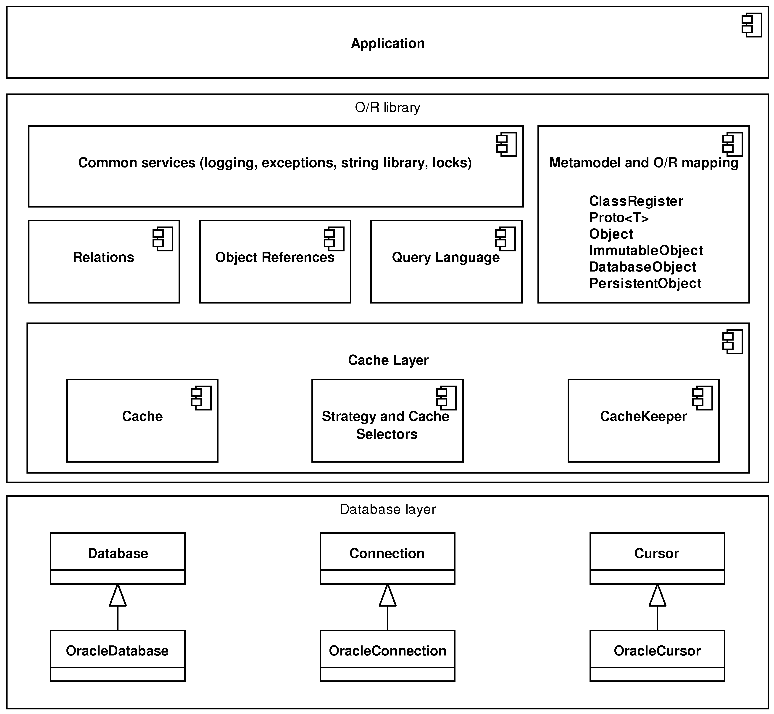
Database layer uses OCI 7 to connect to the Oracle 7 database. The layer has been slightly modified to be able to notify the cache layer of several events like Commit or Rollback.
On the contrary, both the object cache ObjectBuffer and the object references have been completely replaced by the new cache layer and the related infrastructure - database pointers. The differences are explained in the following sections.
Because the new cache layer may use additional maintenance threads, most parts of the library have been made thread-safe. Various synchronisation primitives were added to the common services. The main architectural change is that all basic database CRUD operations are routed through the cache layer which decides when or how to perform them.

The cache layer

Figure 3.5. Caches in the POLiTe 2 library
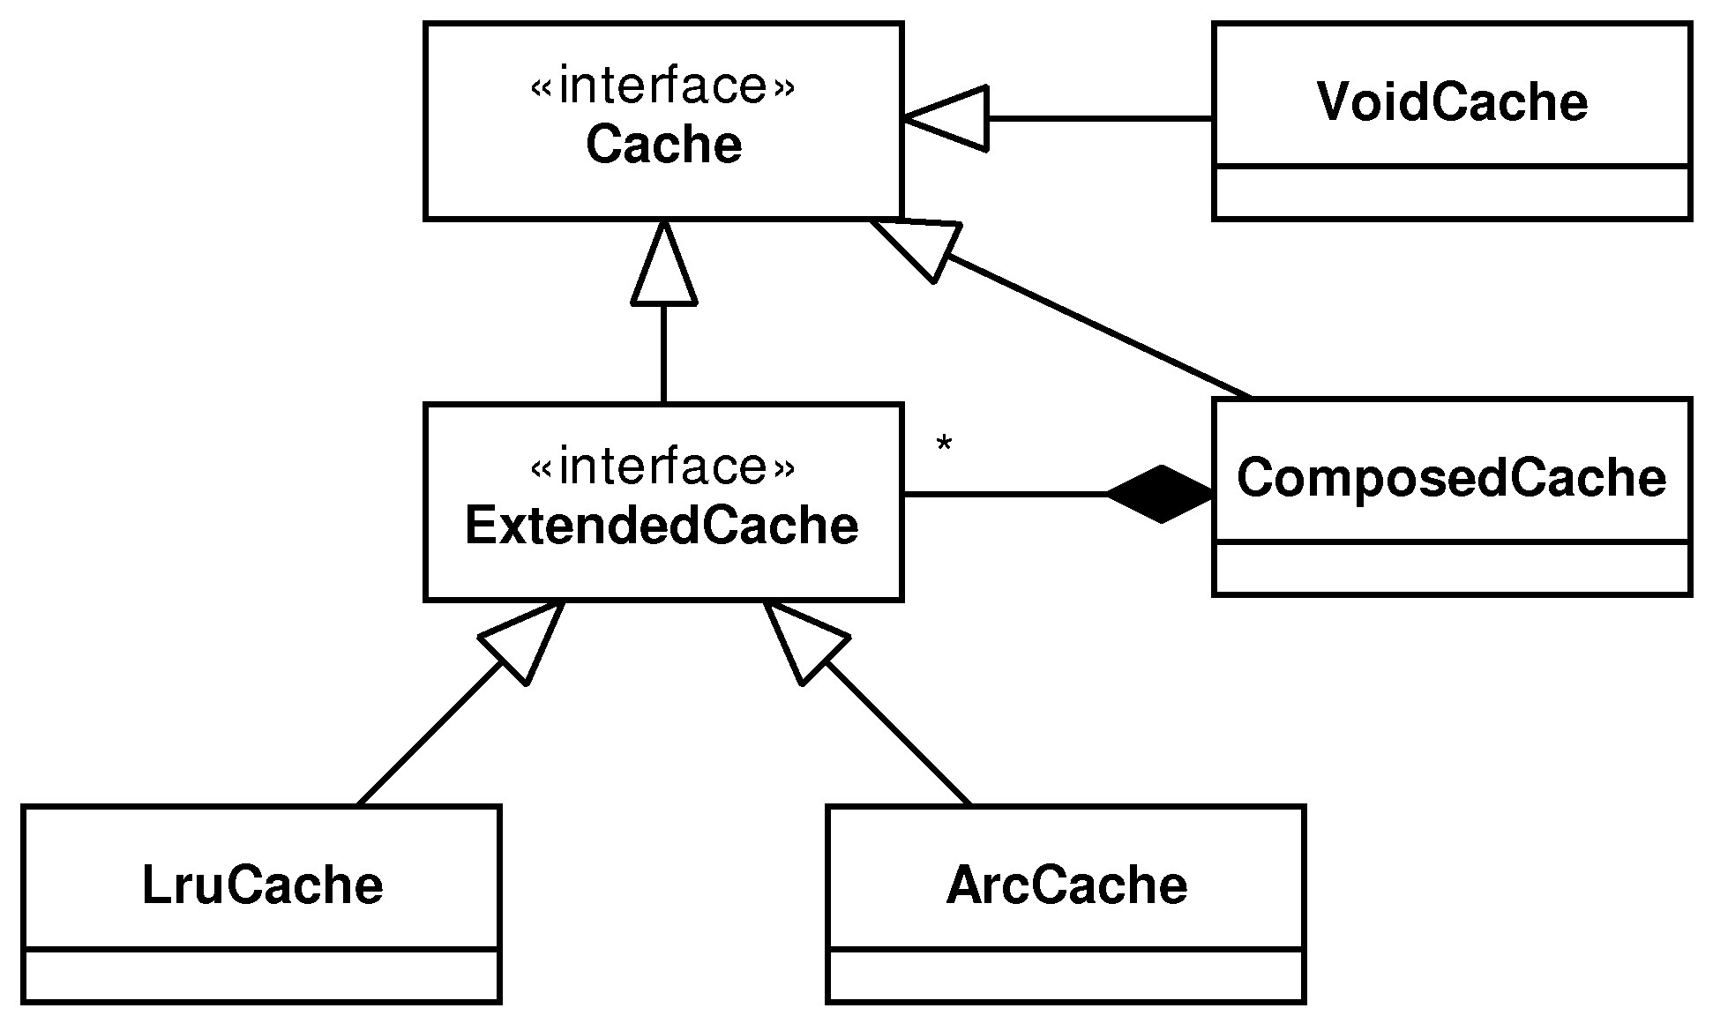
The biggest part of the cache layer is certainly the cache implementations. Cache implementations may derive from one of two interfaces depending on what features they will provide (see the Figure 3.5, “Caches in the POLiTe 2 library”):
- Cache - an interface providing basic synchronous caching functionality.
- ExtendedCache - extends the Cache interface with additional methods that are needed for asynchronous maintenance of the cache using the cache manager CacheKeeper (see later).
Concurrent data access strategies as introduced in the original POLiTe library can be used with caches that implement the ExtendedCache interface.
Caches can be grouped together using the ComposedCache class with the help of selectors. Selectors are classes whose instances determine which strategy or which cache should be used based on the given object type, the object itself or based on other criteria. The ComposedCache uses CacheSelector to decide which cache should be used for the object being processed and then it passes a StrategySelector to the selected cache as a parameter to each of its operations. Then the cache uses the StrategySelector to modify its behaviour with selected strategies.
Caches that implement the extended interface can be maintained by the cache manager called CacheKeeper³. CacheKeeper runs a second thread that scans managed caches and removes instances considered as ‘worst’. If dirty, these instances are written back to the database. CacheKeeper acts also as a facade for composing caches and specifying strategies.
Following cache implementations are provided with the POLiTe 2 library:
- VoidCache - implements the basic Cache interface. This implementation actually doesn’t cache anything, but just holds locked local copies. As the copies are unlocked, changes are propagated immediately to the database and objects are removed from the cache.
- The LRUCache (multithreaded) and the LRUCacheST (single threaded) implement the ExtendedCache interface. These classes use the LRU replacement strategy (see [5]). The multithreaded variant can even be used with the CacheKeeper’s asynchronous maintenance feature.
- The ARCCache (multithreaded) and the ARCCacheST (single threaded) use the ARC replacement strategy (see [6]).

Persistent object manipulation
Original POLiTe transient objects are created using standard C++ dynamic allocation - using the new operator. After making these objects persistent, pointers to these objects are exchanged for indirect references represented by the Ref<T> template. As the ownership of these objects is transferred to the object cache, the pointers may be rendered invalid. In the POLiTe 2 library, the creation and destruction of the objects is managed by the library code and users can access its members by dereferencing indirect pointers.
The indirect pointer template Ref<T> was replaced by the template DbPtr<T>. Its instance may be referred to as a database pointer further in the text. DbPtr<T> is used similarly to the Ref<T> template. Example 3.5, “Persistent object manipulation in the POLiTe 2 library” demonstrates the creation of a transient instance and its manipulation analogously to the Example 3.3, “Persistent object manipulation”.

Example 3.5. Persistent object manipulation in the POLiTe 2 library
// Create a new employee
DbPtr<Employee> e;
e->name(”Ola Nordmann”);
e->age(45);
e->salary(60000);
e->BePersistent(dbConnection);
// Create a new student supervised by the employee created
DbPtr<Student> s;
s->name(”Richard Doe”);
s->age(22);
s->studcardid(”WCD-3223”);
s->supervisor(empl);
s->BePersistent(dbConnection);
// Update the employee’s salary
e->salary(65000);
// There is no Update method as the cache updates the persistent
// image automatically according to the Updating strategy in use.
// Delete the new student
s->DbDelete();
);
The DbPtr<T> can point to instances in several states:
- Transient instances which are present only in memory (and do not have a persistent representation yet), the owner of these instances is the pointer.
- In-memory instances owned by a cache (which may or may not have a database representation. This represents in fact two states of the object).
- Persistent representation of the object. The pointer contains only the identity of the object.
The last object state, the locked local copy, is implemented as an additional level of indirection when dereferencing the database pointer. By dereferencing it using the * operator, user receives an instance of a cache pointer (CachePtr<T>). The existence of the cache pointer guarantees that the object is loaded into the memory and that the memory address of the object will not change until the instance of the cache pointer is destroyed (unlocked). Such process locks the objects in the cache so they can’t be removed unless they are unlocked. The transitions between the object states are displayed in the Figure 3.6, “States of the POLiTe 2 objects”.

Figure 3.6. States of the POLiTe 2 objects
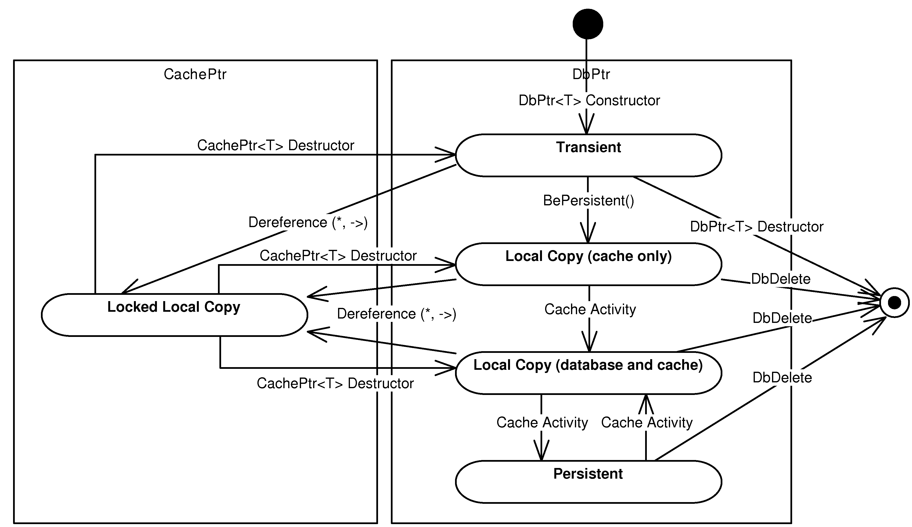
By using the * operator on a database pointer user receives a reference to a loaded and locked instance in a cache. Constructor of the created cache pointer asks cache to load relevant object from the database (if not already present in the cache) and locks the object in the cache. The cache pointer can be dereferenced again resulting in retrieval of direct pointer to the in-memory instance. This process can be simplified just by using the -> operator on the database pointer. An implicit instance of the cache pointer is created and the -> operator invoked on it. Then the requested member of the instance is accessed. After that, the cache pointer instance is destroyed and cache lock released. (This may result in significant performance degradation if using the VoidCache, because only locked copies are contained by the cache. Calling the -> operator causes a persistent object to be loaded from database into the memory, then desired member is accessed and object - if modified - is written back and removed from cache). The process is almost the same as if dereferencing the Ref<T> references, the difference is the additional level - the cache pointer.
If the variable e is of the DbPtr<Employee> type, the following expression:
e->salary(65000);
may trigger a sequence of actions as displayed in the Figure 3.7, “Dereferencing DbPtr in POLiTe 2”

Figure 3.7. Dereferencing DbPtr in POLiTe 2
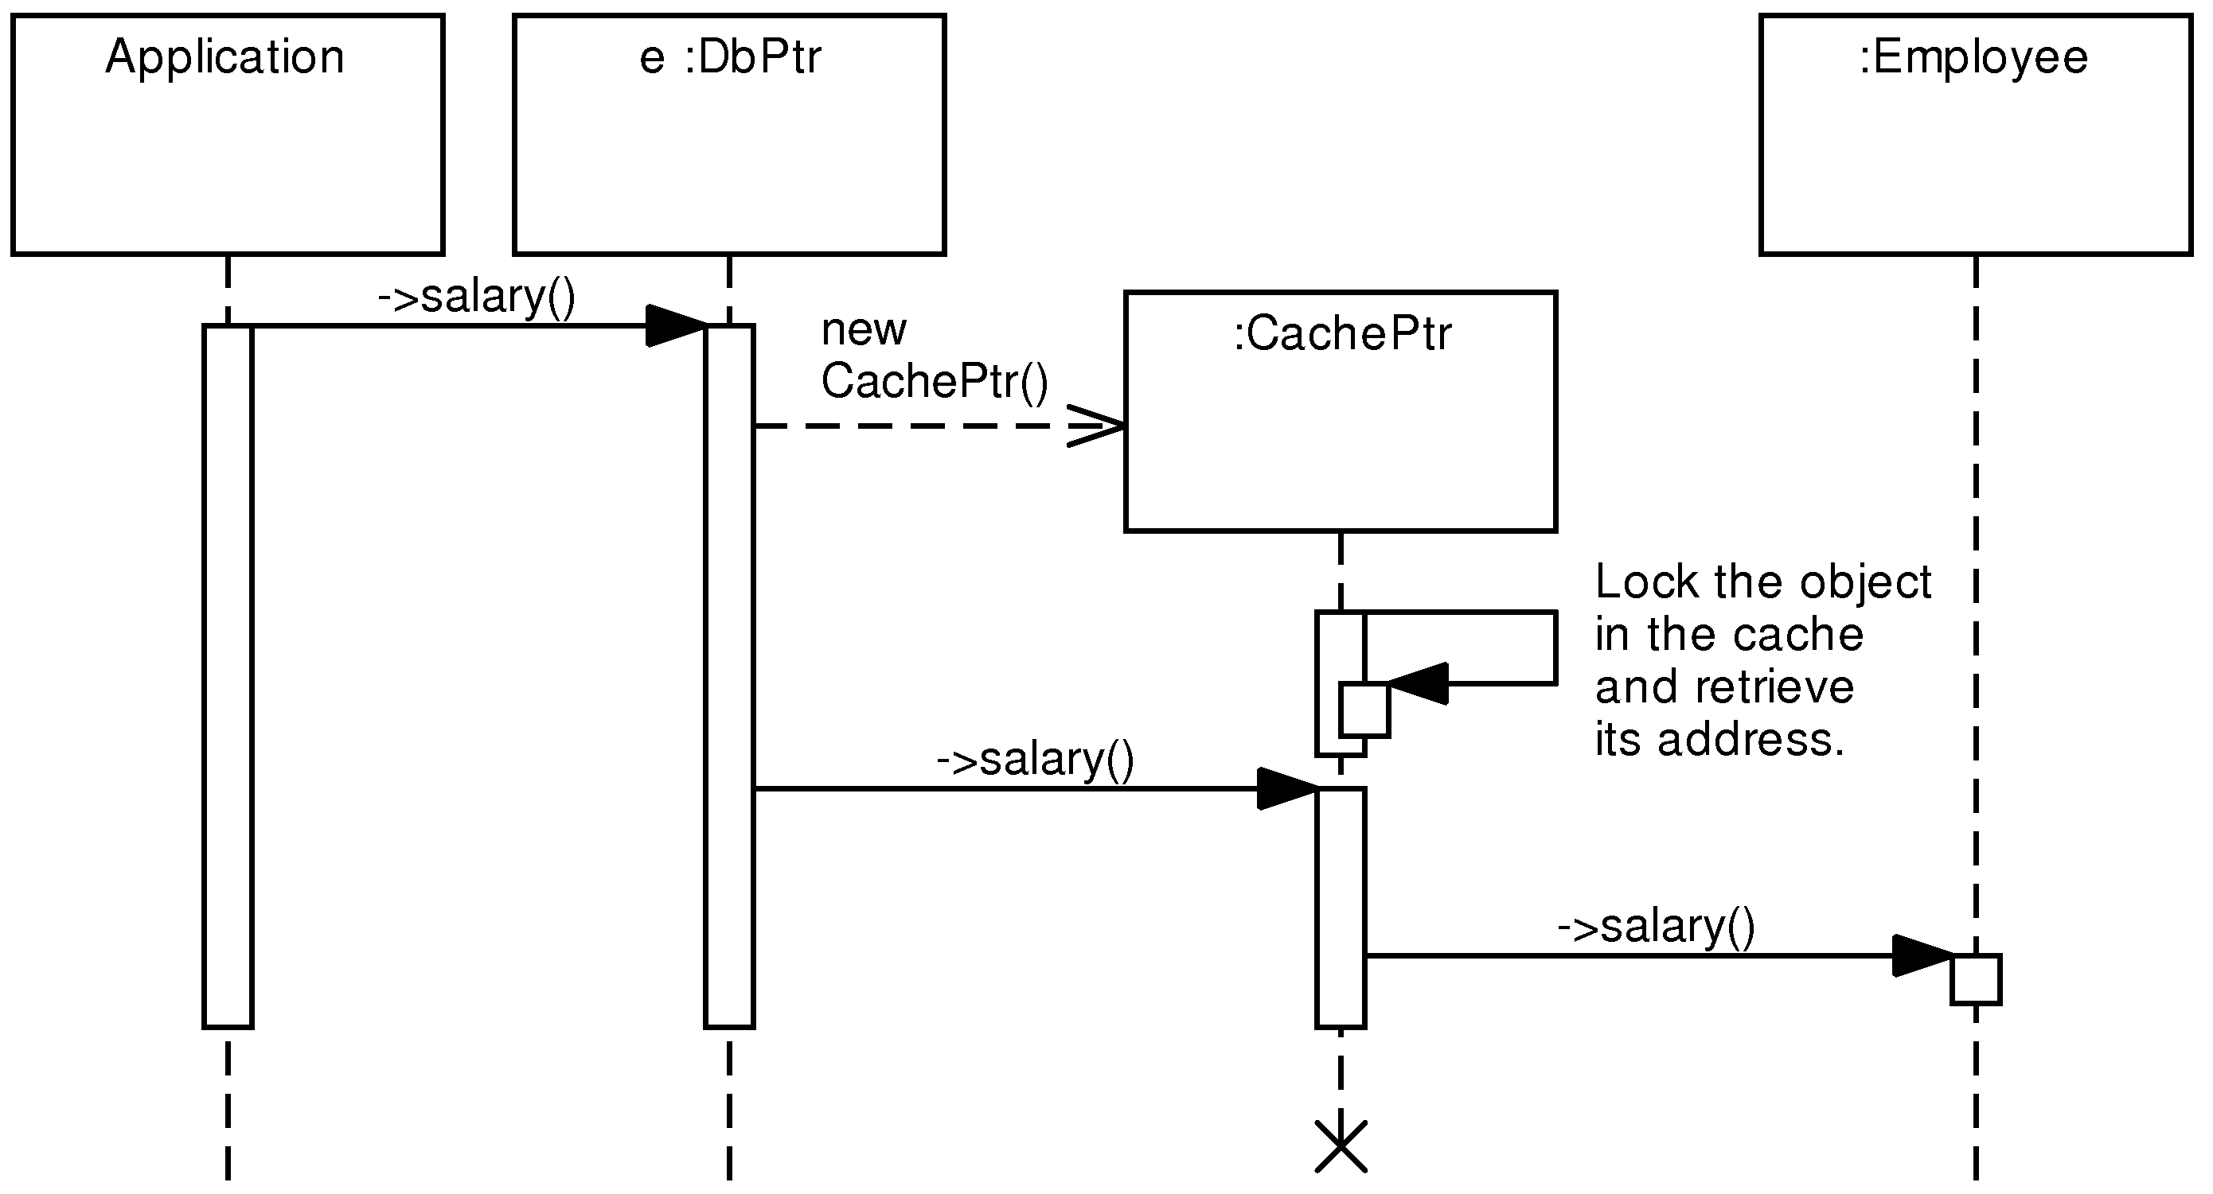

Querying
The query language and query classes as described in the section called “Querying” have not been changed in the POLiTe 2 library. Only the query is now executed and its results fetched in a slightly different way:

Example 3.6. Executing queries in the POLiTe 2 library
// All employees with salary > 40000
Query q(”Employee::salary > 40000”)
// Execute q and iterate through the result
Result<Employee> result(dbConnection, q);
while (++result) {
// members of the current object are accessible
// using result->
} ;
result->Close();

Conclusion
New version of the POLiTe library allows users to utilise advanced persistent object caching features. Unmentioned remained the support for multithreaded environment which includes encapsulation of several synchronisation primitives.
Disadvantages listed in the the section called “Conclusion” also apply to this version of the library as they were not the point addressed by the thesis [1].

IOPC
The IOPC library [2] contains a new API for O/R mapping. This new interface coexists with the old POLiTe-style interface inside one library. The interface is (with few exceptions) clearly divided into two parts - the IOPC and the POLiTe part. Classes written for the first version of the POLiTe library should be usable with this library.

Features of the library
The IOPC library offers all features of the original POLiTe library. We will look only at the new IOPC interface. New features and main differences are listed below:
- No need to describe structure of persistent classes. Persistence works almost transparently.
- All three basic types of class hierarchy mapping are supported - horizontal, vertical and filtered. Combinations of these types in one class hierarchy are also allowed (with a few exceptions).
- Database views that join data from all mapping tabes are generated. These views are used for object loading and they also represent a simple read-only interface for non-library users.
- Ability to define new persistent data types.
- Loading persistent object attributes by groups. Persistent attributes can be divided into several groups which can be loaded separately.
- Easy implementation of new RDBMS into the library⁴.

Architecture of the library
The IOPC library consist of a number of modules, some of them are standalone applications. The hi-level architecture overview can be best explained on the library workflow displayed in Figure 3.8, “The IOPC library workflow”.

Figure 3.8. The IOPC library workflow
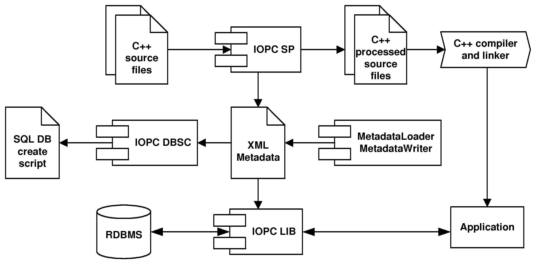
Three main modules can be observed from the figure:
- IOPC SP uses OpenC++⁵ parser and source-to-source translator to modify the source code to support the object persistence and generates XML metadata describing structure of persistent classes.
- IOPC DBSC generates SQL scripts from the XML metadata. The SQL scripts create required database structured needed for the IOPC object-relational mapping.
- IOPC LIB is a library that provides the object persistence services to a program to which it is linked. It uses the metamodel generated by the IOPC SP module and database structures created using the IPOC DBSC scripts.
- XML metadata loading and storing is performed by two statically-linked libraries / classes - XMLMetadataLoader and XMLMetadataWriter. Both classes use the Xerces⁶ parser to handle the XML files. Other type of metamodel storage can be implemented by subclassing the MetadataLoader and MetadataWriter interfaces.

IOPC SP
One of the most interesting aspects of the IOPC library is a new approach to metamodel retrieval. User-created specification of the class structure is not needed. The source classes are parsed and metadata is collected by the IOPC SP module.
IOPC SP is a standalone executable created from patched OpenC++ source code and a IOPC metaclass IopcTranslator. The metaclass affects the source-to-source translation of persistent classes done by the OpenC++ by performing the following operations:
- Generates the set and get methods for all persistent attributes. Setters modify the dirty status of the object and getters ensure that corresponding attribute groups are loaded.
- Modifies every reference to their persistent attributes so that they use the generated get and set methods.
- Generates additional members to the processed class needed by the IOPC LIB.
- Inspects the processed class and writes information about its structure to a XML file by calling the MetadataWriter (its implementation XMLMetadataWriter).
In the end, IOPC SP runs compiler and linker on the translated source code.
As you can see in the Example 3.7, “Definition of persistent classes in IOPC”, persistent classes in IOPC doesn’t need any additional descriptive macros for the persistence layer to be able to understand their structure. The only rules are that they need to be descendants of the IopcPersistentObject and that the attribute types need to be supported by the IOPC. For example, IOPC doesn’t understand the std::string STL type, only the basic C/C++ string representation char* (or its wide character variant) is supported. If the string is allocated dynamically, it needs to be deallocated in the desctructor.

Example 3.7. Definition of persistent classes in IOPC
class Person : public IopcPersistentObject {
public:
char* name;
short int age;
Person() {
name = NULL;
}
virtual ~Person() {
if (name != NULL) free(name);
}
} ;
class Employee : public Person {
public:
int salary;
} ;
class Student : public Person {
public:
char* studcardid;
Ref<Employee> supervisor;
Student() {
studcardid = NULL;
}
virtual ~Student() {
if (studcardid != NULL) free(studcardid);
}
} ;
Processed source code generated by the IOPC SP is deleted immediately after compilation. It is not meant to be modified by developers. Following example displays the processed Student class. It was stripped by the age attribute because it was too long:

class Person : public IopcPersistentObject {
public:
Person() {
set_name ( __null ) ;
}
virtual ~Person() {
Free();
if ( m_name != __null ) free ( m_name ) ;
}
protected:
char * m_name;
bool m_name_isValid;
public:
virtual char * get_name()
{
if (!m_isPersistent || m_name_isValid || !m_classObject->isAttributePersistent(1)) return m_name;
m_classObject->loadAttribute(1, this);
if (!m_name_isValid)
throw IopcExceptionUnexpected();
return m_name;
}
public:
virtual char * set_name(char * _name) {
m_name =_name;
m_name_isValid = true;
if (m_isPersistent) MarkAsDirty();
return _name;
}
protected:
void iopcInitObject(bool loadingFromDB) {
if (loadingFromDB) {
m_name_isValid = false;
}
else {
m_classObject = IopcClassObject::getClassObject(ClassName(), true);
m_name_isValid = true;
}
}
virtual int iopcExportAttributes(IopcImportExportStruct * data, int dataLen) {
if (dataLen != 1) return 1;
data[0].valid = m_age_isValid;
if (m_age_isValid) data[0].shortVal = m_age;
return 0;
}
virtual int iopcImportAttributes(IopcImportExportStruct * data, int dataLen) {
if (dataLen != 1) return 1;
if (data[0].valid) {
if ((m_name_isValid) && (m_name)) free(m_name);
m_name = strdup(data[1].stringVal);
m_name_isValid = true;
}
return 0;
}
public:
static const char * ClassName() { return “Person”;}
public:
static IopcPersistentObject * iopcCreateInstance() {
IopcPersistentObject * object = new Person;
object->iopcInitObject(true);
return object;
}
static RefBase * iopcCreateReference() {
return new Ref<Person>;
}
} ;
static IopcClassRegistrar<Person> Person_IopcClassRegistrar(”Person”);
Rather larger amount of code was inserted into the class definition. IOPC SP generated setter and getter methods for the attributes, serialisation and deserialisation routines (iopcExportAttributes and iopcImportAttributes) and other methods needed by the persistence layer.
Not only the class code was translated. Code that reads or sets attribute values was changed to use the getter and setter methods (like we would use in the POLiTe library):

// original:
Employee e;
e.age = 45;
// translated assignment expression:
e.set_age(45);
IOPC SP also generates a XML metadata file describing structure of the classes, see Example 3.8, “XML metadata file”.

Example 3.8. XML metadata file
<iopc_mapping project_name=”example”>
<class name=”Employee”>
<base_class>Person</base_class>
<mapping db_table=”EMPLOYEE” type=”inherited”>
<group name=”default_fetch_group” persistent=”true”>
<attribute db_column=”SALARY” db_type=”NUMBER(10)” name=”salary” type=”int”/>
</group>
</mapping>
</class>
<class name=”Person”>
<mapping db_table=”PERSON” type=”vertical”>
<group name=”default_fetch_group” persistent=”true”>
<attribute db_column=”AGE” db_type=”NUMBER(10)” name=”age” type=”short”/>
</group>
<group name=”1st_persistent_group” persistent=”true”>
<attribute db_column=”NAME” db_type=”VARCHAR2(4000)” name=”name” type=”char *”/>
</group>
</mapping>
</class>
<class name=”Student”>
<base_class>Person</base_class>
<mapping db_table=”STUDENT” type=”inherited”>
<group name=”default_fetch_group” persistent=”true”>
<attribute db_column=”SUPERVISOR” db_type=”NUMBER(10)” name=”supervisor” type=”Ref&lt;Employee>”/>
</group>
<group name=”1st_persistent_group” persistent=”true”>
<attribute db_column=”STUDCARDID” db_type=”VARCHAR2(4000)” name=”studcardid” type=”char *”/>
</group>
</mapping>
</class>
</iopc_mapping>;
As mentioned, persistent attributes can be divided into several groups which are handled by IOPC separately. By default, two groups are generated - a default_fetch_group containing all numeric attributes and a 1st_persistent_group containing attributes of all remaining data types (strings). The XML metadata file can be customized by developers before running IOPC DBSC.

IOPC DBSC
IOPC DBSC is a standalone executable that generates SQL scripts for various purposes - in particular the scripts to create or delete database structures required by the object-relational mapping. It uses MetadataLoader to load the persistent class metamodel written by the IOPC SP. SQL script created from the previously generated XML metadata file Example 3.8, “XML metadata file” follows.
First it creates database table for the class list and fills it:

CREATE TABLE EXAMPLE_CIDS
(
CLASS_NAME VARCHAR2(64)
CONSTRAINT EXAMPLE_CIDS_PK PRIMARY KEY,
CID NUMBER(10) NOT NULL
CONSTRAINT EXAMPLE_CIDS_UN UNIQUE
);
INSERT INTO EXAMPLE_CIDS VALUES (’Employee’, 1);
INSERT INTO EXAMPLE_CIDS VALUES (’Person’, 2);
INSERT INTO EXAMPLE_CIDS VALUES (’Student’, 3);
Followed by a table (main table) containing OIDs of all persistent objects in the project:

CREATE TABLE EXAMPLE_MT
(
OID NUMBER(10)
CONSTRAINT EXAMPLE_MT_PK PRIMARY KEY,
CID NUMBER(10)
CONSTRAINT EXAMPLE_MT_FK REFERENCES EXAMPLE_CIDS(CID)
);
CREATE INDEX EXAMPLE_MT_CID_INDEX ON EXAMPLE_MT(CID);
Then the mapping tables associated with persistent classes are created (we used the default vertical mapping):

CREATE TABLE PERSON
(
OID NUMBER(10)
CONSTRAINT PERSON_PK PRIMARY KEY
CONSTRAINT PERSON_CD REFERENCES EXAMPLE_MT(OID) ON DELETE CASCADE,
CID NUMBER(10)
CONSTRAINT PERSON_FK2 REFERENCES EXAMPLE_CIDS(CID),
AGE NUMBER(10),
NAME VARCHAR2(4000)
);
CREATE INDEX PERSON_CID_INDEX ON PERSON(CID);
CREATE TABLE EMPLOYEE
(
OID NUMBER(10)
CONSTRAINT EMPLOYEE_PK PRIMARY KEY
CONSTRAINT EMPLOYEE_CD REFERENCES EXAMPLE_MT(OID) ON DELETE CASCADE,
SALARY NUMBER(10)
);
CREATE TABLE STUDENT
(
OID NUMBER(10)
CONSTRAINT STUDENT_PK PRIMARY KEY
CONSTRAINT STUDENT_CD REFERENCES EXAMPLE_MT(OID) ON DELETE CASCADE,
STUDCARDID VARCHAR2(4000),
SUPERVISOR NUMBER(10)
);
Finally, two views are created for each persistent class. Simple views (SV suffix) join all tables needed for loading complete instances of particular persistent classes. Their columns correspond to attributes of the associated classes. Polymorphic views (PV suffix) have same structure as simple views: the difference is that they return not only instances of the associated classes, but also instances of their descendants.

CREATE VIEW Person_sv AS
SELECT OID, AGE, NAME
FROM PERSON
WHERE CID = 2;
CREATE VIEW Person_pv (CID, OID, AGE, NAME) AS
SELECT CID, OID, AGE, NAME
FROM PERSON
WHERE PERSON.CID IN (2, 1, 3);
CREATE VIEW Employee_sv (OID, AGE, NAME, SALARY) AS
SELECT EMPLOYEE.OID, AGE, NAME, SALARY
FROM PERSON, EMPLOYEE
WHERE EMPLOYEE.OID = PERSON.OID;
CREATE VIEW Employee_pv (CID, OID, AGE, NAME, SALARY) AS
SELECT 1, EMPLOYEE.OID, PERSON.AGE, PERSON.NAME, SALARY
FROM PERSON, EMPLOYEE
WHERE EMPLOYEE.OID = PERSON.OID;
CREATE VIEW Student_sv (OID, AGE, NAME, STUDCARDID, SUPERVISOR) AS
SELECT STUDENT.OID, AGE, NAME, STUDCARDID, SUPERVISOR
FROM PERSON, STUDENT
WHERE STUDENT.OID = PERSON.OID;
CREATE VIEW Student_pv (CID, OID, AGE, NAME, STUDCARDID, SUPERVISOR) AS
SELECT 3, STUDENT.OID, PERSON.AGE, PERSON.NAME, STUDCARDID, SUPERVISOR
FROM PERSON, STUDENT
WHERE STUDENT.OID = PERSON.OID;

IOPC LIB
IOPC LIB is a shared library that represents the core of the IOPC project. It is linked to the outputs (object files) of the IOPC SP and provides the run-time functionality.
IOPC LIB is built on the POLiTe library, it uses some of its components and exposes its new interface side-by-side with the original POLiTe interface. The result is that the IOPC library can be used almost the same way as its predecessor. It supports the POLiTe-style persistent objects as well as new persistent objects inherited from the IopcPersistentObject class and processed with IOPC SP. Components from the POLiTe library that IOPC LIB uses are displayed in Figure 3.9, “POLiTe library components used in IOPC LIB”.

Figure 3.9. POLiTe library components used in IOPC LIB
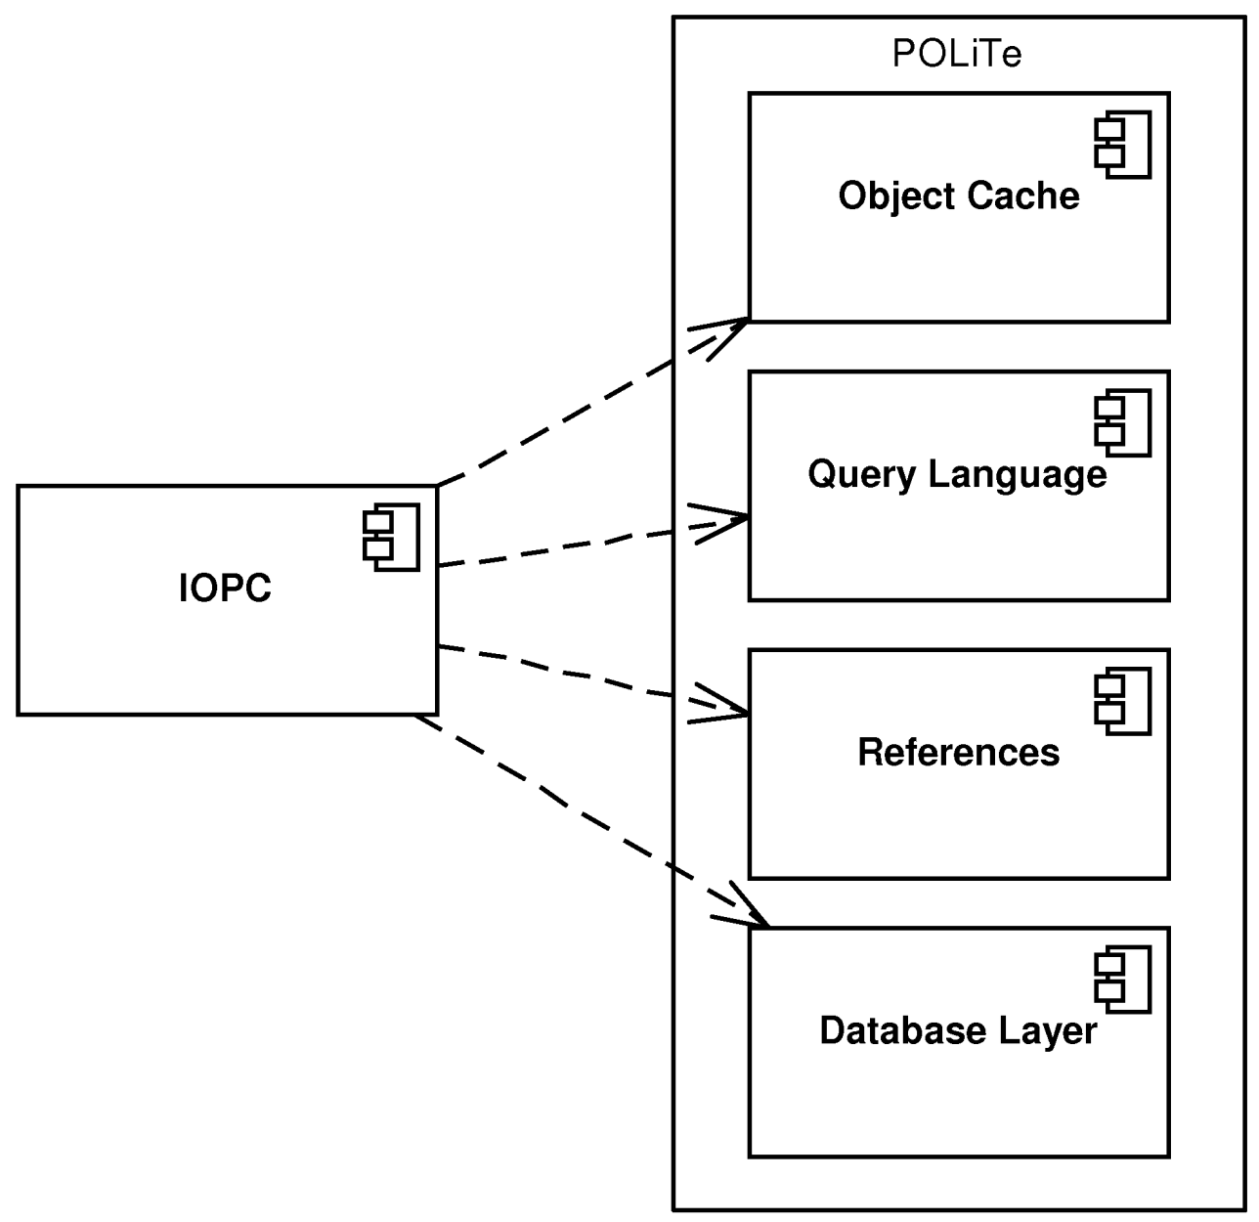
Because the object cache and the object references are reused from the original, persistent object should enter same states using same state transitions as in the section called “Persistent object manipulation”. There is, however, one problem with the current implementation in that it doesn’t implement the locking correctly and all persistent objects look like unlocked all the time. So the Locked Local Copy state can be entered only by instances of the POLiTe persistent classes.
Querying, the query language and all related classes or templates are also reused, so there is no change in this area either.
IOPC persistent objets can be associated exclusively using references as described at the end of the the section called “Metamodel and object-relational mapping.”. Relations described earlier in that section can be used only for the POLiTe persistent objects. IOPC adds a new RefList<T> template to the standard POLiTe Ref<T> reference representing a persistable list of references. The list is stored into a separate table (one per project) which unfortunately doesn’t have standard many-to-many join table schema. Each instance of the RefList<T> is stored as a linked list of OIDs of its members. The table completely unusable in SQL queries unless we are using its recursive features (if available) or procedural constructs like cursor iteration. Second issue is that these lists are always persistent. Every change is immediately propagated to the database regardless of the state of its owner, object cache is also bypassed. This renders the usage of RefList<T> in combination with transient objects quite dangerous as orphaned entries are created in the “join” table. Same problem occurs if persistent object with RefList<T> as a attribute is deleted - the associated linked list is not removed from the database.
Figure 3.10, “Structure of the IOPC LIB” displays the structure of the IOPC library and the relationship between new IOPC- and the original POLiTe interface.

Figure 3.10. Structure of the IOPC LIB
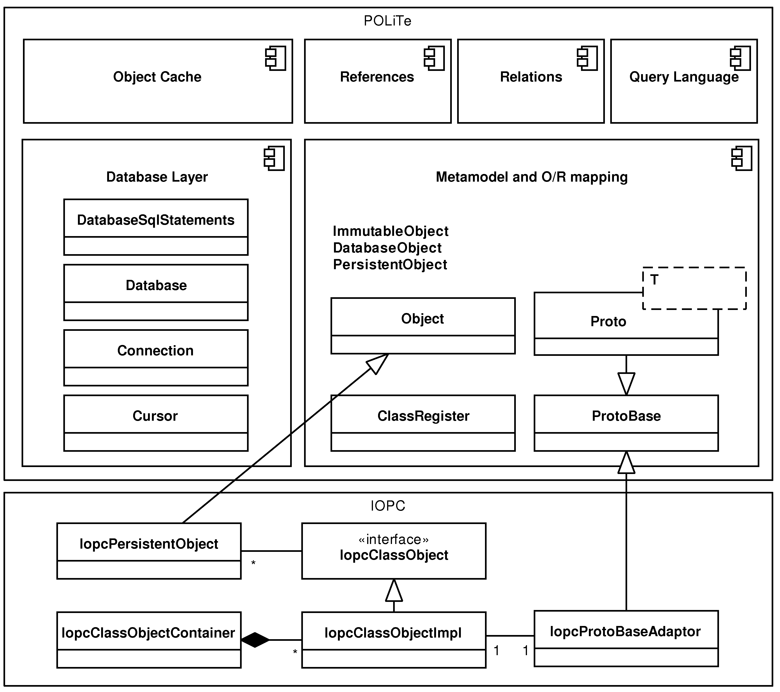
Database layer uses slightly modified original interface. Along with the Database, Connection and Cursor classes there is a new interface class - DatabaseSqlStatements. It serves as an interface for database-dependent SQL statement generation. IOPC contains Oracle 8i implementation of these interface classes (using OCI 8).
IOPC persistent classes are created as descendants of the new base class - IopcPersistentObject. The original base class Object and its descendants (ImmutableObject, DatabaseObject and PersistentObject) were preserved and can be used by the POLiTe persistent objects. Note that IopcPersistentObject is derived from the original Object class allowing it to be used with POLiTe components like object cache or references.
For each descendant of the IopcPersistentObject class there is one IopcClassObjectImpl instance. The purpose of this class is very similar to the concept of prototypes described in the the section called “Metamodel and object-relational mapping.” - it contains all data needed for object-relational mapping of the associated class. IopcClassObjectImpl actually performs the mapping process. The class is linked to the POLiTe prototype system using the IopcProtoBaseAdaptor which maps the prototype interface on the IopcClassObjectImpl instance. Calls invoked on its ProtoBase interface are delegated back to IopcClassObjectImpl. Public interface to the IopcClassObjectImpl class is provided by the IopcClassObject class.
As the name suggests, IopcClassObjectContainer is a place where class object instances are stored. Its first responsibility is to load the class metadata from the MetadataLoader and compare them with the class list stored in the database. Then it creates and initializes the IopcClassObjectImpl instances. Similarly to ClassRegister, it provides methods allowing us to find the class objects by name or by class id.

Conclusion
The main goal of the IOPC library was to make the usage of the POLiTe library simpler and more transparent. The architecture of the library was redesigned for the sake of these requirements. At first glance, the IOPC library looks like a big improvement over the original library, but if we look further into the source code and used technologies, we come upon several critical issues that may cause the usage and deployment of this library almost impossible.
IOPC uses the OpenC++ as a way to retrieve information about the structure of persistent classes. The OpenC++ project seems to be almost dead, last commit to the project’s CVS occurred in 2005. OpenC++ can’t handle most of template constructs, processing files that include GCC STL headers (tested on versions 3.4 and newer) produces a lot of errors. Because the source-to-source translation is used, users can’t be sure if any of their code translated with errors or warnings⁷ will do what was intended. For this reason the IOPC allows only the C strings (char* and w_char*), not the C++ STL strings (std::string and std::wstring).
Next, IOPC uses its own modified version of OpenC++ (called 2.6.t.0) and integrates it into the IOPC SP utility. This approach renders further maintenance of the OpenC++ code difficult. New changes from the OpenC++ CVS have to be merged manually into the IOPC SP source.
Second point is a question, why there are two parallel interfaces in the IOPC library - one for the new persistent objects and one for the POLiTe objects. If there is no known implementation that uses the POLiTe library, there is no need to be backward-compatible. The POLiTe part of the source code will just remain unmaintained (as no one is supposed to use the POLiTe objects in new applications). Because several IOPC objects inherit from the POLiTe classes, many inherited methods doesn’t make sense any more. This makes the API less readable and can lead to user’s confusion. An example of this situation is the IopcProtoBaseAdaptor which contains a number of methods commented as “Fake function”. Second example is the mentioned local copy locking problem. Are we supposed to use the locking only on the POLiTe persistent objects or is it just a bug in the IOPC implementation? The presence of two distinct APIs makes usage of the library less clear and confusing.
The library itself remained as one monolithic block with only signs of library configurability. Many parameters are defined as pre-processor macros, enabling other options (like adding a new database driver) leads to changes in the source code of the library and recompilation. The design of the library even makes impossible to use more than one database driver at a time (the currently used implementation of the DatabaseSqlStatements is stored in a global variable).
Bad design of the program interface. Useful information are hidden in internal structures of the library, these structures are not visible via the library’s API. This concerns mostly the data retrieved from the MetadataLoader - the library could implement some kind of reflection API to be able to query the metamodel.
The library cannot be used in multithreaded environment. There are shared state-aware data structures that are reused between persistence layer calls. This prevents to make the library multithreading-friendly without major modifications.
Despite good idea behind the IOPC library, the implementation is deeply flawed, unusable and unmaintainable. For these reasons, the author of this thesis decided not to continue development upon the source code of this library.

Library comparison
The following table provides side-by-side library comparison. The IOPC column displays features of the IOPC part of the library interface only (not POLiTe).
 | POLiTe | POLiTe 2 | IOPC
Transparent usage | - Macro descriptions | - Macro descriptions | + Uses Open C++
Supported mapping types | - Vertical | - Vertical | + Vertical, horizontal, filtered, combinations
Associations between objects | + Simple reference and relations - one-to-many, many-to-one, many-to-many, chained | + Simple reference and relations - one-to-many, many-to-one, many-to-many, chained | +/- Simple reference and reference list
Caching | - Simple object cache | + Advanced caching features. | -- Simple object cache, no locking
Querying | C++-like syntax, combining queries | C++-like syntax, combining queries | C++-like syntax, combining queries
Read-only database / existing schema support | + | + | -
Library architecture | - Monolithic | - Monolithic | - Monolithic
Supported databases | Oracle 7 (OCI 7) | Oracle 7 (OCI 7) | Oracle 8i (OCI 8)
Multithreading support | - | + | -

Chapter 4. Basic concepts of the IOPC 2 library
The IOPC 2 library is based on the ideas behind the IOPC library. It takes over features of that library where it is useful while it adds the best from the POLiTe and POLiTe 2 libraries as well. Based on the discussion in the previous chapters IOPC 2 focuses on improvements in the following areas:
- Transparent usage - IOPC 2 retrieves description of persistent class metamodel using similar mechanism as IOPC, so no descriptive macros are needed. Though OpenC++ has been replaced by GCCXML due to reasons explained in the section called “Conclusion” and the section called “Obtaining the metamodel description”.
- Reflection - IOPC 2 gives application developers the access to the metamodel through a simple reflection interface.
- O/R mapping - IOPC 2 offers all mapping types supported by the IOPC library plus the ADT mapping as presented in the section called “Database mapping requirements continued”. Persistent objects in POLiTe libraries can be mapped on existing database schemas or read-only databases. IOPC 2 has inherited this feature.
- Caching - the POLiTe 2 cache layer has been reused in the IOPC 2 library. IOPC 2 supports all features added to the POLiTe library successor including multithreading support.
- Library architecture - IOPC 2 library can be used in several configurations depending on the developers’ needs. Database drivers have been separated from the run-time library and now can be switched without the need of library source code modification.
- Removal of obsolete features – the implementation of the IOPC 2 library cuts off all the interfaces that were replaced by their newer and more complex versions. It simplifies the work with the library and its maintainability at the cost of lost of bacward compatibility.
In the following sections, we will discuss theoretical aspects of the IOPC 2 implementation - mostly the O/R mapping and transparency of the library usage. Following Chapter 5, Architecture of the IOPC 2 library provides more detailed insight into the library architecture and usage.

Library architecture
As stated earlier, run-time part of the POLiTe, POLiTe 2 or the IOPC libraries consist of one monolithic block. There is no way how to link the application against only a part of the library, it may even be impossible because of the internal library design. One of the goals of the IOPC 2 implementation was to make the run-time part configurable. For example database drivers have become separate shared libraries. Thus the addition of another database driver does not result in the run-time library recompilation; drivers do not need to be part of the library source code - they can be developed separately in independent projects.
Configurability does not concern only the database drivers, but also other parts of the library. The library can be used in the following configurations:
- Common services - a configuration that provides only basic services like logging, tracing, thread synchronisation and several other utilities.
- Reflection library - a configuration that exposes an interface allowing application developers to use the IOPC 2 reflection capabilities.
- Database access library - a configuration that provides basic database access via loaded database drivers. It doesn’t offer any advanced features as object-relational mapping or caching.
- Persistence library - a configuration that provides the full functionality of the IOPC 2 library. Its features include object persistence, caching, direct database access, reflection and all other features listed above.
The configurations are ordered by dependency, so the reflection library configuration includes features provided by common services and so on. The database access library configuration provides also features of the reflection library, and - as stated earlier - the persistence library configuration provides features of all other configurations.

Obtaining the metamodel description
As it was explained in the section called “Metamodel and object-relational mapping.”, the POLiTe and POLiTe 2 libraries depend on pre-processor macro calls included in class definitions to obtain metamodel description.
The IOPC library tries to avoid disadvantages of this approach mentioned in the section called “Conclusion”. IOPC makes the process of metadata retrieval more user-friendly and transparent by utilizing a modified version of the OpenC++ source-to-source translator. For more on this topic, see the section called “IOPC SP”. The main point is that OpenC++ is incomplete and is not developed any more. This leaves users in a bad situation as they can’t use STL data types (because the OpenC++ doesn’t handle templates very well) or even they can’t be sure if their code was processed correctly.
However, the idea to employ an external tool to analyze and process the source code is convenient, so IOPC 2 should use another tool to solve this situation. GCCXML¹ was chosen to replace OpenC++.
GCCXML is a XML output extension to GCC. GCCXML uses GCC to parse the input source code and then dumps all declarations into a XML file, which can be easily parsed by other programs. The downside is that it processes only declarations. Therefore it can’t be used as a source-to-source translator. Yet GCCXML represents ideal out-of-the-box solution for discussed scenario. GCCXML can handle the C++ language in its entirety and its usage doesn’t involve the risk of translated source code misinterpretation.
IOPC 2 uses the generated XML file to gain knowledge of the structure of classes in the processed source code. This information is then made accessible via reflection interface provided with the library. User applications can then query the metamodel and use it in a way similar to applications written in reflective languages. The reflection mechanism used in IOPC 2 is outlined in Figure 4.1, “Reflection using the GCCXML”.

Figure 4.1. Reflection using the GCCXML
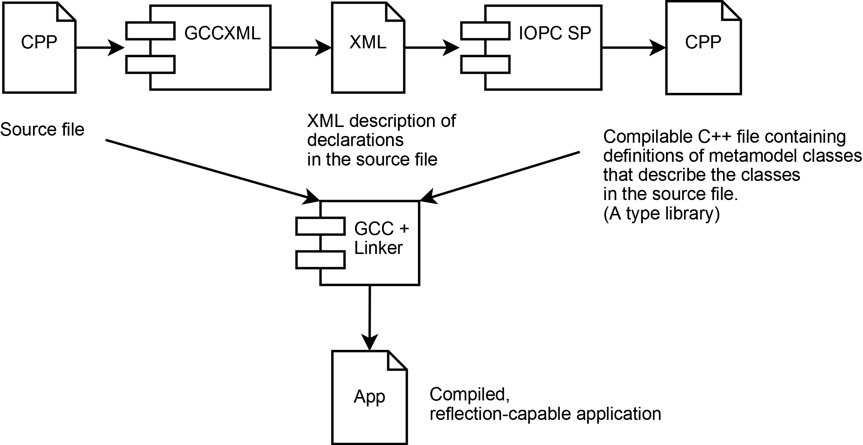
Example 4.1, “Basic persistent class definition in IOPC 2” illustrates persistent class definition in IOPC 2. No special macros are needed. However, it presents only a basic, least convenient variant as more features are provided by using enhanced data types (see the section called “Enhanced data types”) and by specifying additional class metadata (see the section called “Class metadata”).

Example 4.1. Basic persistent class definition in IOPC 2
class Person : public iopc::OidObject {
public:
short int age;
std::string name;
} ;
class Employee : public Person {
public:
int salary;
} ;
class Student : public Person {
public:
std::string studcardid;
DbPtr<Employee> supervisor;
} ;
class PhdStudent : public Student {
public:
short int scholarship;
} ;
The process performs the following steps:
- First, the source file is processed by the GCCXML. GCCXML dumps all declarations from the source file into an easy to parse XML file. An excerpt from the XML file containing elements and attributes related to the processed Person class is displayed in Example 4.2, “GCCXML output”
- The XML file is then processed by the IOPC SP² utility (a part of the IOPC 2 project). IOPC SP produces compilable C++ file containing data structures that describe classes declared in the source file and their attributes (type descriptions). This file, respectively its compiled version, is called a type catalogue. For translated Person class see Example 4.3, “IOPC SP output”
- In the last step, the original source files and created type catalogues are compiled and linked together into a final application.

Example 4.2. GCCXML output
<!-- Class Person
IOPC SP searches for members which are of Field type.
(Other members may be methods, constructors, operators and other -->
<Class id=”_1319” name=”Person” members=”_2960 _2961 _2962 _2963 _2964 _2965 “ bases=”_2649 “>
<Base type=”_2649” access=”public” virtual=”0”/>
</Class>
<!-- fields related to the Person class -->
<Field id=”_2960” name=”age” type=”_195” access=”public” />
<Field id=”_2961” name=”name” type=”_1608” access=”public”/>
<!-- field data types -->
<FundamentalType id=”_195” name=”short int”/>
<Typedef id=”_1608” name=”string” type=”_1564”/>

Example 4.3. IOPC SP output
// Header file .ih
META_BLOCK1(::Person)
META_PARENT1(iopc::OidObject)
META_ATTR1(age, short int, Attribute::VISIBILITY_PUBLIC)
META_ATTR1(name, std::string, Attribute::VISIBILITY_PUBLIC)
META_BLOCK2(::Person)
META_ATTR2(::Person, age)
META_ATTR2(::Person, name)
META_BLOCK3(::Person, Person, )
META_BLOCK4
// Source file .ic
META_REGISTER_TYPE(::Person)
The process is flexible and customisable. Developers can integrate it with their favourite IDEs or build systems. IOPC 2 project contains an example of seamless IDE integration, see the section called “iopcsp”. This way the build process is almost transparent and users don’t need to take any additional steps to make the reflection work.
Information stored in the type catalogues are accessible via reflection interface provided by IOPC 2. It allows developers to query the class metamodel and to execute reflective operations upon it. IOPC 2 library supports the following:
- Looking up a Type object by class name. The Type class (and its descendants) has similar purpose to prototypes from the POLiTe library or to IopcClassObjectImpl from the IOPC library. The difference is that it doesn’t perform any database mapping, it just provides access to the metamodel.
- Obtaining a list of classes.
- Traversing a class hierarchy.
- Obtaining list of attributes, obtaining a concrete attribute by looking it up by its name, listing inherited attributes.
- Querying or setting attribute values at run-time.
- Creating object instances.
- Automatic dirty status tracking on an attribute or object level.

Object relational mapping in the IOPC 2 library
All mapping types offered by the IOPC library are also implemented in the IOPC 2 library - horizontal, vertical, filtered as well as combinations of them. IOPC 2 library provides as much freedom combining them within one inheritance hierarchy as the IOPC library does. Additionally, ADT mapping is available for use with object-relational databases. Developers can combine ADT mapping with the other mapping types under certain restrictions.
IOPC 2 offers most of its functionality if using a generated schema with surrogate keys (OID columns) and OID objects. Such schema contains additional views, tables or types which support the mapping process. IOPC 2 also handles existing schemas with no OID columns or additional database structures as well. It is able to map data from read-only databases or from aggregated query results into standard persistent objects.
Detailed aspects of the object-relational mapping implementation are discussed in the following sections.

Base classes
Figure 4.2, “IOPC 2 base classes” displays base class hierarchy for persistent classes defined in IOPC 2. Data classes in user applications should derive from one of these supertypes. Each of these base classes provides different level of functionality for its descendants.

Figure 4.2. IOPC 2 base classes
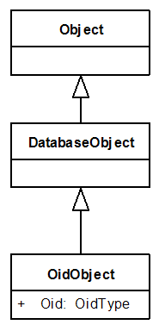
The descendants of Object are capable of reflection. The reflection mechanism inspects descendants (direct or indirect) of this class only. Reflection is database independent and can be used separately as a standalone part of the IOPC 2 library. This also implies that direct descendants cannot be persisted. Persistence is provided for DatabaseObject and OidObject descendants.
Query results can be represented as instances of the DatabaseObject descendants. The objects (and thus the query results) may or may not have an identity. Their identity of DatabaseObjects is specified by supplying a list of key attributes. As described in the section called “The identity of persistent objects”, objects without identity can be used for example to hold results of aggregation queries. DatabaseObjects with the key attributes specified can be mapped into database tables. They even support vertical and horizontal database mapping. However, the subclasses have to share the same set of key attributes. This enables inheritance, but polymorphism is somewhat limited as IOPC 2 is not capable of recovering the effective type of an object from a set of key attribute values. IOPC 2 doesn’t generate structures for classname resolution based on the key values, so when loading an object identified by its key values, the type of the loaded object must be specified. That is also the reason why filtered mapping is not supported for non-OID objects.

Example 4.4. DatabaseObject usage
class Person : public iopc::DatabaseObject {
public:
EString name;
EString idcard;
EString country;
static void iopcInit(iopc::Type& t) {
t.getAttribute(”idcard”)[”db.primaryKey”].setBoolValue(true);
t.getAttribute(”country”)[”db.primaryKey”].setBoolValue(true);
}
} ;
class Student : public Person {
public:
EString studcardid;
} ;
Class hierarchy in Example 4.4, “DatabaseObject usage” shares two key attributes - idcard and country. The IopcInit static method is invoked by the reflection mechanism when the program starts. Usually it creates class metadata³ modifying the database mapping behaviour of this class or of its attributes. In this case it tells the library which attributes are parts of the class composite key. In the generated SQL schema (using the default vertical mapping), all table definitions include the two corresponding key columns - see Example 4.5, “SQL schema generated for DatabaseObject subclasses.”.

Example 4.5. SQL schema generated for DatabaseObject subclasses.
CREATE TABLE Person (
country VARCHAR2(2000), idcard VARCHAR2(2000),
name VARCHAR2(2000),
CONSTRAINT Person_pk PRIMARY KEY (idcard, country))
CREATE TABLE Student (
studcardid VARCHAR2(2000), idcard VARCHAR2(2000),
country VARCHAR2(2000),
CONSTRAINT Student_pk PRIMARY KEY (idcard, country))
OidObject guarantees an identity in form of an internally generated OID to all of its descendants. Unique OID is assigned to any instance of OidObject descendant at its creation time and remains unchanged during its lifetime. OidObject descendants are able to use all types of database mapping and persistent associations. Oid objects depend on database structures generated by the IOPC 2 library. These structures include simple or polymorphic views (as in the original IOPC library - see the section called “IOPC DBSC”) or an Oid - classname catalogue. The catalogue is actually a regular mapping table associated with the OidObject class. Each OID object in the database is represented by a row in the catalogue regardless of the mapping type used. The catalogue table has three columns - OID, CLASSNAME (qualified name of the class this row - OID - belongs to) and SERIALID (timestamp used by the cache layer).
Example 4.6, “SQL schema generated for OidObject subclasses.” contains schema generated for the classes from the earlier Example 4.1, “Basic persistent class definition in IOPC 2”. Note that code of all SQL examples below is generated by the Oracle 10g driver. Source code of associated views can be found in appendix
<todo>priklad pohledu do appendixu</todo>
.

Example 4.6. SQL schema generated for OidObject subclasses.
-- the oid - classname catalogue
CREATE TABLE OidObject (
CLASSNAME VARCHAR2(1000), OID NUMBER(10), SERIALID NUMBER(10),
CONSTRAINT OidObject_pk PRIMARY KEY (OID))
-- mapping tables (using vertical mapping)
CREATE TABLE Person (
age NUMBER(5), name VARCHAR2(2000), OID NUMBER(10),
CONSTRAINT Person_pk PRIMARY KEY (OID))
CREATE TABLE Student (
studcardid VARCHAR2(2000), supervisor NUMBER(10), OID NUMBER(10),
CONSTRAINT Student_pk PRIMARY KEY (OID))
CREATE TABLE PhdStudent (
scholarship NUMBER(5), OID NUMBER(10),
CONSTRAINT PhdStudent_pk PRIMARY KEY (OID))
CREATE TABLE Employee (
salary NUMBER(10), OID NUMBER(10),
CONSTRAINT Employee_pk PRIMARY KEY (OID))

ADT mapping
ADT mapping, as described in the section called “Object-relational databases”, is a new type of database mapping introduced in the IOPC 2 library. It requires the underlying DBMS to support definition of user defined abstract data types (ADT).
ADT mapping can be used with some restrictions. First, only OID objects can be marked for use with the object mapping type. Because structures required for this kind of mapping are generated by the library and will surely not be reused from existing databases, there is no reason why not to use OID objects. Working with OID objects is convenient and also faster than any other alternative. Second, ADT mapping is meant to be used for whole hierarchies of classes and thus no other mapping type can be used in any of their descendants. In contrast, ADT mapping hierarchy can be started at any level of inheritance tree of classes with other mapping type.
This leads to several ways of how to use ADT mapping which should be considered when designing classes and data model.
- One ADT hierarchy for all persistent classes in the application. It also means one table for all types and all classes. This can be achieved by telling the root of all OID objects (class OidObject) to use ADT mapping.
- One ADT hierarchy per top-level class. Top-level classes (direct descendants of OidObject) use the ADT mapping type. These classes and all of their descendants are stored in separate tables and are represented by separate ADT hierarchies. OidObject with all object OIDs is mapped into a separate relational table.
- ADT hierarchy started at a lower level of persistent class hierarchy. Ancestors of an ADT-mapped type can use any other type of database mapping. The base ADT definition consists of the OID attribute and attributes defined in the corresponding class. So the base ADT table has same structure as it was generated for a vertically-mapped class. The horizontal approach (all inherited attributes in the ADT definition) can be considered in the future.
Example 4.7, “Using the ADT mapping.” shows how the ADT mapping can be set for the Student and PhdStudent classes and leaving its parent Person and the class Employee to use the default vertical mapping. Note, that the ADT mapping type is denoted by the code “object” in the IOPC 2 library.

Example 4.7. Using the ADT mapping.
class Person : public iopc::OidObject {
public:
EShort age;
EString name;
} ;
class Employee : public Person {
public:
EInt salary;
} ;
class Student : public Person {
public:
EString studcardid;
DbPtr<Employee> supervisor;
static void iopcInit(iopc::Type& t) {
t[”db.mapping.type”].setStringValue(”object”);
}
} ;
class PhdStudent : public Student {
public:
EShort scholarship;
static void iopcInit(iopc::Type& t) {
t[”db.mapping.type”].setStringValue(”object”);
}
} ;
This time we specify the class metadata db.mapping.type to change the mapping type of the two classes to ADT mapping. Example 4.8, “SQL schema from classes that use ADT mapping.” displays an excerpt from the generated SQL schema.
The static methods insert_object, update_object and delete_object are used by IOPC 2 to insert, modify or delete the ADT instances. Constructors couldn’t be used because Oracle 10g doesn’t allow specifying its parameters in arbitrary order as required by the library.

Example 4.8. SQL schema from classes that use ADT mapping.
CREATE TABLE Person (
age NUMBER(5), name VARCHAR2(2000), OID NUMBER(10),
CONSTRAINT Person_pk PRIMARY KEY (OID))
CREATE OR REPLACE TYPE tStudent AS OBJECT (
OID NUMBER(10), supervisor NUMBER(10), studcardid VARCHAR2(2000),
STATIC PROCEDURE insert_object(
p_OID NUMBER, p_studcardid VARCHAR2),
STATIC PROCEDURE update_object(
p_OID NUMBER, p_studcardid VARCHAR2),
STATIC PROCEDURE delete_object(
p_OID NUMBER)
) NOT FINAL
CREATE OR REPLACE TYPE tPhdStudent UNDER tStudent (
scholarship NUMBER(5),
STATIC PROCEDURE insert_object(
p_OID NUMBER, p_studcardid VARCHAR2, p_scholarship NUMBER),
STATIC PROCEDURE update_object(
p_OID NUMBER, p_studcardid VARCHAR2, p_scholarship NUMBER),
STATIC PROCEDURE delete_object(
p_OID NUMBER)
) NOT FINAL
CREATE TABLE Student OF tStudent (
CONSTRAINT Student_pk PRIMARY KEY (OID) )

Mapping algorithm prerequisites
The mapping algorithm operates with several lists of classes and attributes which are pre-create at the start of the user application. These lists are generated for all persistent classes - descendants of the DatabaseObject class.
- AllParents - a list of ancestor classes that have a corresponding database table. This includes only classes that use horizontal or vertical mapping. Classes that use filtered mapping do not have a associated database table as their columns are inserted into one of their ancestors. Because ADT-mapped classes are handled in a different way, they are not inserted into this list either. The list represents tables that will be accessed when performing a CRUD operation on an instance of the current class. Only one database operation is needed to modify database data belonging to an instance of any class in an ADT-mapped class subgraph. See the examples at the end of this section and also refer to the mapping algorithm description.
- The list is created by level-order walking through the parent hierarchy starting with parents of the current class first. If the process encounters a horizontally-mapped class, its parents are not processed (because horizontally-mapped classes store all, even inherited attributes into one table). If the current class derives from OidObject, and if OidObject doesn’t use ADT mapping, OidObject is also appended to this list.
- FilteredTypes - list of classes that use table associated with the current class as a destination for their attributes when filtered mapping is used. Note that there must be at least one path between the source and destination classes in the inheritance hierarchy that does not contain a horizontally-mapped class.
- PersistentAttributes - list of persistent attributes declared in the current class. Developers may declare some of the class attributes as transient. Transient attributes are ignored by the persistence layer.
- KeyAttributes - list of key attributes that are inherited or declared in the current class. If the current class derives from OidObject, the OID attribute is included in the list. A class cannot re-define key attributes if they were already defined in one of its ancestors.
- InheritedAttributes - list of persistent attributes (retrieved from PersistentAttributes) inherited from all persistent ancestors.
- AllPersistentAttributes - union of the PersistentAttributes and InheritedAttributes lists.
- MappedAttributes - list of attributes that are physically mapped into table associated to the current class. In fact they represent columns of this table. The list may include attributes from other classes. Attributes are categorized by their origin:
- Persistent attributes of the current class. (PersistentAttributes)
- If the current class uses horizontal mapping, the list includes non-key inherited persistent attributes from the InheritedAttributes list. Attributes inherited from the OidObject are excluded as the Oid - classname catalogue (a table associated with OidObject) is accessed even when using horizontal mapping.
- Persistent attributes from classes that use filtered mapping - persistent attributes from classes in the FilteredTypes list.
- Inherited KeyAttributes - even if the class doesn’t employ horizontal mapping.
This list is not generated for classes that use ADT mapping.
To understand how the lists are generated, see the following examples. First, lists generated for the default scenario - all persistent classes use vertical mapping. Lists for the Student class:
- AllParents: Person, OidObject
- FilteredTypes: no members
- PersistentAttributes: studcardid, supervisor
- KeyAttributes: oid
- InheritedAttributes: oid, serialid, classname (all from OidObject), name, age
- AllPersistentAttributes: oid, serialid, classname (all from OidObject), name, age, studcardid, supervisor
- MappedAttributes: oid (key), studcardid, supervisor (regular columns)
Second, the class Student uses horizontal mapping and PhdStudent uses filtered mapping to map its attributes to table associated with the Student class. Only the contents of the AllParents, MappedAttributes and FilteredTypes lists would change:
- AllParents: OidObject
- FilteredTypes: PhdStudent
- PersistentAttributes: studcardid, supervisor
- KeyAttributes: oid
- InheritedAttributes: oid, serialid, classname (all from OidObject), name, age
- AllPersistentAttributes: oid, serialid, classname (all from OidObject), name, age, studcardid, supervisor
- MappedAttributes: oid (key), studcardid, supervisor (regular columns), age, name (inherited columns), scholarship (filtered column)
Schema generated for this scenario would look like this:

Figure 4.3. SQL schema generated from classes using combined mapping
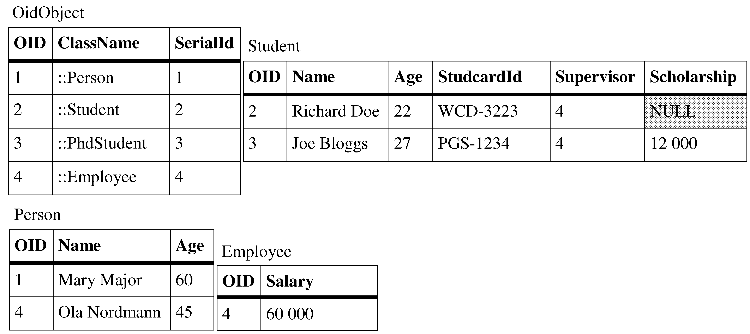
As you may see, there is no PhdStudent table as all its columns were appended to the Student table. As a result of the horizontal mapping, rows belonging to these two classes do not have entries in the Person table.
And the last example - classes from the previous section. ADT mapping is enabled for Student and its PhdStudent descendant, see Example 4.7, “Using the ADT mapping.” for the class model definition. This time, the lists for the PhdStudent class:
- AllParents: Person, OidObject
- FilteredTypes: no members
- PersistentAttributes: scholarship
- KeyAttributes: oid
- InheritedAttributes: oid, serialid, classname (all from OidObject), name, age, studcardid, supervisor
- AllPersistentAttributes: oid, serialid, classname (all from OidObject), name, age, studcardid, supervisor, scholarship
- MappedAttributes: not generated.

The mapping algorithm
In this section, we will describe the algorithm for CRUD operations performed by the IOPC 2 persistence layer. First, the top-level part of the algorithm for inserting, updating and deleting persistent objects is described.

Inserting, updating and deleting persistent objects
Given an object O, the algorithm iterates through its parent class hierarchy (starting with the class of O itself) and calls one of the Insert_Row() or Insert_Object() methods on it (depending on which mapping type is used). The Insert_Row method is described in Figure 4.5, “Description of the Insert_Row method. Not used for ADT mapping.”. Update_Row or Delete_Row methods have similar structure.

Figure 4.4. Top-level part of the object-relational mapping algorithm

if O uses ADT mapping then
Insert_Object(O) // Update_Object or Delete_Object
else if O uses horizontal or vertical mapping (O has a corresponding db table) then
Insert_Row(O, class of O) // Update_Row or Delete_Row
end if
foreach class C in AllParents do
Insert_Row(O, C) // Update_Row or Delete_Row
end
- First, the algorithm handles either the whole subgraph of ADT mapping classes (as they are stored as one ADT instance at a time)
- or the class of the object being inserted (if it has its own associated database table).
- Then it iterates through ancestors of the objects’ class and inserts values of attributes defined in them into a new database row.

Figure 4.5. Description of the Insert_Row method. Not used for ADT mapping.

Insert_Row(object O, class C):
foreach attr A in C.MappedAttributes
if A is not filtered attribute [category 1, 2, 4]
insert value of O.A into the new db row
else -- filtered attribute [category 3]
if class of O is descendant of class containing the attribute A
insert value of O.A from O into the new db row
else
insert NULL as attribute A into the new db row
end if
end if
end
The method iterates through attributes (or actually columns of the associated table to the class C) and inserts values to a new row. The process is quite self-explanatory except for filtered attributes (category 3). If a class has two descendants that use filtered mapping as shown in the Figure 4.6, “Inserting objects using filtered mapping”, a row representing an instance of class A (or its descendant) will contain NULLs in columns of attributes from class B and vice versa. Condition that solves this issue is marked (1) in the algorithm.

Figure 4.6. Inserting objects using filtered mapping
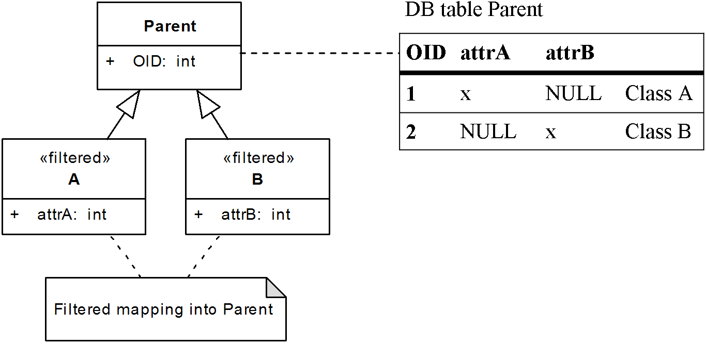
The table in Figure 4.6, “Inserting objects using filtered mapping” further illustrates the need for classes that use filtered mapping to derive from OidObject. When loading an object with OID “1”, the object-relational layer has to know which class to instantiate and only OidObject provides such database structures that store this information.
Same algorithm as in Figure 4.5, “Description of the Insert_Row method. Not used for ADT mapping.” is used for storing changes from objects that already have a database identity (Update_Row method). Changes are propagated as SQL UPDATEs with the WHERE generated from list of KeyAttributes and their values. For OID objects this means that the WHERE filters only by the objects’ OID value. Condition (1) from the algorithm is slightly modified in a way that no NULLs are inserted but simply the NULL-attributes are not updated. Deleting data is a trivial case - Delete_Row sends one SQL DELETE command to delete the requested row. The DELETE command uses same WHERE clause as the UPDATE does.
You can see that most of the work is done by correctly pre-generating the lists from the previous section, in particular the MappedAttributes and AllParents lists. They actually contain projection of the class model on the database structures according to the mapping types used.

Storing objects that use ADT mapping
As for the ADT mapping, the algorithm for inserting, updating or deleting is even simpler (see (1) in Figure 4.4, “Top-level part of the object-relational mapping algorithm”). IOPC 2 relies on the object-relational features provided by the underlying database. Insert operation usually creates a new instance of relevant ADT and inserts it into a ADT hierarchy base table⁴. Moreover due to significant differences between DBMSs in the area of object-relational features, most of the work is delegated to the database driver side. IOPC 2 database drivers are responsible for generating the needed database structures including the ADTs. The library doesn’t take any special steps to support multiple inheritance, so it is fully in charge of the database driver. If the ORDBMS doesn’t support multiple inheritance of ADTs, it doesn’t make much sense to bend the database engine to support it.
Example 4.8, “SQL schema from classes that use ADT mapping.” in the section called “ADT mapping” discussing ADT mapping illustrates how the needed database structures may look like. If we assume that these database structures are already created, inserts, updates and deletes are reduced to simple calls to the database access layer. If using the Oracle 10g database driver, these calls are only delegated further to the insert_object, update_object or delete_object static methods of corresponding ADTs.
The only additional task the ADT mapping requires is to decide which persistent class attributes will be mapped to ADTs. The simplest scenario is if all of the persistent classes starting with OidObject use ADT mapping - all attributes will be mapped to corresponding ADTs and point (3) in the general algorithm (Figure 4.4, “Top-level part of the object-relational mapping algorithm”) will be skipped. However, if the ADT mapping hierarchy is started at a lower level and derives for example from a class that uses vertical mapping, the attributes defined in classes “above” the root(s) of the ADT mapping hierarchy must be skipped and must not be propagated to the corresponding ADTs (as described in the section called “ADT mapping”).

Loading objects from database
Figure 4.7, “Iterative loading algorithm” illustrates how object instances are loaded from database.

Figure 4.7. Iterative loading algorithm

if O uses ADT mapping
Load_Object(O)
else if O uses horizontal or vertical mapping (O has a corresponding db table) then
Load_Row(O, class of O)
end if
foreach class C in AllParents do
Load_Row(O, C)
end
The algorithm is very similar to the previous one (Figure 4.4, “Top-level part of the object-relational mapping algorithm”). Retrieving instances in such way - class by class - is quite inefficient. The algorithm can be implemented as pre-generated views executing queries that join the involved tables. The views (simple and polymorphic views) are generated for descendants of OidObject. Instead of sending multiple SELECTs to retrieve data directly form the mapping tables, only one SELECT executed on a simple view is sufficient. The algorithm just loads values of AllPersistentAttributes from corresponding simple view. Source code of these views can be found in ???.
Iterative algorithm (without views) is used for classes that derive from DatabaseObject (and not from OidObject) and for instances that are requested to be exclusively locked in database. Rows belonging to such instances must be locked one-by-one usually by sending SELECT FOR UPDATE statements.
Modifying these views to be updatable for inserts, updates and deletes was considered, but not included into this release. Current DBMSs place many restrictions on the way how updatable views should be constructed and used. Most of them etirely disallow using joined tables in updatable views; Oracle for example supports updatable join views, but allows only columns from one table to be updated at a time⁵.

Loading classes that use ADT mapping
Again, loading instances of classes that use ADT mapping is a very simple task. In both Oracle and DB2, single SELECT statement can load all attributes of an ADT. If all classes of our example class model used ADT mapping, a SELECT statement to load a single Student instance would look like Example 4.9, “Loading objects using ADTs from an Oracle database”.

Example 4.9. Loading objects using ADTs from an Oracle database

SELECT
TREAT(VALUE(X) AS tStudent).OID AS OID,
TREAT(VALUE(X) AS tStudent).CLASSNAME AS CLASSNAME,
TREAT(VALUE(X) AS tStudent).age AS Person_age,
TREAT(VALUE(X) AS tStudent).name AS Person_name,
TREAT(VALUE(X) AS tStudent).studcardid AS Student_studcardid,
TREAT(VALUE(X) AS tStudent).supervisor AS Student_supervisor
FROM OidObject O
WHERE O.OID = 2
Because, as mentioned before, ADT mapping hierarchies can be started at lower level and its roots can derive from non-ADT-mapped classes, either iterative algorithm from the section called “Loading objects from database” or pre-generated views are used to retrieve object instances from database.

Conclusion
If we look at the table from the section called “Library comparison” we may see changes, mostly improvements in many of the listed areas:
- IOPC 2 added another mapping type - the ADT mapping and further enhanced the O/R mapping capabilities.
- IOPC 2 supports read-only databases, it even supports inheritance between non-OID classes (tables) if the involved tables share the same set of keys.
- The library is based on a modular design allowing it to be used in several configurations and with various database drivers.
- IOPC 2 provides a reflection feature which allows users to inspect the structure of reflection capable classes at run-time. Reflection works almost transparently as it needs no descriptive macros from the application developers.
- Reflection provides metadata description for the O/R mapping mechanism which uses them to provide effortless object persistence services to the application developers. However, there are some limitations when compared to the IOPC predecessor which result from the exchange of OpenC++ for GCCXML - for example the need to use enhanced data types in some scenarios. More on this can be found further in the text.
- <todo>pridat odkazy</todo>
Remaining topics are discussed in the following chapter. Thesis conclusion
<todo>odkaz</todo>
contains final library comparison and evaluation.

Chapter 5. Architecture of the IOPC 2 library

Architecture overview
Structure of the IOPC 2 project including library dependencies is displayed in Figure 5.1, “Overview of the IOPC 2 architecture”. IOPC 2 consists of a stand-alone application iopcsp and a set of shared libraries that are used at run-time.

Figure 5.1. Overview of the IOPC 2 architecture
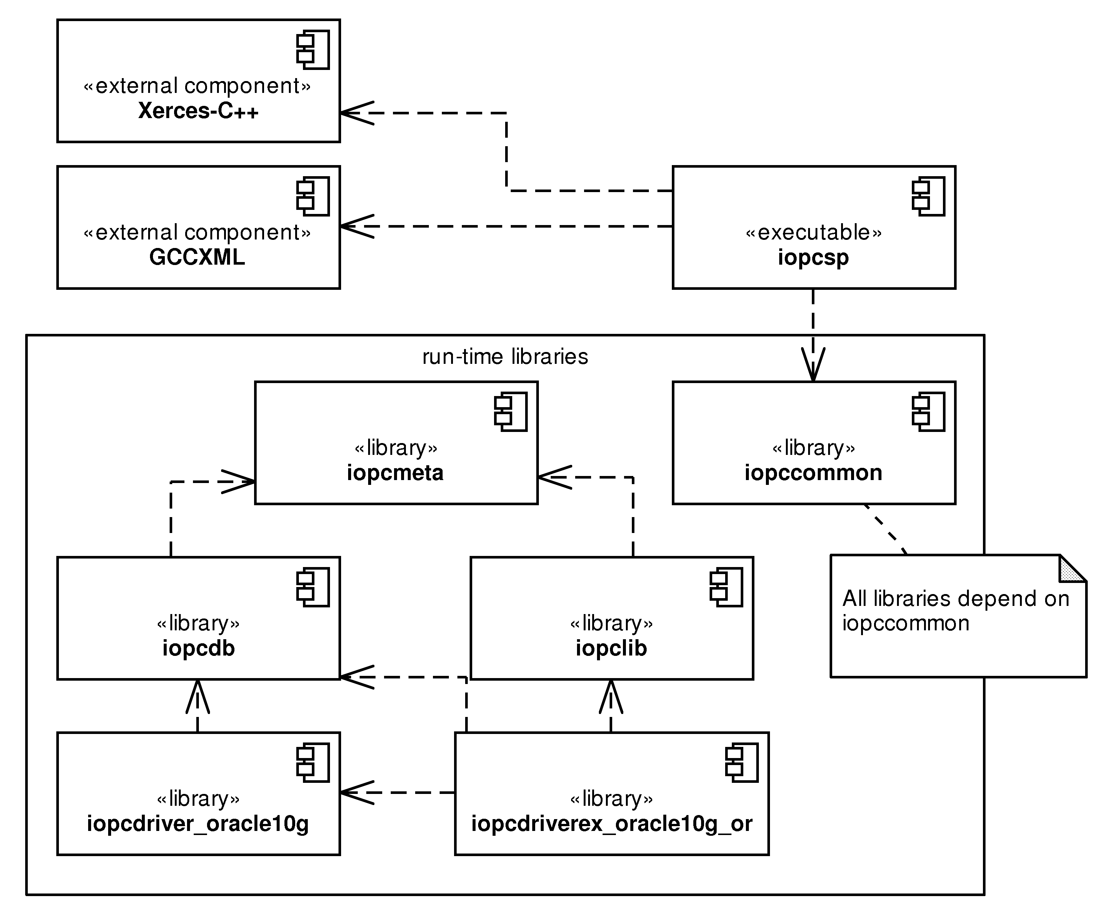
The following list provides a short description of each of the components.
- iopcsp is a stand-alone application that reads GCCXML output, extracts description of reflection-capable classes and generates source code of metadata libraries. Metadata libraries are later linked to the user application.
- iopccommon contains shared services for other parts of IOPC 2 including iopcsp. These services include tools for thread synchronization, tracing, logging or exception handling.
- iopcmeta is the reflection interface provided by the IOPC 2 library. It contains classes that whose instances describe metamodel of the source code processed by iopcsp.
- iopcdb supports the database layer modularity by providing a DriverManager facility by which loaded database driver register themselves. iopcdb provides access to these drivers via a unified interface and allows user applications to execute SQL statements.
- iopcdriver_oracle10g is Oracle 10g database driver for the IOPC 2 library.
- iopcdriverex_oracle10g_or is an extension to the Oracle 10g driver that adds object persistence capabilities to it.
- iopclib puts everything together into an O/R mapping layer. iopclib implements the O/R mapping algorithm as described in previous chapter. Further it provides persistent object caching features (originating from the POLiTe 2 library), script generation and querying functionalities and many more.
There are additional components that are not displayed in Figure 5.1, “Overview of the IOPC 2 architecture”. They are not directly related to the core functionality, but can be useful in the build process either of user applications or of the IOPC 2 library itself:
- iopcsp_compile.sh is a Bourne shell script that can be used with the Eclipse/CDT IDE¹ for managed build using the IOPC 2 library.
- iopcsp.sh is a Bourne shell script for use with standard Makefile to build application that uses the IOPC 2 library.
- test is a project that tests most of the library functionalities.
the section called “Library architecture” stated that IOPC 2 can be used in various configurations. These configurations are realised by linking subsets of the presented libraries together with the user application. Available configurations are:
- Common services - iopccommon.
- Reflection library - iopccommon, iopcmeta. Source code must be processed using iopcsp (also applies to the following two configurations).
- Database access library - iopccommon, iopcmeta, iopcdb and a database driver - for example the iopcdriver_oracle10g.
- Object persistence library - iopccommon, iopcmeta, iopcdb, iopclib, a database driver supporting all required O/R mapping features - for example the iopcdriver_oracle10g along with its extension iopcdriverex_oracle10g_or.

Common services
The iopccommon library contains support classes and utilities that are used by other parts of the library. The classes can be divided into three groups:

Thread synchronization classes
The thread synchronization classes were taken from the POLiTe 2 library. Synchronization primitives encapsulated by these classes are:
- Mutex (non-recursive) - the Mutex class.
- Mutex (recursive) - the Lock class.
- Conditional variable - the CondVar class.
- Read-write lock - the RWLock class.
- Read-write-exclusive lock - the RWXLock class.

Class metadata
Although the class metadata container is implemented as a generic structure in the iopccommon library, it is primarily designed to be used with the reflection features. Therefore we will provide its description later, in the the section called “Class metadata”.

Utilities
Utilities offered by the iopccommon library include reference counted pointer, various string manipulation methods, tracing and logging. Logging is encapsulated by the LogWriter singleton class.
Log messages have a severity level attached which helps to determine how critical the message is. Message filtering based on the level is also possible. Tracing macros defined in the same file as the LogWriter class are used through the IOPC 2 library allowing developers to dump detailed debugging information in case of application crash or malfunction. These macros can be enabled or disabled by setting appropriate filter in the LogWriter class or by (un)commenting macro options IOPC_DEBUG, IOPC_TRACE in the same file and by recompiling the whole IOPC 2 library. This way a diagnostic version of the library can be created.

Database access
One of the IOPC 2 library basic requirements is database independence. This can be achieved by separating the database access logic behind a shared interface.
The original POLiTe and the POLiTe 2 libraries access the database via such interface, the problem is that they contain several SQL statements outside the database layer code. These SQL statements are written for the Oracle 7 RDBMS and porting the library to another database system means to find and update them. In the end, recompilation of the whole library is needed.
The IOPC library tried to solve this issue by providing a new interface - the DatabaseSqlStatements class. Implementation of this interface encapsulates all SQL fragments needed by the library. Moving the library to another RDBMS became quite easy, but not as easy as it could be, because whole library needs to be recompiled every time a new driver is added or updated.
In the IOPC 2 library, database drivers are separated into shared libraries. The library provides a facility for managing and accessing these drivers. Adding or updating a database driver doesn’t involve any modifications in the library code or its recompilation. Users can use more than one driver at a time. Even all SQL code is separated into the drivers.
If the user application needs to communicate with a database, it must be linked with the iopcdb library and with at least one driver. Currently, only Oracle 10g driver iopcdriver_oracle10g is implemented. Application can however use any number of linked drivers at a time. Drivers may be enhanced with several extensions. Extensions provide additional functionalities to them. Again, only one driver extension is implemented at the time - the iopcdriverex_oracle10g_or extension. It adds the iopcdriver_oracle10g driver support for O/R mapping.

Basic classes
Figure 5.2, “Basic classes of the database layer” shows an overview of basic classes and subsets of their methods.

Figure 5.2. Basic classes of the database layer
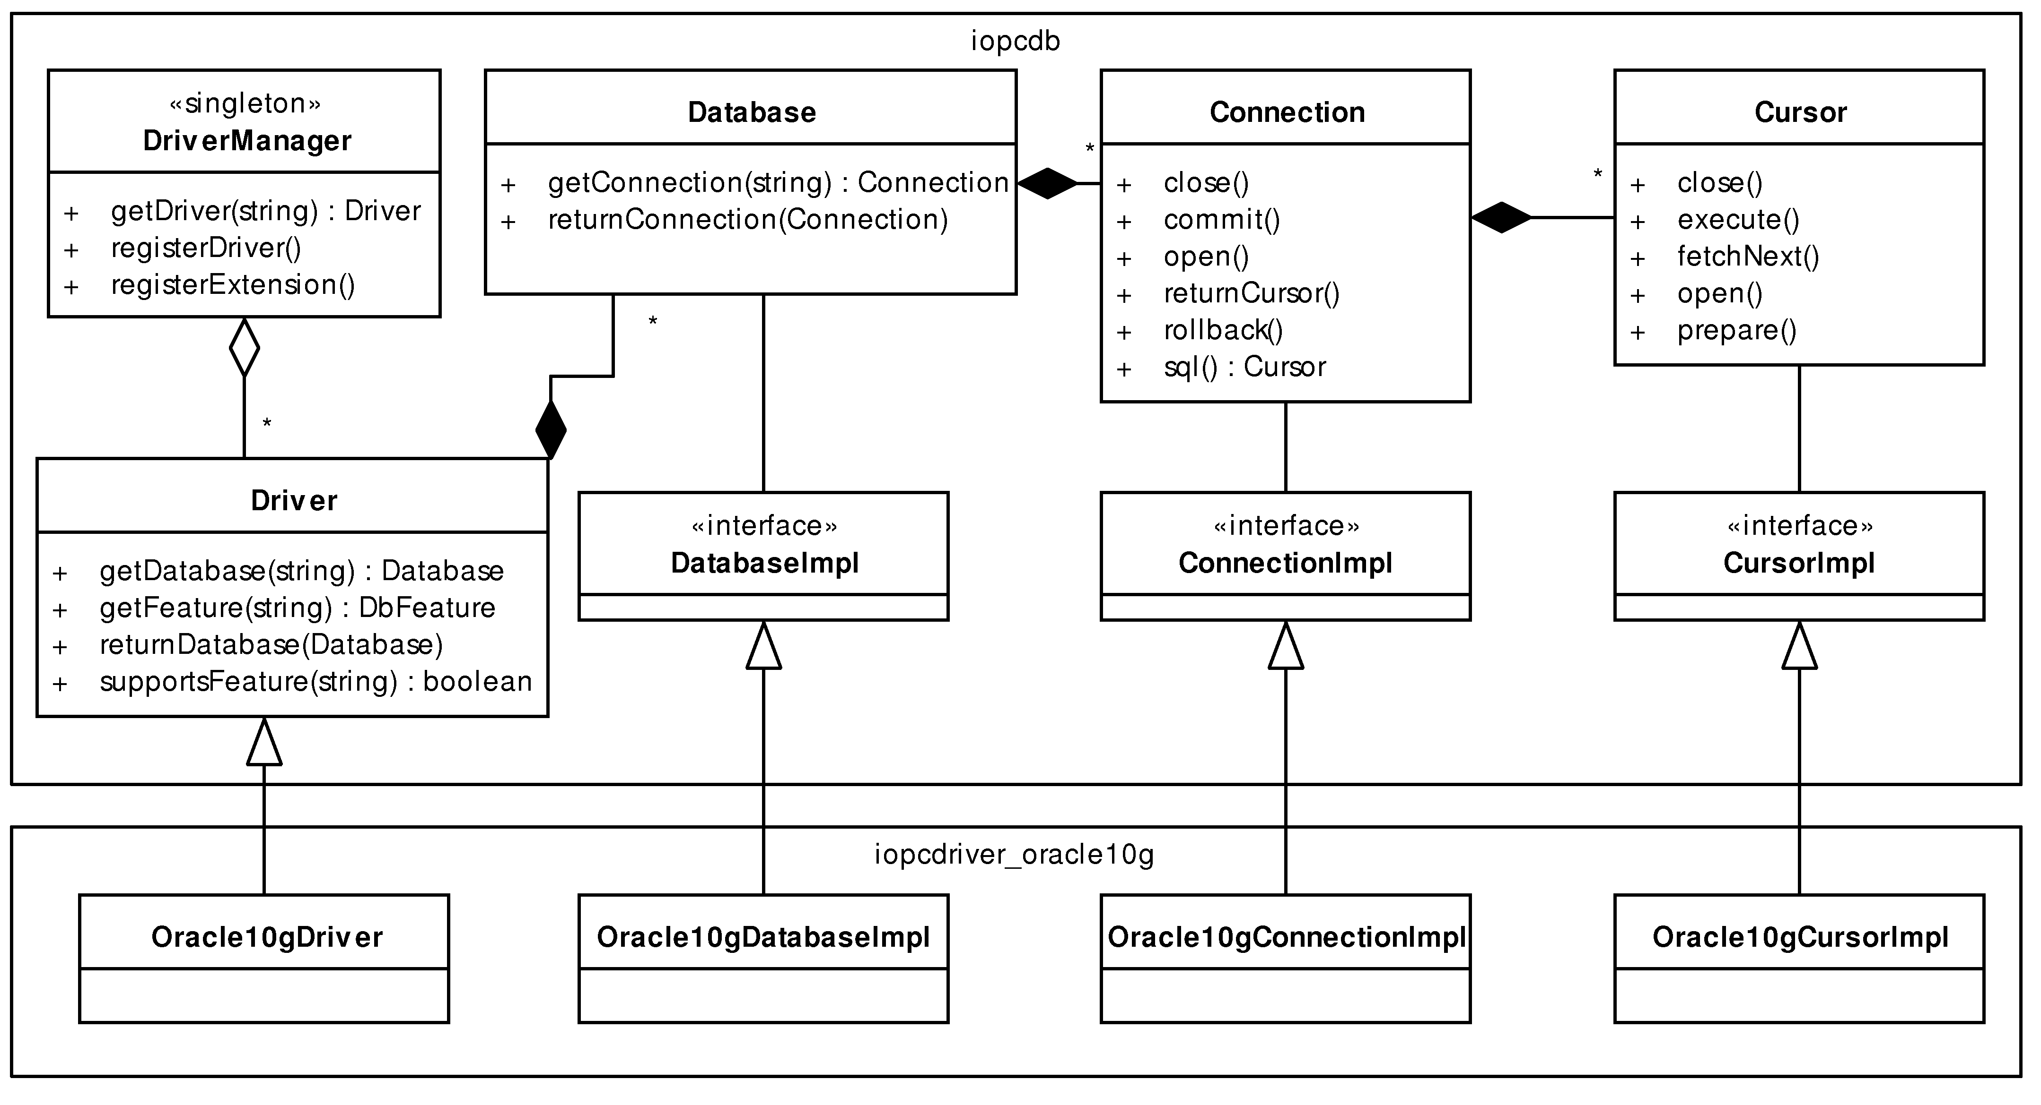
DriverManager is a central part of the driver model. A single instance of this class holds references to all drivers loaded in the user application. Users can obtain reference to a database driver by calling its method getDriver(name). Database driver is represented as an instance of the Driver class.
Next three classes - the Database, Connection and Cursor can be found in all previous versions of the IOPC and POLiTe libraries. Their interface was slightly modified in IOPC 2 and implementation was moved from their subclasses to subclasses of the abstract classes (interfaces) DatabaseImpl, ConnectionImpl and CursorImpl. Each database driver must implement these interfaces.
The reason for almost duplicating the Database and Cursor interfaces is that they are used in a decorator pattern to modify the effect of their interfaces at run-time. As you may see in Figure 5.3, “Using the decorator pattern”, the classes CachedDatabase and CachedConnection are designed to decorate the BasicDatabase and BasicConnection classes. BasicConnection and BasicDatabase implement the basic database independent functionality, mostly the connection and cursor management. Database dependent operations are delegated to database drivers using the -Impl interface classes. The CachedDatabase and CachedConnection classes decorate behaviour of some “basic” methods like commit or rollback by performing a caching related operations - for example writing modified local copies to database before commit.

Figure 5.3. Using the decorator pattern
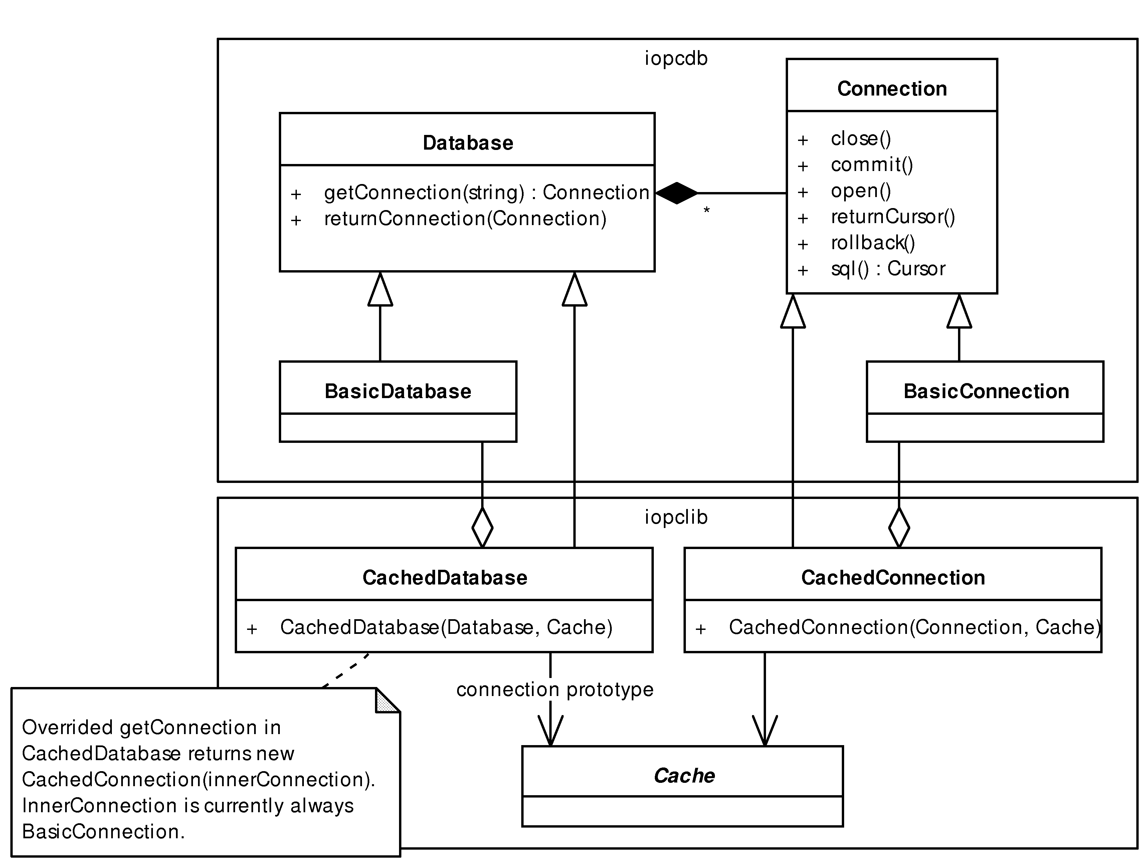
Example 5.1, “Connecting to an Oracle database in IOPC 2” shows how a connection to Oracle database instance “XE” can be made. First we create only a simple connection allowing only basic SQL statements to be executed, then we release this connection and a new one using the CachedConnection decorator class. This connection can be used with the O/R mapping features, see later.

Example 5.1. Connecting to an Oracle database in IOPC 2
Database* db = DriverManager::getDriver(
“IopcOracle10g”).getDatabase(”XE”);
Connection* conn = db->getConnection(
“username=iopc;password=iopc”);
conn->sqlNonQuery(”INSERT INTO test VALUES(’Test’)”);
// Connections need to be released when no longer needed
db->returnConnection(conn);
DriverManager::returnDatabase(db);
// CachedDatabase returns CachedConnection instances
// (no need to decorate them)
CachedDatabase* db2 =
new CachedDatabase(DriverManager::getDriver(
“IopcOracle10g”).getDatabase(”XE”), new VoidCache());
CachedConnection* conn2 =
(CachedConnection*)db2->getConnection(
“username=iopc;password=iopc”);
conn2->open();
...

Driver features
Driver features reflect differences between database systems. Different database systems provide different features or services. In IOPC 2, interfaces to such services(features) can be grouped into units called driver extensions. Modules of the IOPC 2 library define interfaces (representing the features) and database driver creators optionally implement them to their drivers or grouped in driver extensions. The library then asks the drivers what features they offer. Based on the answers it enables or disables some of its functionalities provided.
Driver extensions are shared libraries that are linked together with the drivers and user applications. One such extension implemented for the Oracle 10g driver is iopcdriverex_oracle10g_or. It enhances the iopcdriver_oracle10g Oracle 10g driver with the support for object-relational mapping.
The features are descendants of the DbFeature abstract class. Features declared in the iopcdb library are:
- SqlStatementsFeature - declares methods that are used to generate basic SQL statements like the INSERT, UPDATE, DELETE, CREATE TABLE, DROP TABLE and others.
- TypeMappingFeature - declares methods that are used to translate C++ data types to the SQL.
As part of the iopclib library, there are additional features declared that are needed for the object-relational mapping proccess:
- MappingStatementsFeature - declares methods that are used to generate shared SQL statements needed for the object-relational mapping.
- ORStatementsFeature - declares methods that are used to generate SQL statements supporting object-relational mapping to purely relational tables. (Relational databases)
- ObjectStatementsFeature - declares methods that are used to generate SQL statements needed by the ADT mapping type. (Object-relational databases)
Figure 5.4, “Oracle 10g database driver extensions and driver features” illustrates how the driver features and extensions are used by the Oracle 10g database driver.

Figure 5.4. Oracle 10g database driver extensions and driver features
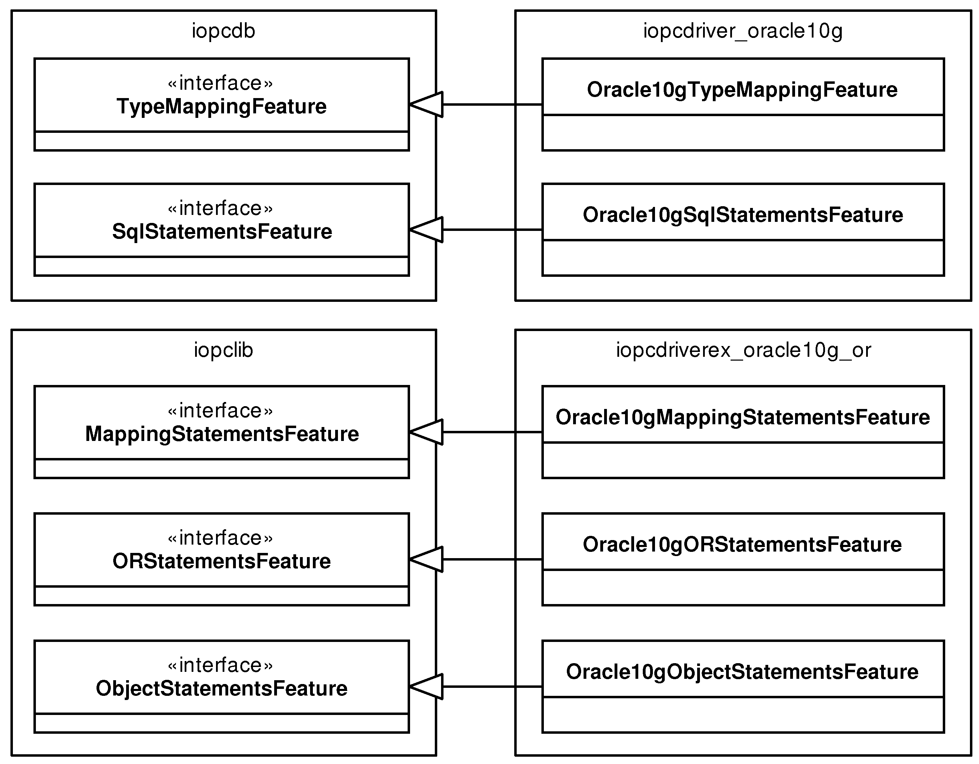

The metamodel
Metamodel description is created for all descendants of the Object class. Source files must be processed using iopcsp and the result must be compiled and linked together with the iopcmeta library and the user application. The metamodel can be then inspected using classes and structures defined in iopcmeta.

The metamodel classes
Figure 5.5, “The iopcmeta classes” provides an overview of these classes.

Figure 5.5. The iopcmeta classes
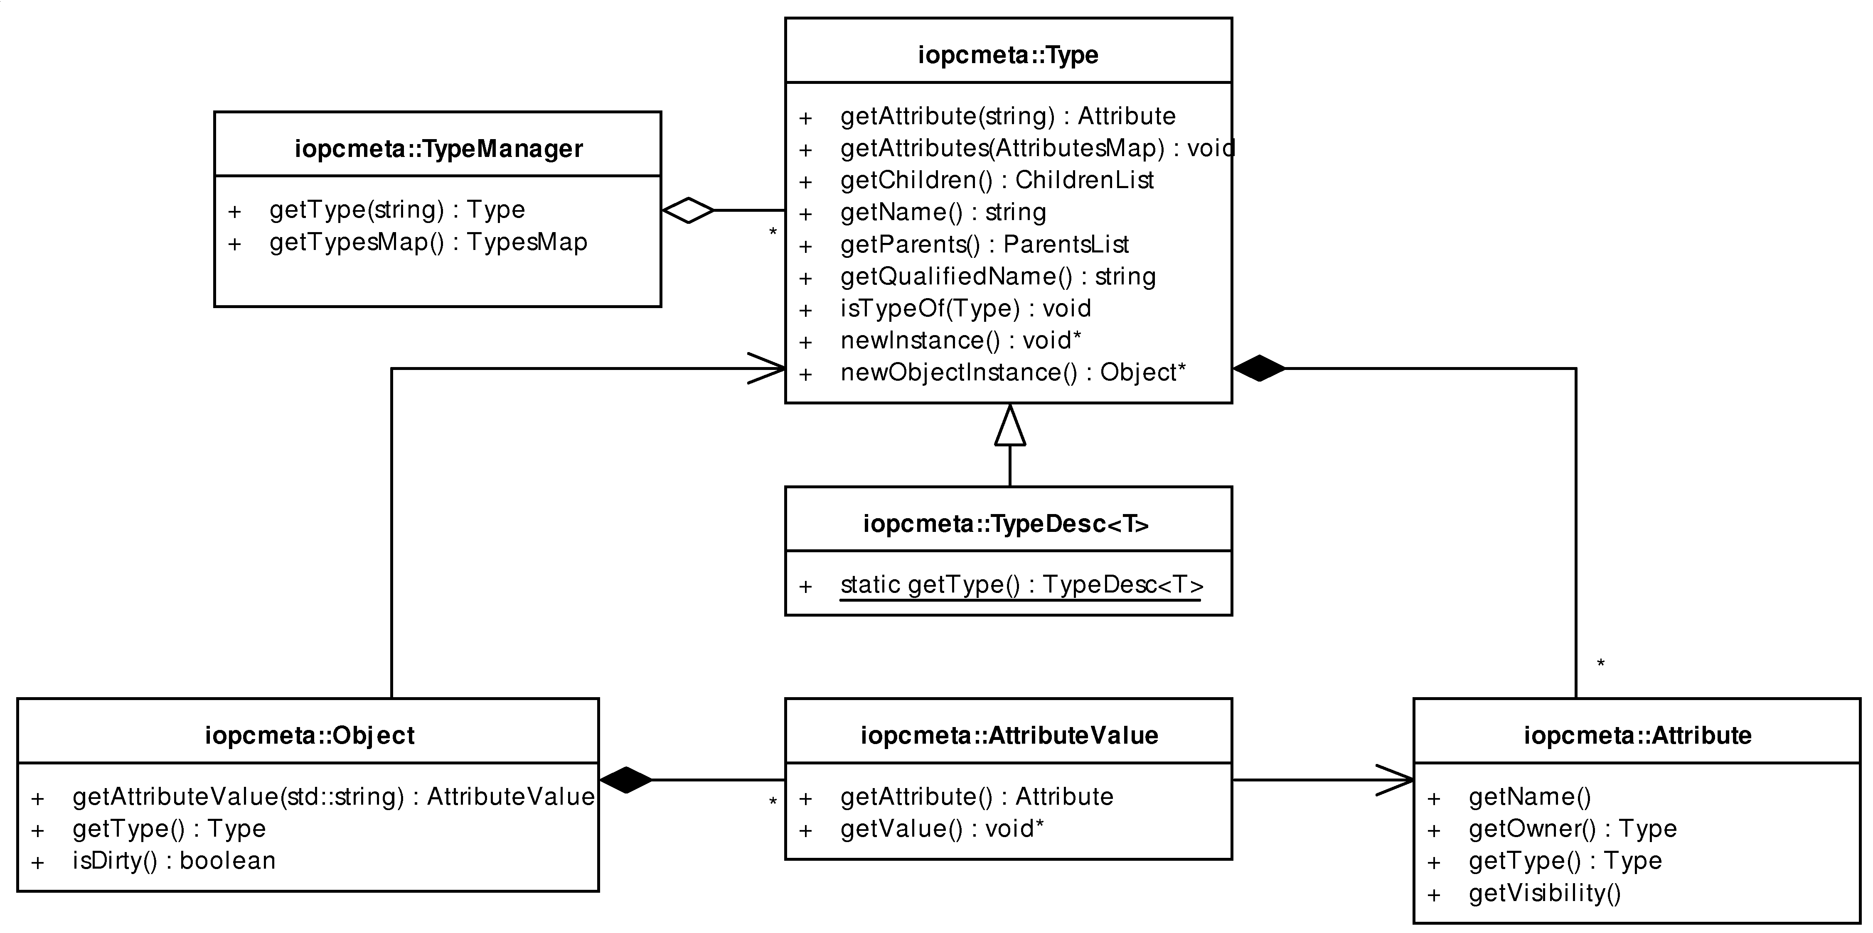
The Type class and its descendant, the TypeDesc<T> template class, are the central point of the reflection mechanism. Instances of the TypeDesc<T>specializations represent reflection-capable classes and all basic C++ types. There is only one instance of the template specialization for a reflection-capable class or basic type. As mentioned before, the concept is similar to prototypes in the POLiTe libraries and to IopcClassObjectImpl from the IOPC library. However, classes defined in iopcmeta do not provide any object-relational mapping capabilities.
The TypeDesc<T> template class uses technique called type traits to encapsulate various type-dependent data and to provide access to the metamodel description at compile-time in a static way. For example, given the class User, the correspondent type trait is TypeDesc<User> and the solitaire type instance is accessible via the TypeDesc<User>::getType() call. Type traits are defined in a manner illustrated in Example 5.2, “Type traits”. As you can see, this is a good way how to unify the metamodel interface for C++ basic types along with the object types declared in the IOPC 2 library.

Example 5.2. Type traits
// Generic template
template<typename T>
class TypeDesc : public Type {
public:
virtual const std::string getName() const;
...
}
// Template specializations for particular types
template<>
class TypeDesc<int> : public Type {
virtual const std::string getName() const { return “::int”; }
}
template<>
class TypeDesc<Object> : public Type {
virtual const std::string getName() const { return “iopc::Object”; }
}
TypeManager is a singleton class which maintains a list of the instances of the Type subclasses. As the call to TypeDesc<T>::getType() is a method how to gain access to the metamodel in a static way, the call to TypeManager::getType(std::string typeName) can be used to obtain the type information from a run-time constructed type-name string.
The Object class as a predecessor of all reflection-capable classes doesn’t offer much functionality. It provides infrastructure for the dirty status tracking and list of AttributeValue objects that allow developers to modify object attribute values using the reflection. This leads us to the Attribute class which instances represent attributes of a particular class. Object also contains a getType() method which is the last way leading us to the corresponding Type instance.
Example usage of reflection can be found in Example 5.3, “Using the reflection interface”. The example prints a brief description of the Person class we defined earlier. For more examples, see ???.

Example 5.3. Using the reflection interface
const Type& t = TypeDesc<Person>::getType();
cout << “Type name: “ << t.getQualifiedName() << endl;
cout << “Attributes: “ << endl;
const Type::AttributesMap& attributes = t.getAttributes();
for(Type::AttributesIterator it = attributes.begin(); it != attributes.end(); it++) {
cout << it->first << “: “ <<
it->second.getType().getQualifiedName() << endl;
}
// For simplicity we assume that multiple inheritance
// is not used
cout << “Parent: “ << t.getFirstParent().getQualifiedName() << endl;
cout << “Children: “ << endl;
const Type::ChildrenList& children = t.getChildren();
for(Type::ChildrenIterator it = children.begin(); it != children.end(); it++) {
cout << (*it)->getQualifiedName() << endl;
}
// Output is:
Type name: ::Person
Attributes:
age: iopc::EShort
name: iopc::EString
Parent: iopc::OidObject
Children:
::Employee
::Student

Enhanced data types
Mostly because of the need of dirty status tracking for the object-relational layer a set of classes encapsulating C++ built-in types was created. The basic requirement is that starting from a specific time, an object needs to be aware if value of any of its attributes has changed. There are several transparent ways how to fulfil this requirement (like preserving a copy of the object and comparing it with the original when needed) and one of the simplest is to have the attributes to be aware of their own changes. This is achieved in the library by creating new data types that mimic behaviour of built-in types. These types are called enhanced data types. Developers are, however, not forced to use these types, they can use built-in types and manually notify the object that its state has changed.
POLiTe libraries solved this problem by using setter methods generated from descriptive macros. The additional task of the setter methods is simply to modify the dirty status flag of the containing object. IOPC library took advantage of the OpenC++ parser’s ability to process entire source code and changed every relevant assignment operation to use generated setter methods similar to the POLiTe ones.
Second goal was to create a common interface for data types of class attributes that will unify the way how they are mapped to the database. Thanks to enhanced data types, string values, numeric values or references to other objects (using the DbPtr<T> class as attribute) can be treated in a similar way in the database drivers and in the database part of the library (iopcdb). Enhanced data types are also given the ability to represent NULL values. The NULL status becomes part of an attribute itself as opposed to the preceding versions of the library. Such design helps to further minimize impedance mismatch by unifying data domains of C++ data types and column types of database tables. Structure of the enhanced data type classes is displayed in Figure 5.6, “Structure of the enhanced data type classes”.

Figure 5.6. Structure of the enhanced data type classes
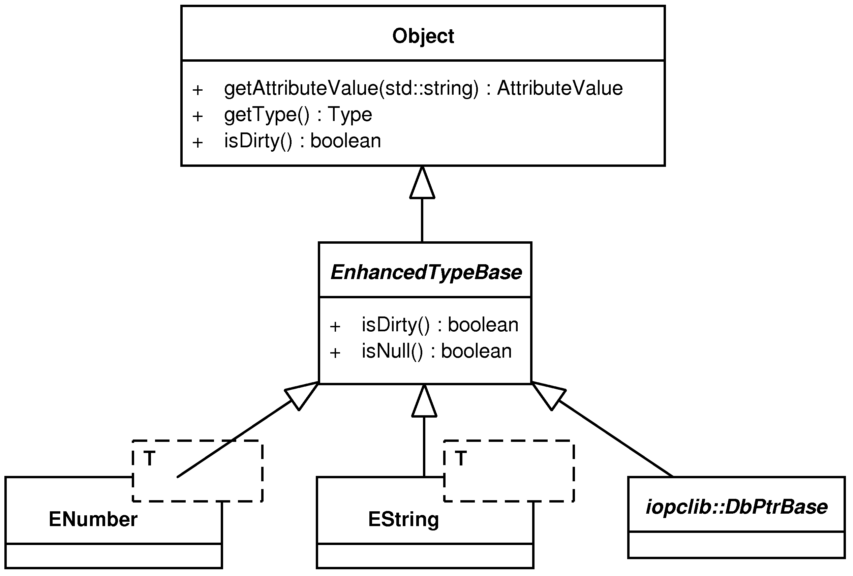
Enhanced data types are designed to be used like built-in C++ types. Example 5.4, “Java annotations and C# attributes” illustrates this feature along with the NULL values and dirty status tracking.

Example 5.4. Java annotations and C# attributes
EInt a = 8;
a = a + 2;
int b = 2 + a;
EFloat d = 2.5;
d = (d + 2.5 + a) / 2;
EDouble c = (a + 2)*(a + 3);
cout << “a: “ << a << “ b: “ << b << “ c: “ << c << “ d: “ << d << endl;
d.setNull();
cout << “a.isDirty(): “ << a.isDirty() << endl;
cout << “c.isDirty(): “ << c.isDirty() << endl;
cout << “d: “ << d.toString() << endl;
Output is:
a: 10 b: 12 c: 156 d: 7.5
a.isDirty(): 1
c.isDirty(): 0
d: null

Class metadata
<todo>Metadata loader - interface v iopcMeta, bude to volano na spravnem miste v inicializaci</todo>
Modern languages like Java or languages based on the .NET platform provide language constructs that allow programmers to add custom information to class metadata. These constructs - attributes in C# or annotations in Java - have declarative meaning and do not directly impact semantics of a program. Information stored in attributes or annotations can be accessed at run-time using reflection. Class metadata concept goes well with object-relational mapping layer as the information about into which database tables to map, which mapping type to use or how the table columns should be named have also declarative character. Such an information don’t change at run-time.

Example 5.5. Java annotations and C# attributes
// Demonstration on the Hibernate library
// http://www.hibernate.org
// Java
@Entity
@Table(name=”tab_person”)
public class Person implements Serializable {
@Column(name = “name”, nullable = false)
public String getName() { ... }
}
// C#
[Class(Table=”tab_person”)]
class Person
{
[Property(Name = “name”, NotNull=true)]
public string Name { ... }
}
IOPC 2 library also implements this concept, but in a very simple way. There is a class MetadataHolder in the iopccommon which, when instantiated, behaves like a dictionary. MetadataHolder can contain data of several types - integer or boolean values, void pointers or strings. Data stored in the dictionary are identified by a string key.
Classes that describe the metamodel like Type or Attribute derive from MetadataHolder. Their instances inherit the behaviour of a dictionary which simulates the decorative behaviour of the Java or .NET language constructs. However, a significant difference is that the metadata is appended at run time. It can be hardcoded into a class initialization method (see the Example 5.6, “Example usage of metadata in the IOPC 2 library” and ??? for further explanation) or loaded from a configuration file during the library initialization (
<todo>metadata initializer</todo>
).

Example 5.6. Example usage of metadata in the IOPC 2 library
class Person : public iopc::OidObject {
public:
iopc::EString name;
// the class initialization method
static void iopcInit(iopc::Type& t) {
t[”db.table”].setStringValue(”person”);
t.getAttribute(”name”)[”db.column”].setStringValue(”name”);
t.getAttribute(”name”)[”db.type.notNull”].setBoolValue(true);
}
...
} ;

iopcsp
iopcsp is a standalone application, already introduced in the the section called “Obtaining the metamodel description”. The application processes XML output of GCCXML and generates C++ files containing structures that describe classes from files originally processed by the GCCXML. To get better understanding of what the application does, we will repeat the description of the metamodel generation process in more detail:
- The process is invoked on every CPP file of a user’s project.²
- GCCXML reads the input CPP file and generates a XML file describing all declarations from the input file and from all files included (it runs the C preprocessor). In the provided implementation this output file is given a filename “input-filename.cxml”.
- iopcsp reads the CXML file and transforms it into a couple of C++ compilable source files named “input-filename.ih” and “input-filename.ic”. iopcsp searches for all descendants of the Object class and for each of them it writes several lines of macro code into both IH and IC files. The macro code in the IH file expands to a full definition of the TypeDesc<T> template specialisation whereas the IC file contains the template instantiation and a static instance of a TypeRegistrar class which registers the type by the TypeManager singleton. The registration is initiated when the user application starts.
- Last step may vary between scenarios. All IC and IH files compiled into object files can be archived using the ar program and the created archive, as a “type catalogue”, can be linked to the rest of the user application. Another approach is to create archives containing the IC/IH object files together with the object files of the original input CPP sources.
The process is customisable and currently is driven by a shell script. The script can be modified by developer needs and even integrated into their favourite IDEs. An example is provided with this thesis illustrating how to use it with simple makefile or integrated into Eclipse’s CDT³ managed build system.
Managed build system generates project build files automatically based on the project resources and user settings. Build file generation can be customized by users. Example project provided with this thesis changes the default compile command executed on each compilation unit in the project (g++) to iopc_compile.sh shell script call. iopc_compile.sh runs the steps described above these paragraphs and compiles the compilation unit using g++.
The example project provided on the enclosed DVD is named example_managed. During its build, a type catalogue archive is created and in the end of the build process the catalogue is lined to the resulting binary. Second example provided - example - illustrates a project which is built using standard Makefiles. This time, a type archive for every compilation unit is created.

Usage transparency differences from IOPC
IOPC uses OpenC++ source-to-source translator which gives it full control over the source code structure. IOPC processes not only class declarations, but also method bodies and everything else. On the other hand, IOPC 2 uses GCCXML which processes only declarations. GCCXML output doesn’t contain function bodies, therefore it is not possible to modify the original source code and dump the modified version into a new file that will be compiled. Such approach could work if the class declarations were in separate files and completely without any function code. This solution was however rejected as it led to other source code modifications and to build process complications.
Solution used in IOPC 2 is less intrusive as it generates only new structures (the type descriptions - TypeDesc<T>) into additional compilation units. It doesn’t modify the original source code in any way and to read attribute values from reflection-capable instances it uses only “safe” C++ techniques ⁴. There are two restrictions that somehow violate the usage transparency and that the developers should keep in mind when creating the reflection-capable (or persistent) classes.
The first problem is, how to access private or protected members in reflection-capable classes from the type descriptions. There are several ways how to accomplish this task, but all aside from direct memory access to these members are either not considered “safe” by the author or involve modification of the class declaration. For IOPC 2 the latter option was chosen. Developers need to include a friend class declaration as shown in Example 5.7, “Java annotations and C# attributes” if they want to access such members via reflection or to make them persistent using the O/R mapping provided. The friend declaration should be understandable for developers as it clearly says what it does (provides access to the private members to some other entity - the reflection). It is not needed if all such members are declared as public.

Example 5.7. Java annotations and C# attributes
class Person : public iopc::OidObject {
private:
EShort age;
EString name;
public:
void setData(std::string name, short int age) {
this->name = name;
this->age = age;
}
std::string getName() const { return name; }
short int getAge() const { return age; }
// Needed
friend class TypeDesc<Person>;
} ;
Second point concerns the dirty status tracking of persistent objects. All IOPC 2 library predecessors used getter and setter methods for this task. However, these methods couldn’t be used in IOPC 2 because it would involve source code modification. For this reason, the enhanced data types were created - see the section called “Enhanced data types”. They provide automatic dirty status tracking and they can also represent the SQL NULL values. Developers do not need to use the enhanced data types if they manually call the Object::setDirty() method to tell the library that value of the object has changed. In contrast, if developers need to set or read NULL values using the O/R mapping, they must use the enhanced data types as there is no alternative for such task in the library.

The persistence layer - iopclib
iopclib puts together all other components into an object-relational library. It uses iopcdb with appropriate database drivers (iopcdriver_oracle10g) for database access. iopclib requires the drivers to have the object-relational features implemented and linked (the iopcdriverex_oracle10g_or extension). Metamodel description is generated using the GCCXML and iopcsp and is accessed using the iopcmeta library. The iopccommon library is implicitly used by all of these components and also by iopclib itself.

Database mapping
iopclib defines the base classes DatabaseObject and OidObject as described in the the section called “Base classes”. The OID data type is defined by a typedef, so it can be changed in the future. Now it defaults to EULong. If we want the non-oid objects to be cached, we need a way how to describe their identity. In iopclib the identity of persistent objects is expressed as an instance of the KeyValues class. KeyValues contain a list of key-value pairs which represents any single-attribute or composite (multi-attribute) key.

Figure 5.7. Classes involved in the database mapping process
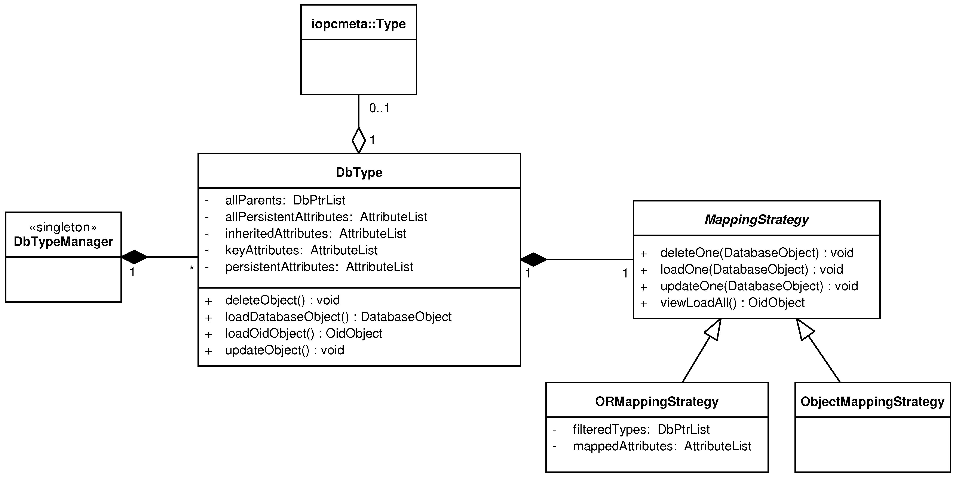
The idea behind the O/R mapping part is to wrap each type representing a persistent class⁵ into a class that will provide persistence related tasks. Such class has been named DbType as displayed in the Figure 5.7, “Classes involved in the database mapping process”. For each persistent class type there is exactly one instance of the DbType class. These instances are managed by the DbTypeManager singleton.
DbType class implements the mapping algorithm described in the the section called “The mapping algorithm”. The algorithm has been split between the DbType, ObjectMappingStrategy and ORMappingStrategy classes. DbType performs the table-level part of the algorithm while the strategy classes implement the attribute-level operations - this means the Load_Object or Insert_Object⁶ methods for the ADT mapping type (ObjectMappingStrategy) and Load_Row or Insert_Row⁶ methods for the other mapping types (ORMappingStrategy). The lists described in the section called “Mapping algorithm prerequisites” needed by the algorithm can be found in these classes.
When one of the main CRUD methods of DbType is invoked, the program iterates through the inheritance hierarchy of the related class type according to the algorithm and calls the ObjectMappingStrategy or ORMappingStrategy to perform the attribute-level operations. The strategies in turn call the database driver’s ObjectStatementsFeature or ORStatementsFeature to generate SQL statements that will be executed. If possible, these statements are cached and not re-created each time. After that, the SQL statements are sent to the underlying DBMS via the database driver being used.
Another important class defined in iopclib is the ScriptsGenerator. ScriptsGenerator has only two methods - getDbCreateScript and getDbDrobScript. As the method names suggest, the class generates SQL CREATE and DROP scripts which create or delete database schema required for the O/R mapping to work. The generator first creates a list of topologically ordered persistent classes according to their inheritance dependencies and then calls the MappingStatementsFeature for each of them in order to generate the scripts. Example 5.8, “Using the ScriptsGenerator to create required database schema.” how to prepare required database schema.

Example 5.8. Using the ScriptsGenerator to create required database schema.
vector<string> script;
script = ScriptsGenerator::getDbCreateScript(conn->getDriver());
for(vector<string>::const_iterator it = script.begin();
it != script.end(); it++) {
conn->sqlNonQuery(*it);
}

Persistent object manipulation

Figure 5.8. Classes manipulating with persistent objects
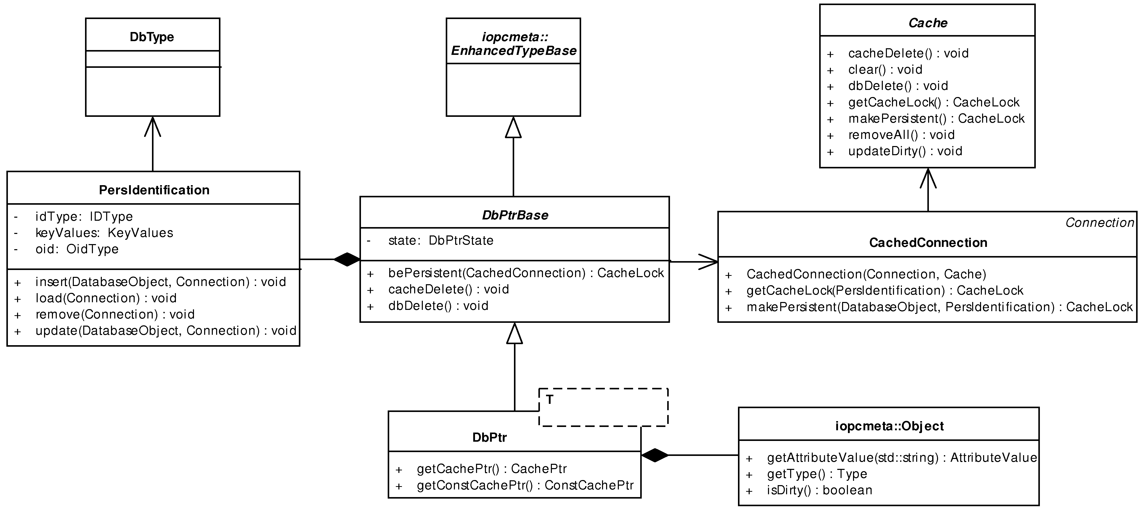
Most classes presented in this and in the next section are adapted from the POLiTe 2 library, so we will provide only a brief overview of their structure and of the way how they interact. For detailed description, see [1].
Instances of the PersIdentification class represent identity of persistent objects. The class encapsulates both the OID and the KeyValues. It also provides access to CRUD methods defined in DbType. PersIdentification instances are used as keys in the cache layer containers and in this context they represent the only communication channel between the cache layer and the O/R mapping services - see the sequence diagrams below.
As in the POLiTe 2 library, developers must use indirect references to manipulate database object in their transient or persistent state. IOPC 2 uses exactly the same concept as described in the section called “Persistent object manipulation”.
The indirect references - database pointers - are represented by instances of the DbPtr<T> template class. DbPtr<T> can point to database object instances in one of the following states:
- Transient instances which are not yet managed by a cache. The owner of these instances is the database pointer. If the pointer is destroyed before delegating the object ownership to a cache, the object is also destroyed.
- Instances managed by a cache. They may or may not already have a database representation.
- Persistent instances that are not present in a cache. The pointer contains only their identity description (a PersIdentification instance).
bePersistent is the method that transfers the object ownership to a cache. It has only one argument - a database connection (CachedConnection). The cache that is associated with this connection becomes the new owner of the object.

Example 5.9. Using the bePersistent method
// Creates a new transient Person instance
// owned by the database pointer p
DbPtr<Person> p;
p->name = “Mary Major”;
p->age = 60;
// Transfers the ownership to the cache associated
// with the connection conn.
p.bePersistent(conn);
Example 5.9, “Using the bePersistent method” illustrates how to use the bePersistent method. First, as outlined in the Figure 5.9, “The bePersistent operation”, the transient instance is passed to a cache associated with the used connection. Then the cache takes ownership of the object and stores a reference to it into its internal structures. A CacheLock instance is returned. CacheLock class is used to lock local object copies in a cache so that they can be safely used by the user application. The local copy cannot be manipulated by the cache while it is locked.

Figure 5.9. The bePersistent operation
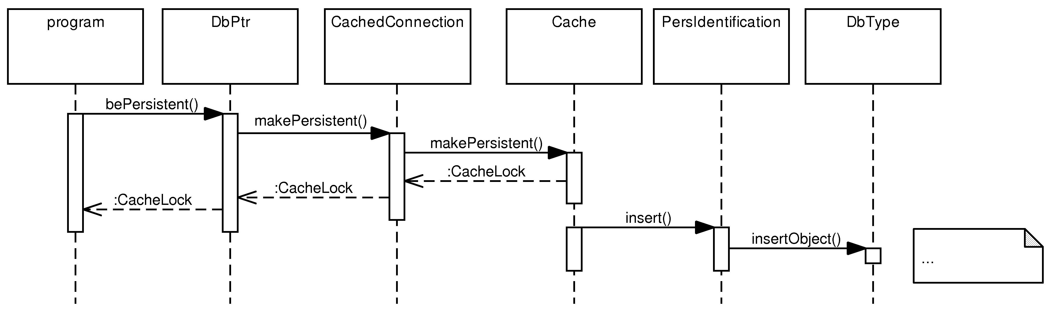
When the lock is released, the cache is free to create a persistent copy of the object in the underlying database and eventually to remove the local copy from memory. Depending on the cache implementation and updating strategy used, the actual flow of events may differ slightly.
By dereferencing a database pointer instance, or by calling one of the getCachePtr or getConstCachePtr methods, an instance of a cache pointer can be retrieved. Cache pointer can be constructed for transient as well as for cache-managed objects. If a cache pointer for a cache-managed object is created, the cache is instructed to lock (or to load from a database and lock) the object it points to (the CacheLock class is used). The lock is released as soon as the cache pointer instance is destroyed. Cache locks can also be dereferenced and, this time, a pointer to the actual database object instance is returned. The cache pointer is implemented as the CachePtr and ConstCachePtr classes. The only difference between them is that the latter one returns only a constant pointer to the object and locks it as read-only in the cache. Objects that have a read-only lock can be read by multiple threads at a time.
Both pointer classes (DbPtr<T> and (Const)CachePtr<T>) overload the -> operator. As described in the section called “Persistent object manipulation”, if a call to the operator->() function is made and if the object returned also overloads the -> operator, C++ automatically calls the operator->() on it again. Figure 5.10, “Database pointer and cache pointer interaction” illustrates what happens if the following source code excerpt is executed.
p->age = 59;

Figure 5.10. Database pointer and cache pointer interaction
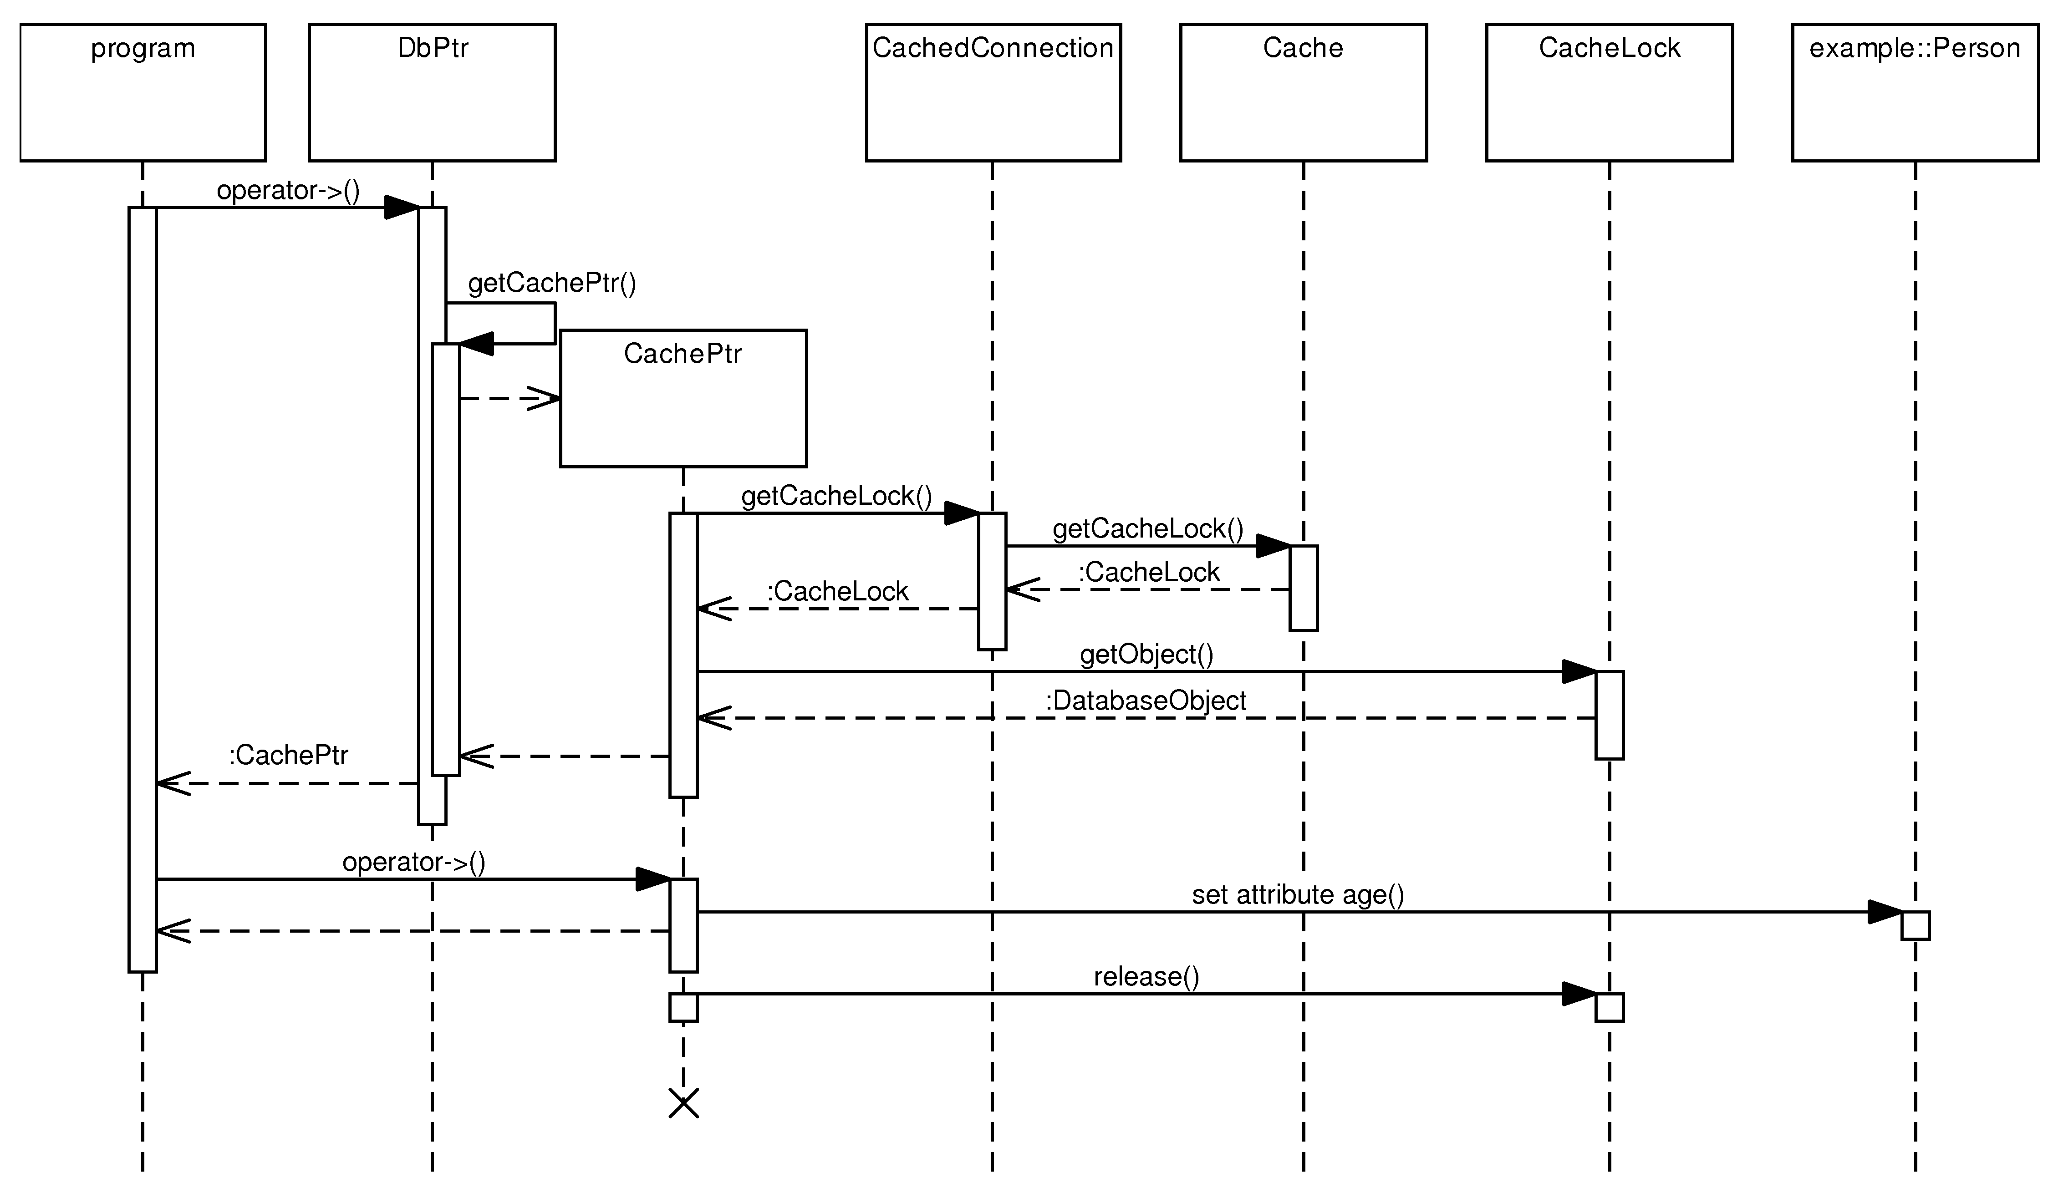
The first -> operator call results in the CachePtr<T> instance creation. Its constructor retrieves a CacheLock instance containing a reference to the locked local copy. When obtaining a CacheLock, the cache looks for the requested object in its containers and if not found, the database mapping part of the library is asked to load it from a database. Then, the object instance is locked as described above and CachePtr<T> retrieves a direct reference to the locked local copy from the CacheLock.
After that, C++ chains the operator-> call and invokes it on the newly created CachePtr<T> instance. CachePtr<T> in turn returns reference to the database object itself and the age attribute is accessed. Immediately after the assignment operation, the life cycle of the CachePtr<T> instance ends and its destructor is called. Inside the destructor, the cache lock is released.

Figure 5.11. Interaction with the O/R mapping services
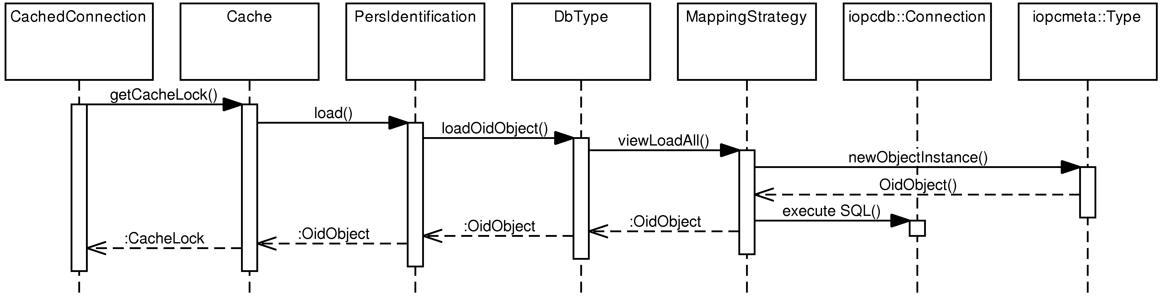
Figure 5.11, “Interaction with the O/R mapping services” indicates how the flow of the previous scenario would continue from the getCacheLock call, if the requested object was not present in the cache. As mentioned earlier, the cache layer uses the PersIdentification class to call the database mapping routines.

The cache layer
The cache layer was ported from the POLiTe 2 library. Its interfaces and overall architecture remained almost unchanged. Cache layer depends on infrastructure described in the previous section. Because these infrastructure classes were preserved or enhanced, there was no reason to change the architecture of the cache layer. Again, the structure and behaviour of the cache layer were described before, so for detailed information about it please refer to [1]. Following paragraphs describe its hi-level architecture and design of its interfaces.

Figure 5.12. Basic classes of the cache layer. VoidCache architecture.
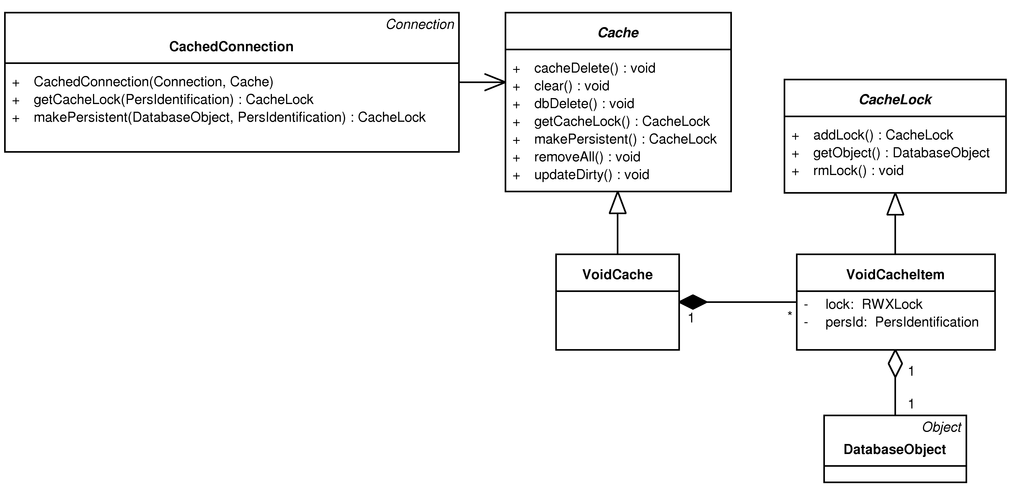
Each cache must implement the Cache interface. It defines following operations:
- makePersistent (insert) - cache obtains ownership of a new database object. The object is made persistent according to the updating strategy and caching algorithm used. Persistent copy creation can be enforced by invoking the updateDirty method.
- getCacheLock (load) - if needed, cache loads requested object from the database, locks it and returns a reference to it.
- updateDirty (update) - writes all changes including new objects to the database. updateDirty is called from CachedConnection.commit().
- dbDelete (delete) - deletes the specified object from the cache as well as from the database.
- clear - writes all changes to the database and removes all objects from the cache.
- removeAll - clears the cache, and discards all changes. Nothing is written back to the database. Called from CachedConnection.rollback().
Classes in Figure 5.12, “Basic classes of the cache layer. VoidCache architecture.” represent the basic framework for building simple synchronous cache implementations. One such implementation is the VoidCache. The VoidCache actually doesn’t cache anything - it merely loads and locks objects from the database as user requests. After the lock is released, changes made to the object are immediately propagated back to the database and the object removed from the cache. VoidCache stores the locked items in its containers as instances of the VoidCacheItem class.
IOPC 2 (and POLiTe 2) contains also an advanced interface designed for more complex cache implementations - the ExtendedCache interface. It adds methods that are needed by the cache manager CacheKeeper to run an asynchronous maintenance. Additionally, it allows to specify various strategies that modify behaviour of extended caches. Developers can define rules that specify which extended caches and which strategies should be used for particular objects. Architecture of the extended interface is displayed in Figure 5.13, “Extended interface of the cache layer.”.

Figure 5.13. Extended interface of the cache layer.
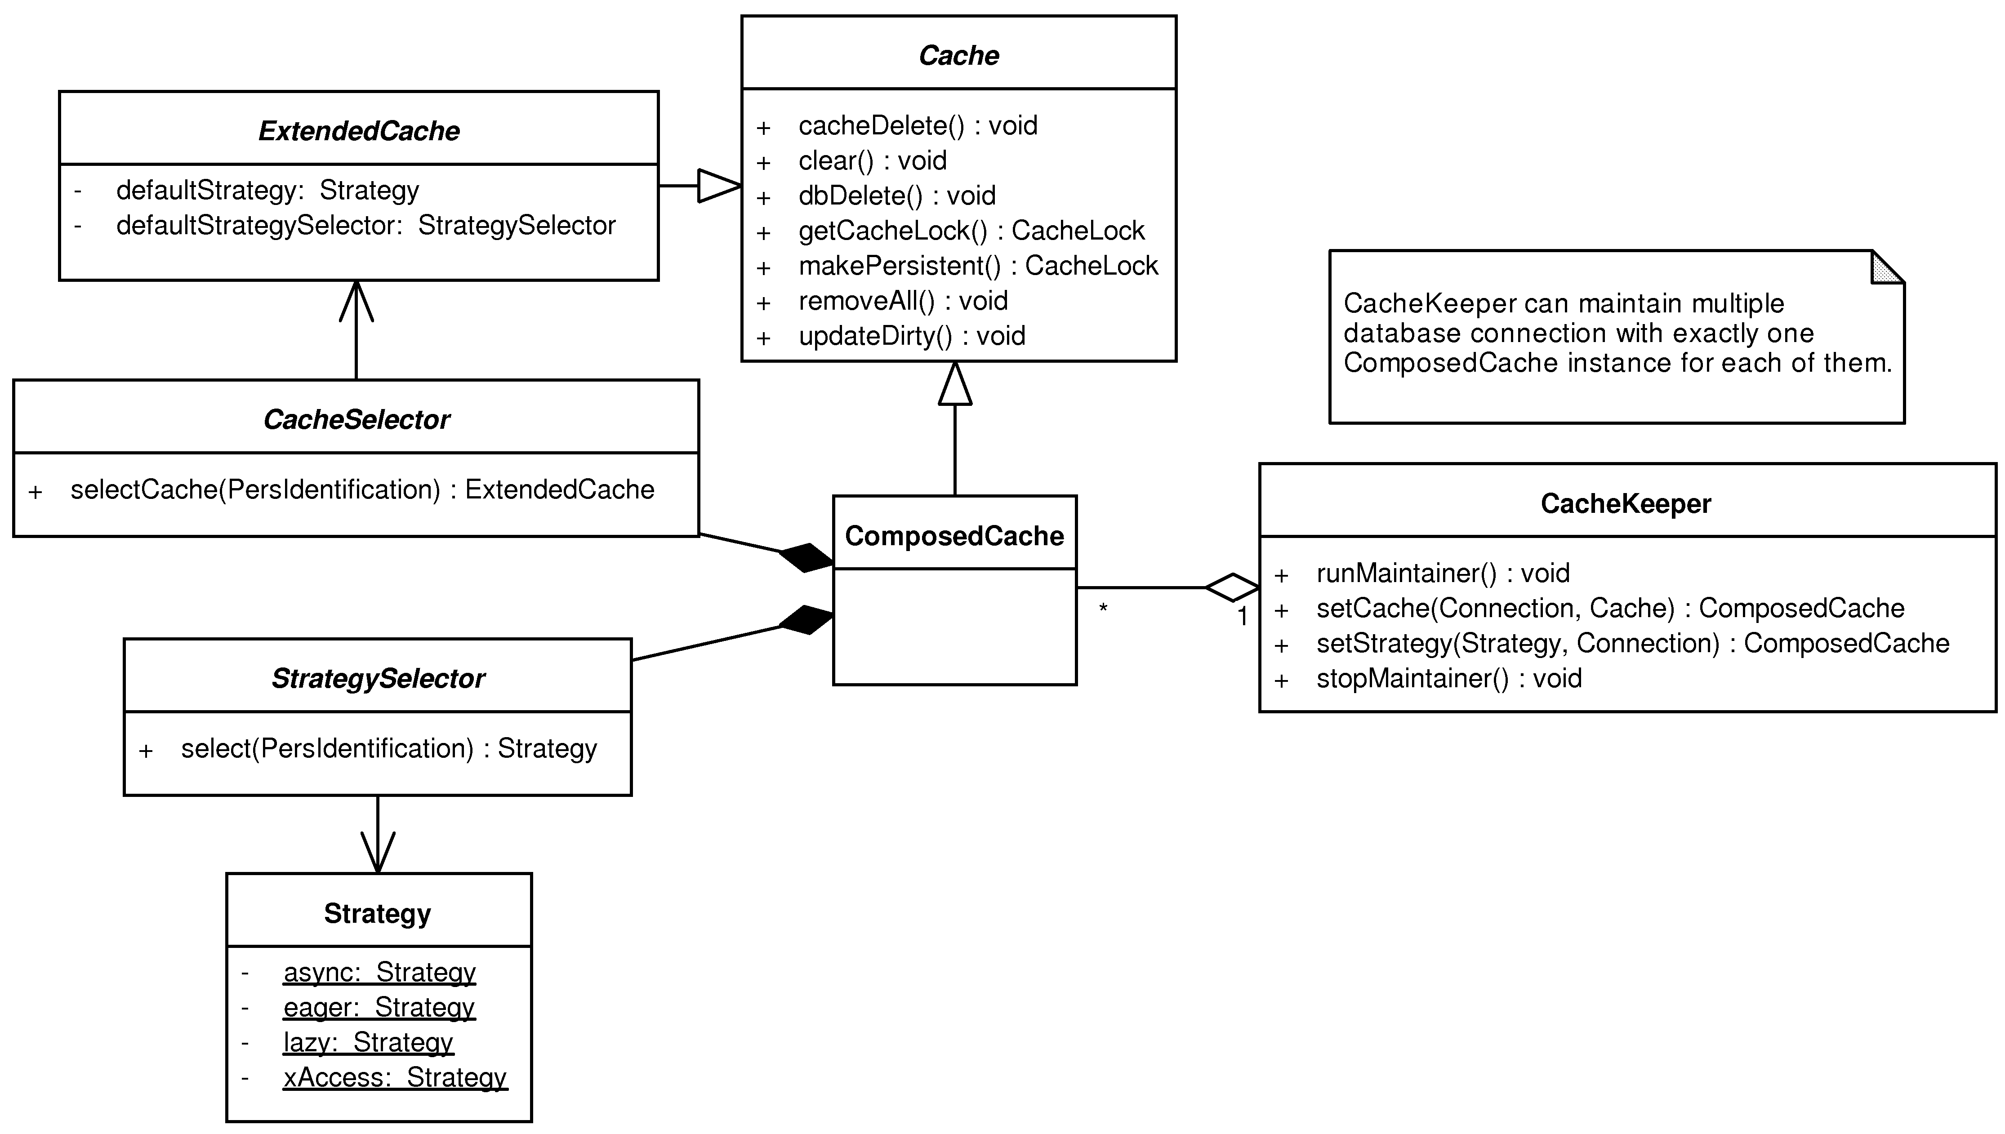
- Strategy - instances of this class can be used to modify behaviour of an extended cache. The instances represent combinations of the updating, reading, locking and waiting strategies introduced in the original POLiTe library - see the section called “Persistent object manipulation”. The class contains four of such predefined strategy combinations that can be used right away (as static instances).
- CacheSelector and StrategySelector - selector interfaces are used to specify rules that decide which strategy or which cache will be used for specific objects. SimpleStratSelector and SimpleCacheSelector implement these interfaces and provide basic rules which associate specific strategies or caches respectively with persistent object types. This means that the decisions are based on the processed object types.
- ComposedCache derives from the basic cache interface Cache and acts as a proxy that combines different extended caches into one “basic” cache. It uses CacheSelector to determine which cache should be used for the object being processed. StrategySelector is then passed to the cache where it is used to customize its behaviour.
- CacheKeeper - a single CacheKeeper instance is assigned one or more database connections. For each of these connections an instance of ComposedCache is created. CacheKeeper provides a facade for these caches by exposing an interface that allows developers to specify caches and strategies for particular connection and database object type combinations. However, the main benefit of using CacheKeeper is that it runs a second thread that scans managed caches and removes instances considered as ’worst’. If dirty, these instances are written back to the database.
The library offers two caches that implement the extended interface - MapLruCache and MapArcCache. As their names suggest, they use LRU and ARC replacement policies, respectively. For detailed description please refer to [1]. There are also singlethreaded variants of these two caches (suffixed with “ST”) which cannot be used in multithreaded environment and thus cannot use the asynchronous maintenance that the CacheKeeper provides.

Querying
Queries in IOPC 2 are realised as instances of the SimpleQuery and FreeQuery classes. Both classes derive from the same predecessor - the Query class as displayed in Figure 5.14, “The Query classes”. The base class declares the getSql method, whose implementation translates the query represented by the particular Query descendant instance to SQL. The Driver passed as a parameter is used in the translation process to accommodate the result to the destination SQL dialect.

Figure 5.14. The Query classes
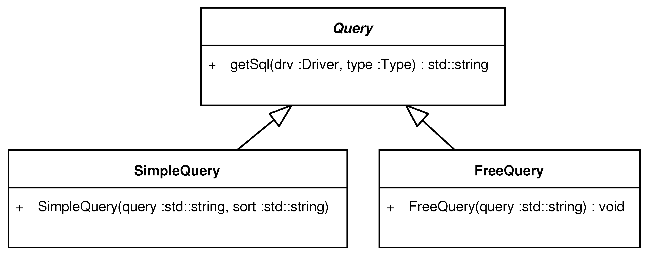
The SimpleQuery class is used to create basic queries which select data only from a single view or table specified by the result type of the query result (see below). The result can be ordered and filtered by restricting attribute values of the type. SimpleQuery is used to retrieve instances of one particular type. SimpleQuery represents only the WHERE and ORDER BY parts of the resulting SQL SELECT statement.
For more complex queries there is the FreeQuery class. This class allows developers to specify everything after the FROM keyword. There are absolutely no restrictions on joins, subselects or other SQL language constructs.
To make the queries independent from the table, view and column naming, users can insert application-level class names, attribute names and class metadata (see the section called “Class metadata”) references into any part of the query. This is probably best explained by an example:
SimpleQuery query(”$::Person::name$ = ‘Ian’”)
The translation process looks for the dollar signs and substitutes data type and attribute names that it finds between them. The ::Person::name string will be substituted for the name of the corresponding database table/view and column. By default, the Oid object names reference the associated polymorphic views, while the non-Oid object names are replaced by the names of physical tables.
The data type and attribute names can be further expanded with class metadata codes. This way, we can force the data type name to be substituted with corresponding table name instead of its pregenerated view name:
FreeQuery query(”$::Person[db.table]$ WHERE $::Person[db.table]::name[db.column]$ = ‘Ian’”)
The db.table and db.column class metadata are created by the iopclib library. For full list, see ???.
Results of the queries are encapsulated by the Result template class. Its only template parameter determines the type of the objects in the result set the query returns. Queries are executed by invoking the open method. After that, an iterator (ResultIterator) can be obtained and used in a standard C++ way. Example 5.10, “Example query in IOPC 2” shows how the example query from the section called “Querying” (”Find all students older than 26.”) can be implemented in IOPC 2.

Example 5.10. Example query in IOPC 2
SimpleQuery q(”$::Student::age$ >= 26”);
Result<Student> r(conn, q);
r.open();
for (Result<Student>::iterator it = r.begin(); it != r.end(); it++) {
cout << “name: “ << it->name << endl;
}

Chapter 6. Conclusion
IOPC 2 managed to unify the the POLiTe 2 and IOPC libraries into one solid, flexible and extensible platform. Thanks to its well-designed interface and modular architecture, the library can be easily customized, enhanced and used. Its ability to integrate with IDEs and its reflective features provide the developers with almost transparent object-relational mapping functionality.
If we compare the table from the section called “Library comparison” with what has been written about IOPC 2 in the last two chapters, we may see changes, mostly improvements in many of the listed areas:
 | POLiTe | POLiTe 2 | IOPC | IOPC 2
Transparent usage | - Macro descriptions | - Macro descriptions | + Uses Open C++ | + Uses GCCXML
Supported mapping types | - Vertical | - Vertical | + Vertical, horizontal, filtered, combinations | + Vertical, horizontal, filtered, ADT, combinations
Associations between objects | + Simple reference and relations - one-to-many, many-to-one, many-to-many, chained | + Simple reference and relations - one-to-many, many-to-one, many-to-many, chained | +/- Simple reference and reference list | - Only simple reference
Caching | - Simple object cache | + Advanced caching features. | -- Simple object cache, no locking | + Advanced caching features (same as POLiTe 2).
Querying | C++-like syntax, combining queries | C++-like syntax, combining queries | C++-like syntax, combining queries | SQL syntax, class metadata embedding
Read-only database / existing schema support | + | + | - | +
Library architecture | - Monolithic | - Monolithic | - Monolithic | + Modular, configurable
Supported databases | Oracle 7 (OCI 7) | Oracle 7 (OCI 7) | Oracle 8i (OCI 8) | Oracle 10g (OCI 10)
Multithreading support | - | + | - | +
IOPC 2 was designed with emphasis on modularity. IOPC 2 doesn’t provide only object-relational mapping services. It is a set of libraries which can be used in one of four configurations - an object persistence library, a database access library, a reflection library and an all-purpose library providing some useful tools. The database access library can be further customised with separate database drivers.
The reflection library represens a unified interface which allows developers to inspect the structure of the reflection-capable classes at run-time. It offers some of the features which are incorporated into reflective languages like Java or C#. To get the metamodel description IOPC 2 uses GCCXML, which represents a more reliable solution then OpenC++ used by IOPC.
Object-relational mapping capabilities of the original IOPC library has been enhanced by one additional mapping type - the ADT mapping. ADT mapping is a result of discussion on possibilities of object-relational databases presented in this thesis. It demonstrates how their features can simplify the development of an object-relational layer. IOPC 2 also retained the ability to work with existing or read-only database schemas.
Although the IOPC 2 library covers many of the needs developers may pose on a object persistence library, there is a lot of room for improvement and future enhancements. A major issue of this library is the lack of a persistable data type representing a list of references. To express various kinds of associations between persistent objects, POLiTe libraries used relation objects as described earlier in the section called “Metamodel and object-relational mapping.”. POLiTe libraries also allowed to use a simple reference to model the one-to-many relation. IOPC replaced the concept of relation objects with the persistent references and reference lists. The reference lists were however almost unusable, so they were removed from the IOPC 2 implementation and remained to be implemented in the future. The future implementation should also use some of the ORDBMS features like references or arrays to store these lists in the database. Reintroduction of the relation objects may also be possible.
This leads us to the second, smaller, issue - IOPC 2 aside from ADTs doesn’t use other ORDBMS features. There are many other ways how to enhance functionality of the library in this area. Other areas may also improved - the reflection can be given the ability to describe and invoke methods.
IOPC 2 also lacks proof of concept - a real-life or real-life-like application that would demonstrate that the library is usable for the purpose for which it is designed. The application could be web-based as well as a thick client. Such test would probably reveal other issues or misconceptions which may result in additional requirements on the library. For example the web application requirements would surely include a connection pool facility to speed up the connection creation process. Similarly, another non-Oracle database driver could be implemented - support for a lightweight in-process database like SQLITE¹ would be interesting.

Literature used
[1] Jan Hadrava. Správa persistentních objektů. Master Thesis. Prague, Charles university. 2004.
[2] Josef Troch. Persistence objektů v C++. Master Thesis. Prague, Charles university. 2004.
[3] Michal Kopecký. Object persistency in C++. Doctoral Thesis. Prague, Charles university. 2004.
[4] Michal Kopecký. POLiTe User’s Reference. Prague, Charles university. 2002.
[5] A. Silberschatz et al. Applied Operating System Concepts. JohnWiley & Sons, Inc.. 2000.
[6] N. Megiddo and S. M. Dharmendra. ARC: A Self-Tunning, Low Overhead Replacement Cache. USENIX File & Storage Technologies Conference (FAST). March 31, 2003.
[7] Frank Manola and Jeff Sutherland. SQL3 Object Model. URL: http://www.objs.com/x3h7/sql3.htm.
[8] Michael Stonebraker and Dorothy Moore. Object-Relational Dbmss: the Next Great Wave. San Francisco: Morgan Kaufmann Pub. 1996.
[9] Oracle. Oracle Database Online Documentation 10g Release 2. URL: http://www.oracle.com/pls/db102/homepage.
[10] Wikipedia. Object database. URL: http://en.wikipedia.org/wiki/ODBMS.

1see [10]
2http://www.hibernate.org/
3http://www.nhibernate.org/
4http://msdn.microsoft.com/en-us/library/bb399572.aspx
5Persistent Object Library Test
6Implementation of Object Persistency in C++
1A Universally Unique Identifier
2Binary large object
3For simplicity, we will consider the ADT mapping as one of the object-relational mapping types and the process of storing or loading ADT-mapped instances will also be called object-relational mapping.
4Cache. All related structures will be called as the cache layer.
1Oracle Call Interface
2Create (insert) / Read (select) / Update / Delete
3Caches that implement the basic Cache interface can be maintained too, but the CacheKeeper doesn’t provide the asynchronous maintenance for them.
4However, recompilation of several IOPC modules is still needed
5http://opencxx.sourceforge.net/
6http://xml.apache.org/xerces-c/
7Although the IOPC SP states that those errors can be ignored
1http://www.gccxml.org [http://opencxx.sourceforge.net/]
2Although its name matches the name of a IOPC module with similar functionality (see the section called “IOPC SP”), this tool was written from scratch for the IOPC 2 library.
3For more on this topic, see the section called “Class metadata”. Also note that this time we use the enhanced attribute datatypes, see the section called “Enhanced data types”.
4In DB2 the instance would be inserted into a table associated with that ADT [TODO].
5see [9] - Database Administrator’s Guide
1http://www.eclipse.org/, http://www.eclipse.org/cdt/
2This is not necessarily true because the build process can be modified to accept only a subset of the project files.
3http://www.eclipse.org/cdt/
4No direct memory access to these members, etc.
5Class that derives from DatabaseObject
6And its update and delete variants.
1http://www.sqlite.org

